Freiheit
Schreibt, was immer ihr wollt, egal was euch einfällt.
Schließt auf, was in euch schlummert:
________________________________________
____________________________________
_______________________________________________
_________________________________________________
____________________________________________________
____________________________________________________________
_____________________________________________
_____________________________________________
____________________________________________
__________________________________________________
_____________________________________________________
______________________________________________
_______________________________________________________
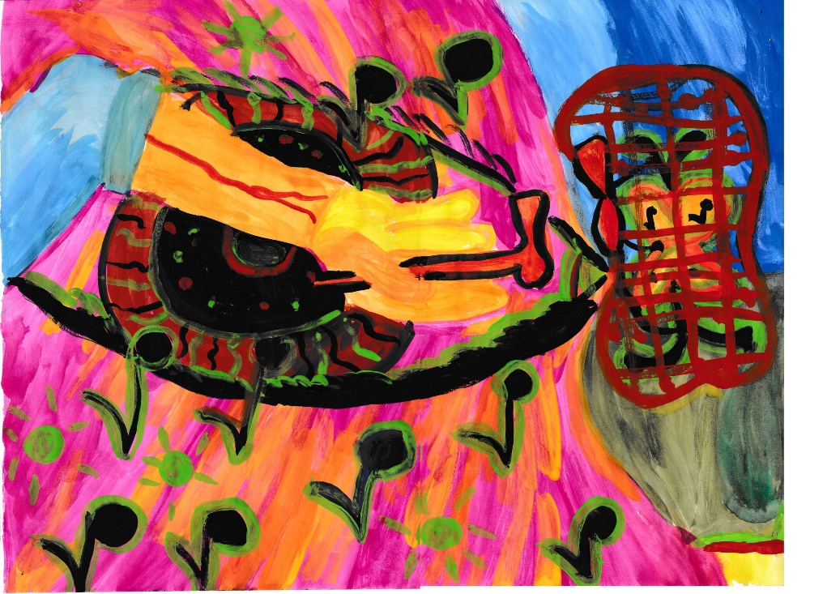

______________________________________________________
__________________________________________________________
_____________________________________________________
__________________________________________________
__________________________________________________
Brecht aus: ________________________________________
___________________________________________________________
________________________________________________

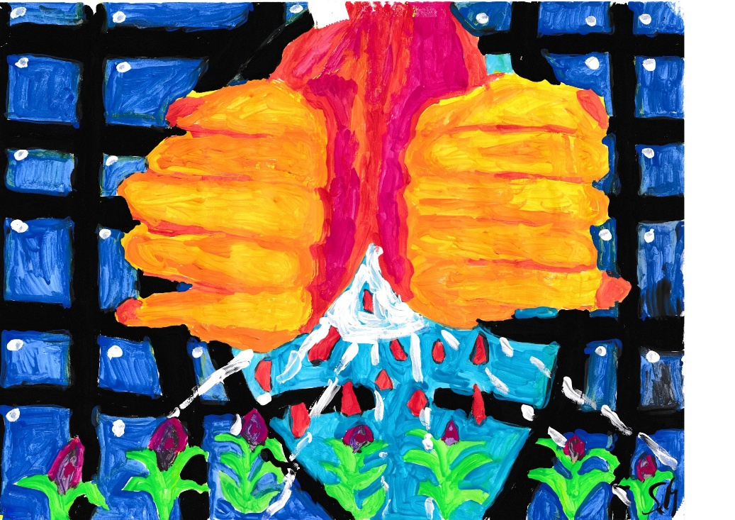

______________________________________________________
__________________________________________________________
______________________________________________________
__________________________________________
_____________________________________________________
___________________________________________________
______________________________________________________
___________________________________________________
______________________________________________
____________________________________________________
__________________________________________________________
______________________________________________________
_________________________________________________________
_____________________________________________________________
_______________________________________________________
_______________________________________________________
____________________________________________________________
_______________________________________________________
___________________________________________________________
Seht die Möglichkeiten:
_____________________________________________________

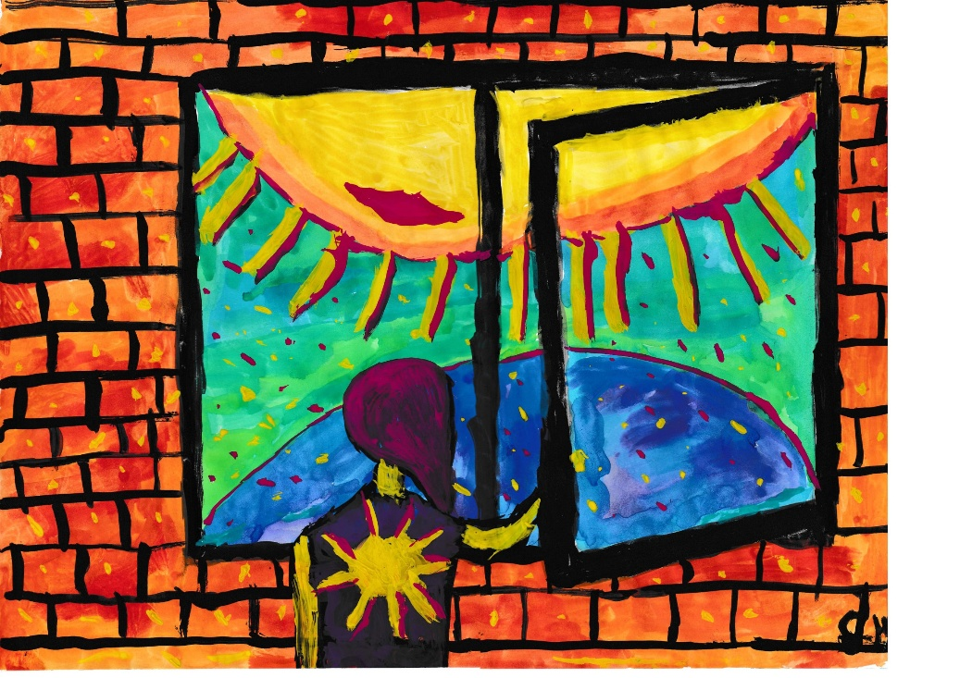
_________________
_______________________________________________________
_________________________________________________________
________________________________________________________
_______________________________________________________
__________________________________________________________
_______________________________________________________
________________________________________________
___________________________________________________
________________________________________________________
______________________________________________________
________________________________________________________
___________________________________________________________
_________________________________________________
_______________________________________________________
___________________________________________________________
______________________________________________________
_________________________________________________________
_______________________________________________________
_________________________________________________________
___________________________________________
_____________________________________________________

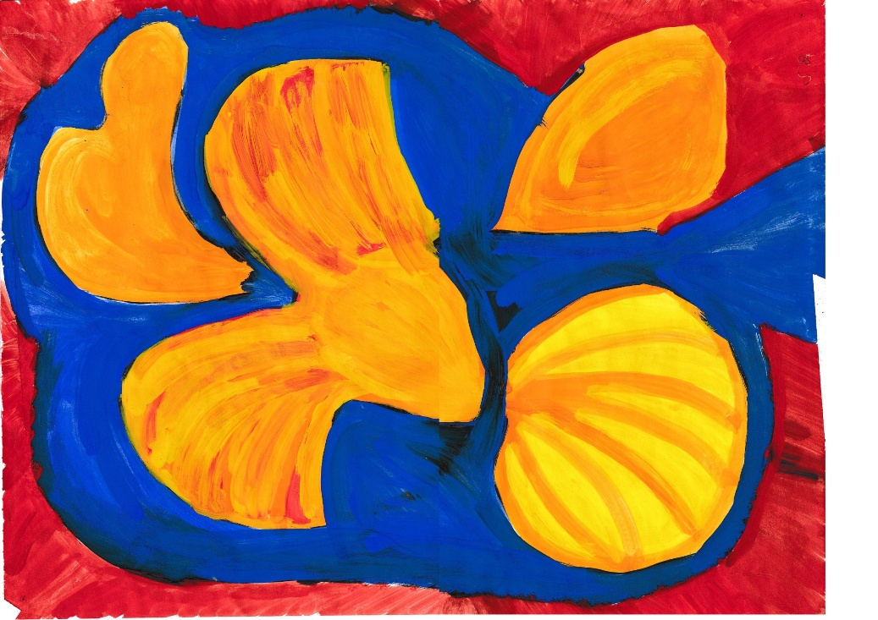

Lasst euren Geist fliegen

_________________________________
________________________________________________
_______________________________________________________
_________________________________________________________
____________________________________________________
__________________________________________________________
_______________________________________________________
_____________________________________________________
_____________________________________________________
________________________________________________________
______________________________________________
_______________________________________________________
_________________________________________________
_________________________________________________
________________________________________________________
Seid bunt:

___________________________________________
________________________________________________
__________________________________________
________________________________________________
________________________________________
______________________________________________
_____________________________________
________________________________________________
______________________________________
____________________________________________
____________________________________________
__________________________________________________
_____________________________________________
________________________________________________
__________________________________________________
________________________________________________

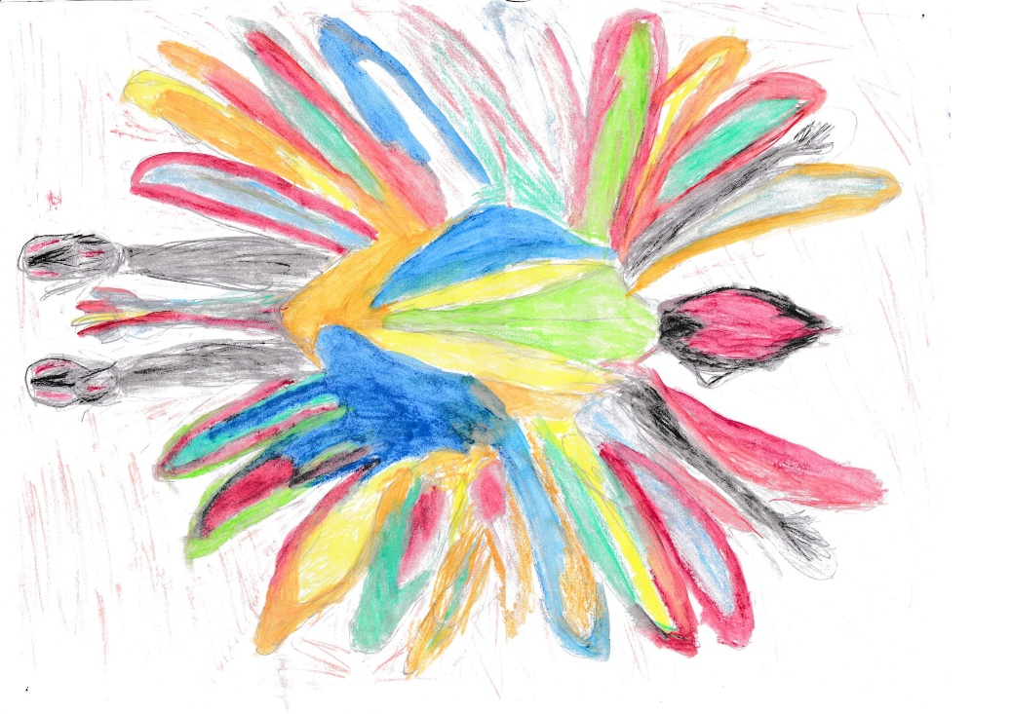

Seid stolz auf Erreichtes:
__________________________________________________
_______________________________________________
___________________________________________________
_______________________________________________
________________________________________________
_____________________________________________________
___________________________________________________________
_____________________________________________________
________________________________________________
_______________________________________________________
______________________________________________________
______________________________________________
_________________________________________________
_____________________________________________
____________________________________________
________________________________________________
_____________________________________________

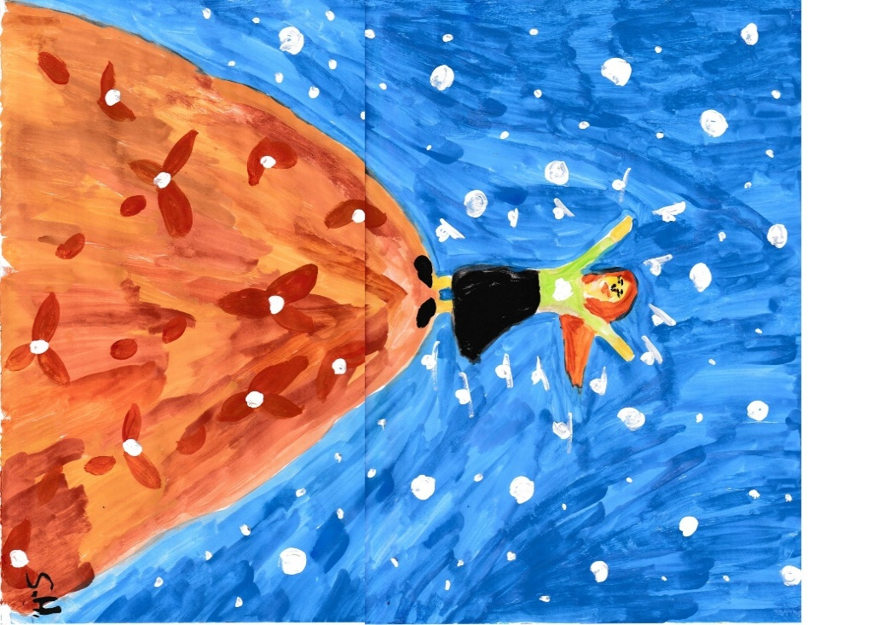
Greif zu den Sternen:

_____________________________________________
______________________________________________
______________________________________________________
____________________________________________
_____________________________________________
___________________________________
________________________________________________
______________________________________________
______________________________________________
_____________________________________________________
______________________________________________
___________________________________________________
___________________________________________
_____________________________________________________
___________________________________________________________
__________________________________________________

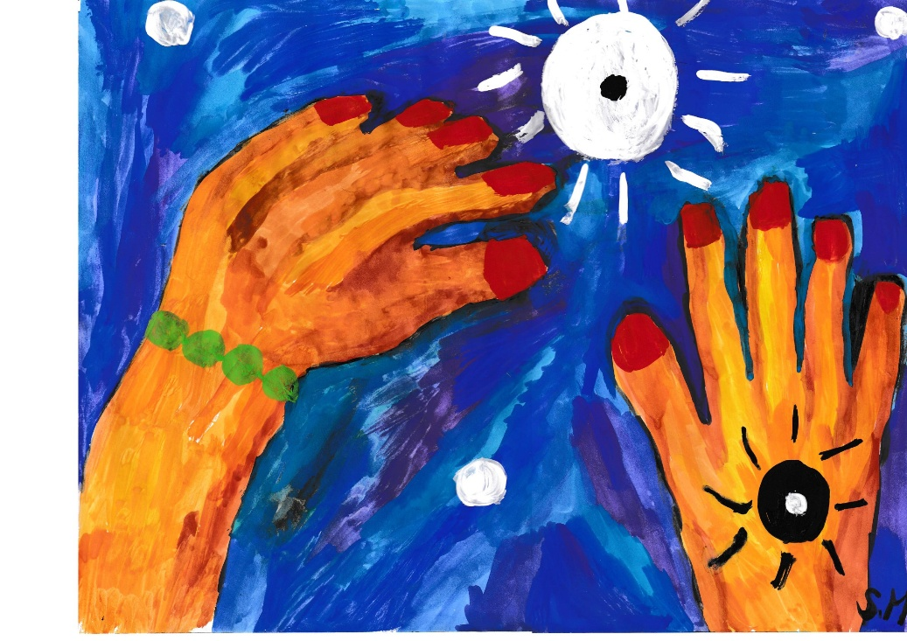

______________________________________________
_______________________________________________________
____________________________________________________________
Wachse:
___________________________________________________
_________________________________________
_________________________________________________

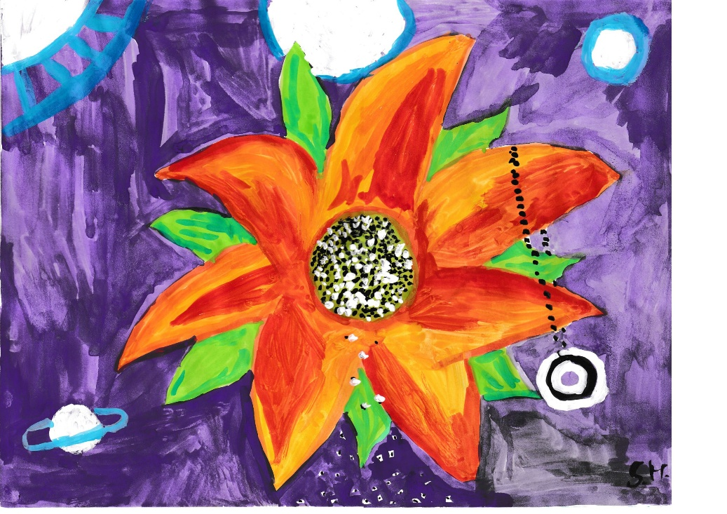

_________________________________________________
______________________________________________________
____________________________________________
________________________________________________
__________________________________________________________
___________________________________________________
__________________________________________________________
___________________________________________________
_____________________________________________________
__________________________________________________________
____________________________________________________
_______________________________________________________
____________________________________________________________
________________________________________________________
______________________________________________
__________________________________________________________
________________________________________________
_____________________________________________________

Träume:
_____________________________________________
____________________________________________________
_________________________________________
______________________________________________
_____________________________________________________
____________________________________________
__________________________________________________
____________________________________________
________________________________________________
_______________________________________________________
_____________________________________________
___________________________________________________
__________________________________________
________________________________________________
_________________________________________________
____________________________________________________
___________________________________________
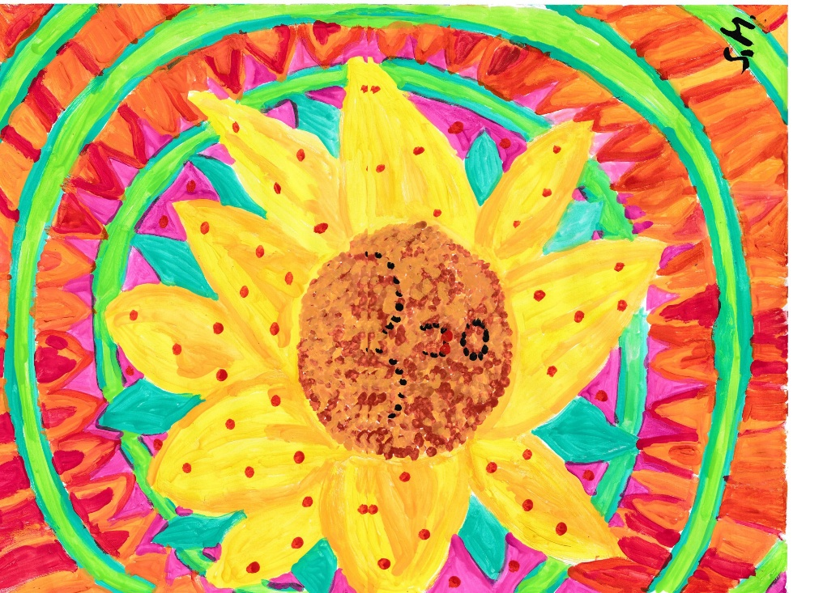

_______________________________________________________
_____________________________________________________

Sieh weiter:
_______________________________________________________
_________________________________________________

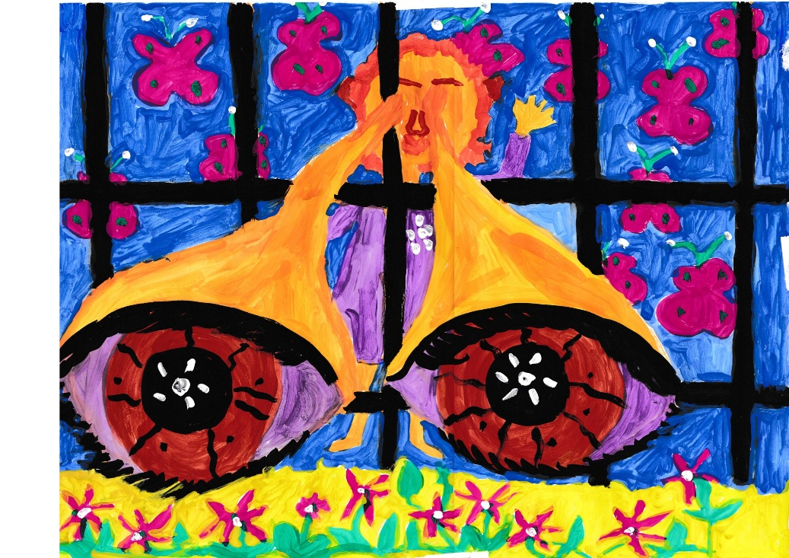
___________________________________________________
________________________________________________________
_____________________________________________________
__________________________________________________
________________________________________________________
________________________________________________________
_____________________________________________________
__________________________________________________________
______________________________________________
_________________________________________________________
_________________________________________________
____________________________________________________________
____________________________________________________
_______________________________________________________
_____________________________________________________________
________________________________________________________
__________________________________________________
________________________________________________________
_____________________________________________________________
__________________________________________________
_____________________________________________________
Vertraue:
______________________________________
___________________________________________
__________________________________
________________________________________
___________________________________________
________________________________________
__________________________________
_________________________________________
_________________________________
________________________________________
_____________________________________________
________________________________________
____________________________________________
___________________________________________________
________________________________________________________
_____________________________________________________
_______________________________________

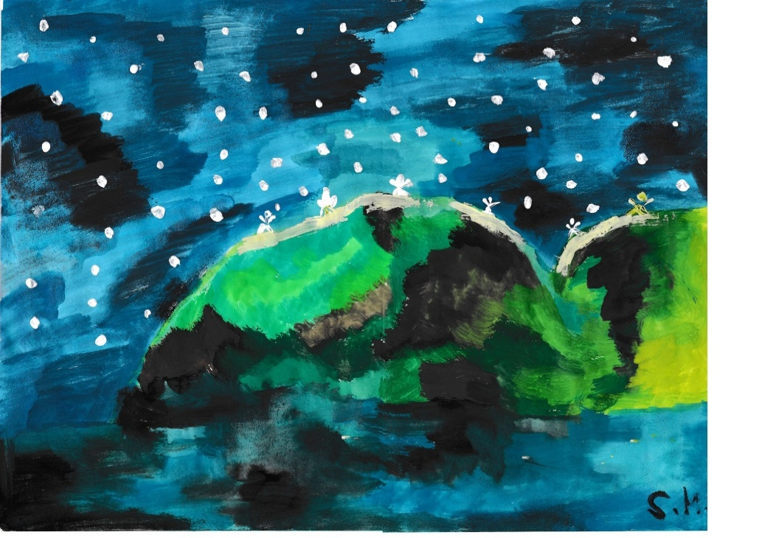

______________________________________________________
______________________________________
__________________________________________________
____________________________________________________________
___________________________________________________
Spinne:

____________________________________________________





















