Land und Leute
Wo auch immer hier seid, was auch immer es euch bedeutet:

Natur:
_______________________________________________
__________________________________________________________
________________________________________________________
__________________________________________________
________________________________________________________
__________________________________________________________
_________________________________________________________
________________________________________________________
___________________________________________________
__________________________________________________
____________________________________________________
________________________________________________________
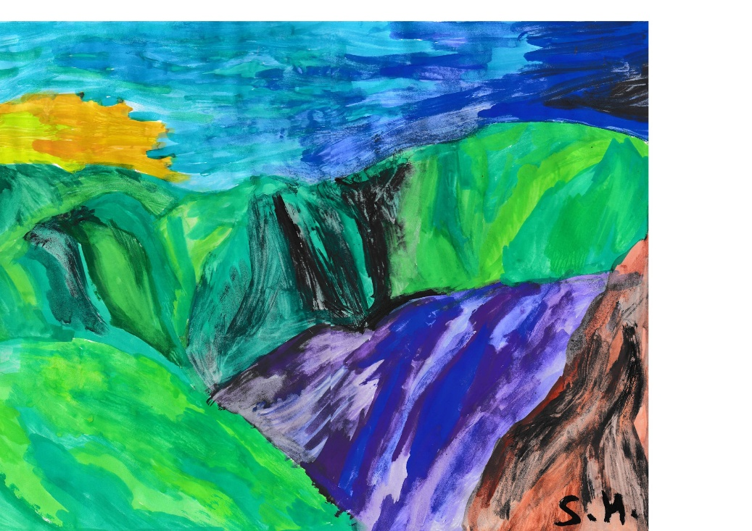

_____________________________________________________
___________________________________________________________
___________________________________________________
________________________________________________________
_____________________________________________________
Pflanzen:
____________________________________________
_______________________________________________
________________________________________
______________________________________________
__________________________________________
_______________________________________
______________________________________
__________________________________________
____________________________________________
_____________________________________
________________________________________
_____________________________________
________________________________________
____________________________________
___________________________________________
____________________________________
_________________________________________
_________________________
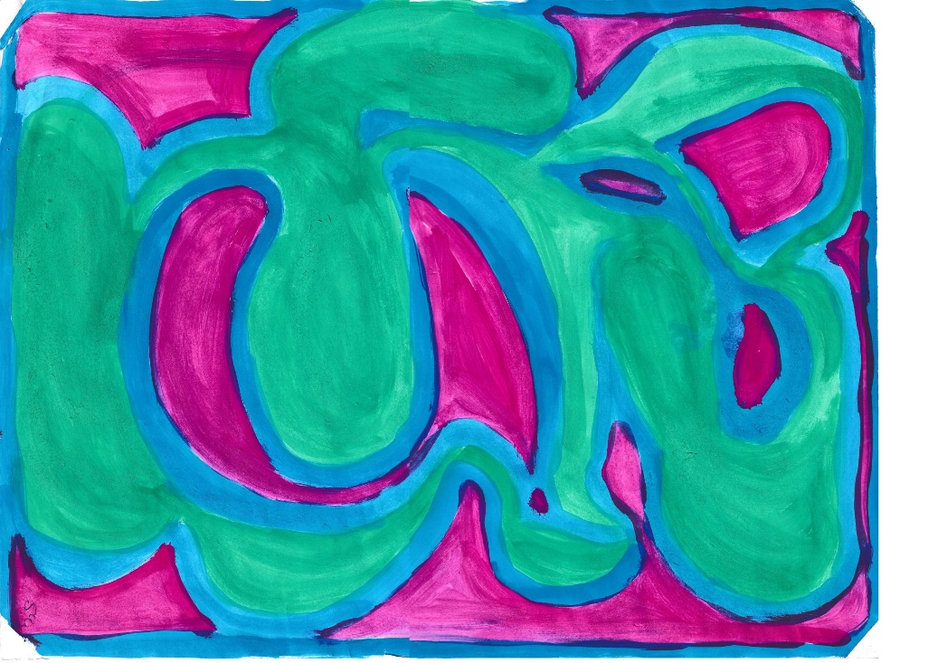
Soziales:
_______________________________________________
_____________________________________________
________________________________________
______________________________________________
___________________________________________
__________________________________________________
__________________________________________
_____________________________________________
____________________________________________
______________________________________________
________________________________________
_______________________________________________
______________________________________
_______________________________________________
__________________________________________
_________________________________________
__________________________________________________
____________________________________________
_________________________________________
_______________________________________________________
____________________________________________________________
___________________________________________________________

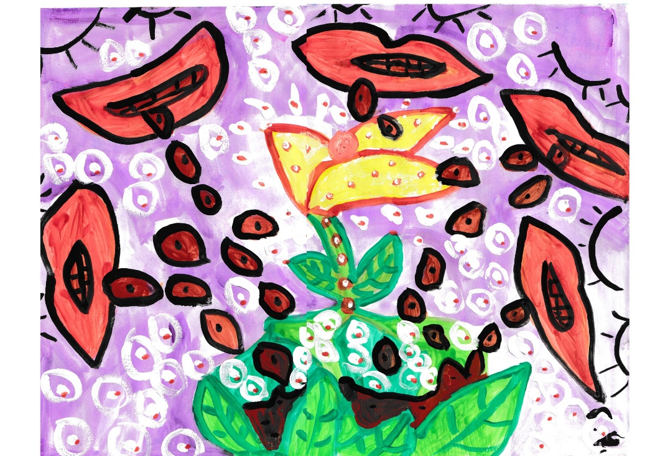
Regeln:

_________________________________________
______________________________________________
___________________________________________________
_________________________________________
_____________________________________________
________________________________________________
________________________________________
____________________________________________
______________________________________________
_____________________________________________________
______________________________________________
______________________________________
___________________________________________
______________________________________
___________________________________________
___________________________________________
________________________________________________
___________________________________________________
__________________________________________________

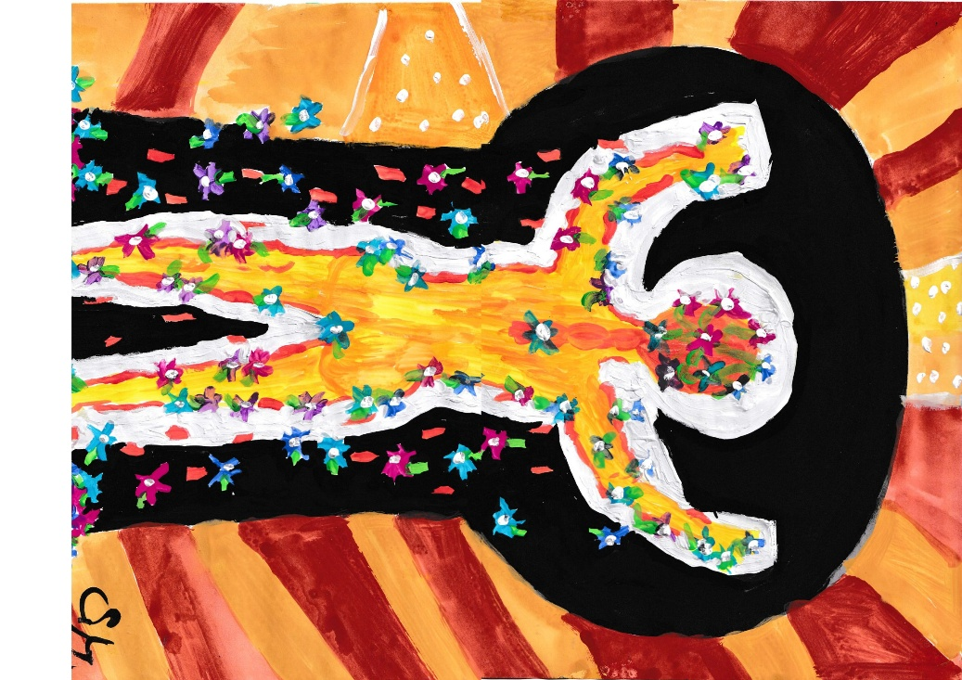

Das Besondere:
____________________________________________
_________________________________________
________________________________________________
____________________________________
_______________________________________________
___________________________________________________
_______________________________________
____________________________________________
____________________________________________
__________________________________________
_______________________________________________
__________________________________________________
_______________________________________________
_____________________________________________
_________________________________________
____________________________________________
____________________________________________
_______________________________________
________________________________________________
________________________________________________________
______________________________________________________
_________________________________________
____________________________________________________

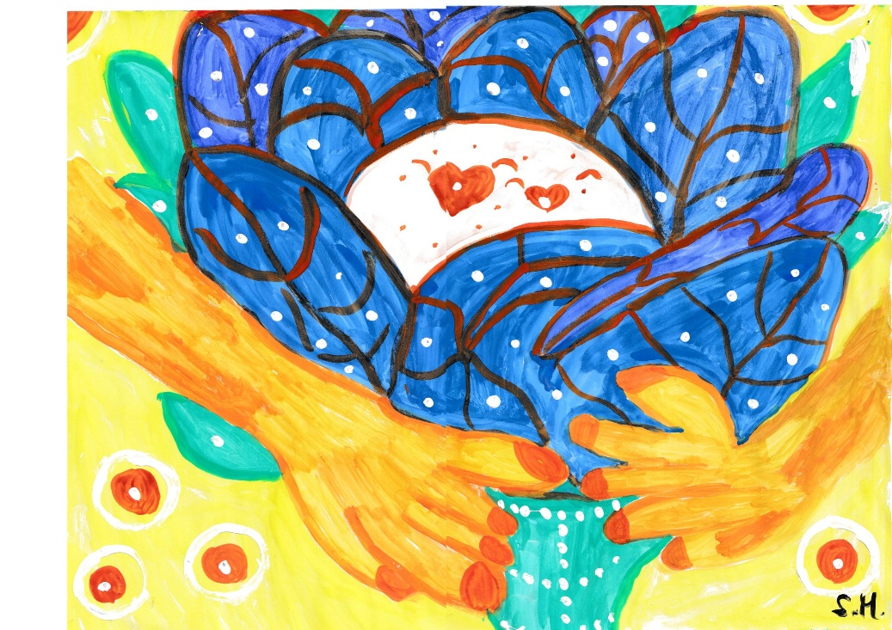

Locals:
______________________________________
_____________________________________________
___________________________________________________
_________________________________________
_____________________________________________
___________________________________________________
_____________________________________________
__________________________________________
_______________________________________________
_____________________________________________
________________________________________
_____________________________________________
___________________________________
______________________________________
_______________________________________________

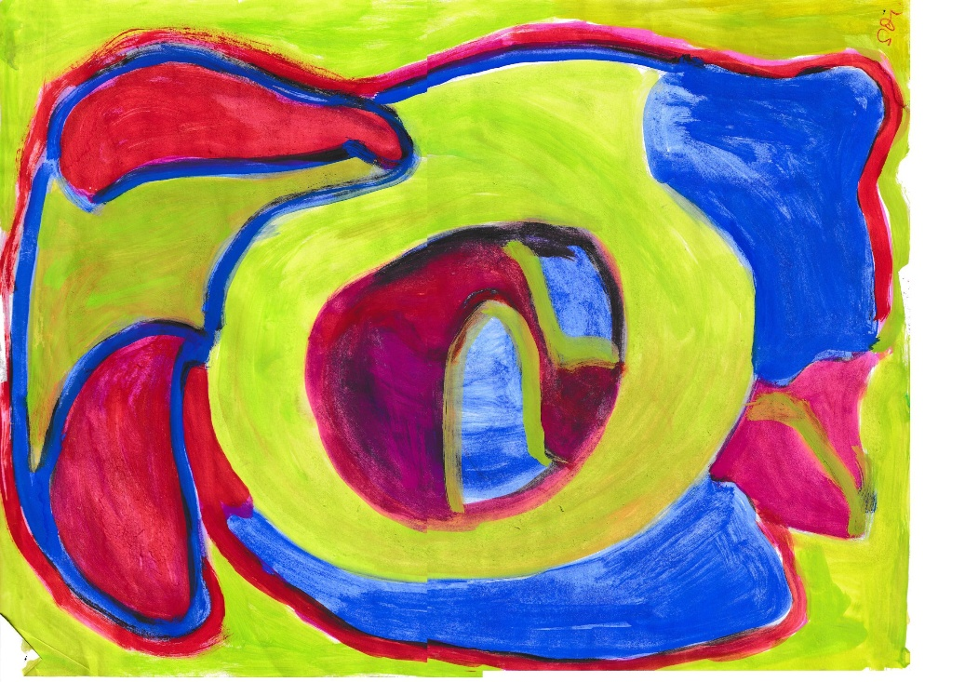
Gebirge:
_______________________________________________
_____________________________________
______________________________________________
__________________________________________
___________________________________________
_________________________________________________
______________________________________________
_______________________________________
_____________________________________
__________________________________________
_________________________________
__________________________________________
_____________________________________
__________________________________
____________________________________
_____________________________________________
__________________________________________

_____________________________________________
_______________________________________
_______________________________________________

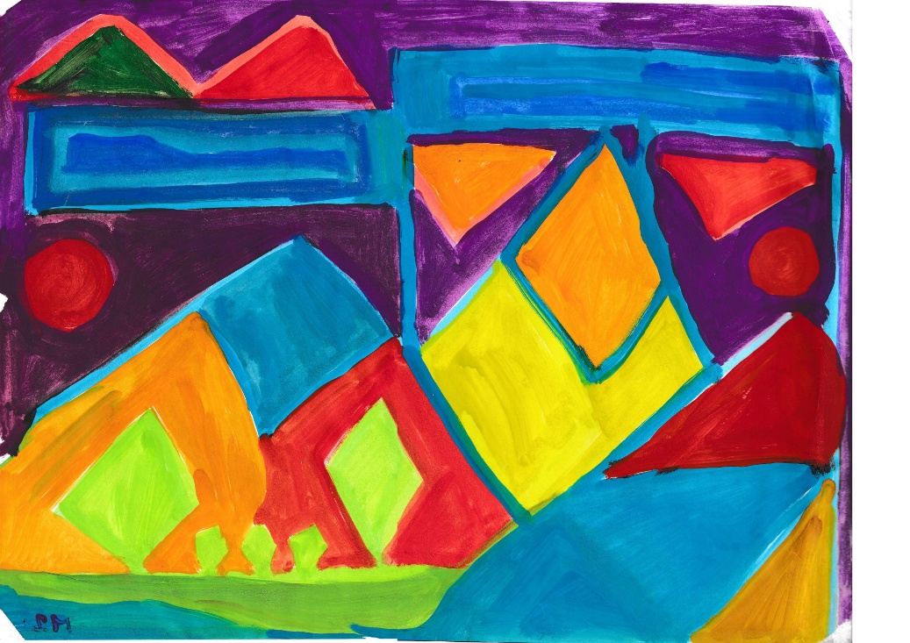

Herrschender Geist:

____________________________________
_______________________________________
______________________________________
___________________________________________
____________________________________
___________________________________
________________________________________
______________________________________
__________________________________________
_______________________________________
_________________________________________
____________________________________________
_______________________________
__________________________________________
_______________________________________
_________________________________________________

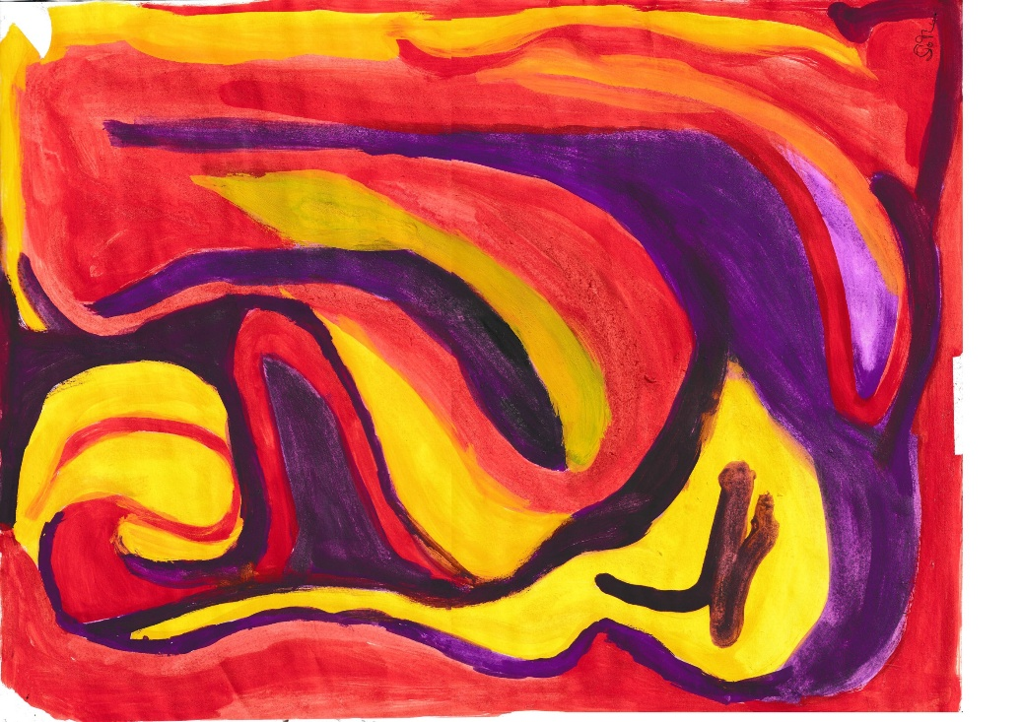

Schlechtes

_____________________________________________
___________________________________
_____________________________________
________________________________________
_____________________________________
_____________________________________
__________________________________
____________________________________________
__________________________________
______________________________________
__________________________________
____________________________________
___________________________________
___________________________________
__________________________________________
_____________________________________

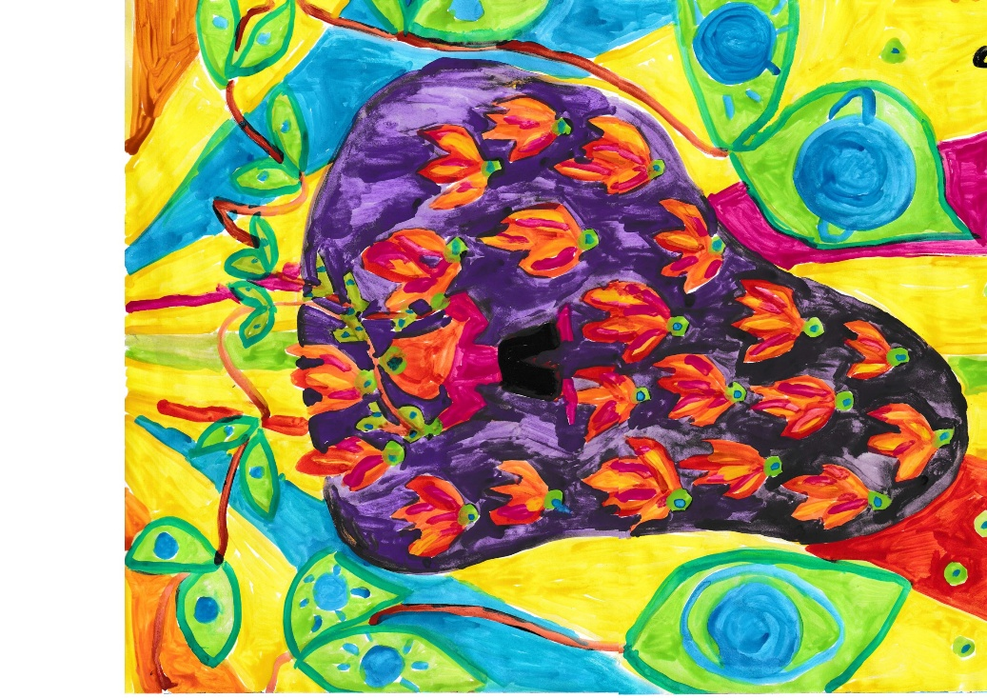

Gutes:
________________________________________________
________________________________________
_____________________________________________
______________________________________________
__________________________________________________
_________________________________________
________________________________________________
_________________________________________
_____________________________________________
_______________________________________
_____________________________________
_____________________________________________
____________________________________
_____________________________________
_________________________________
_________________________________________
_____________________________________________
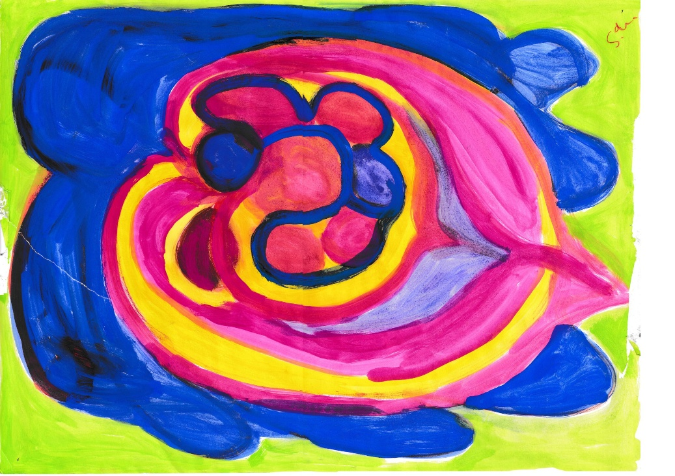

Nachts:
__________________________________________
_________________________________________________
_________________________________________________
_____________________________________________________
_____________________________________________
___________________________________________________
_____________________________________________
________________________________________
___________________________________
__________________________________________
__________________________________
__________________________________________________
_______________________________________
_________________________________
_______________________________________
______________________________________
____________________________________________________

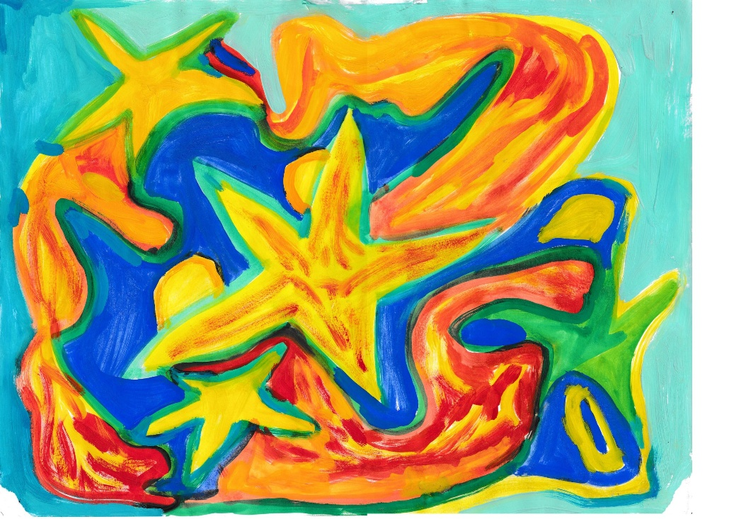
______________________________________
_______________________________
_____________________________________________
___________________________________________________
_________________________________________________________

Und Tschüß:

______________________________________________
______________________________________________
__________________________________________
_____________________________________________________
____________________________________
_____________________________________________
_______________________________________
______________________________________________
________________________________________
________________________________________________
__________________________________________________________
________________________________________
_______________________________________________
__________________________________________
_______________________________________
________________________________









