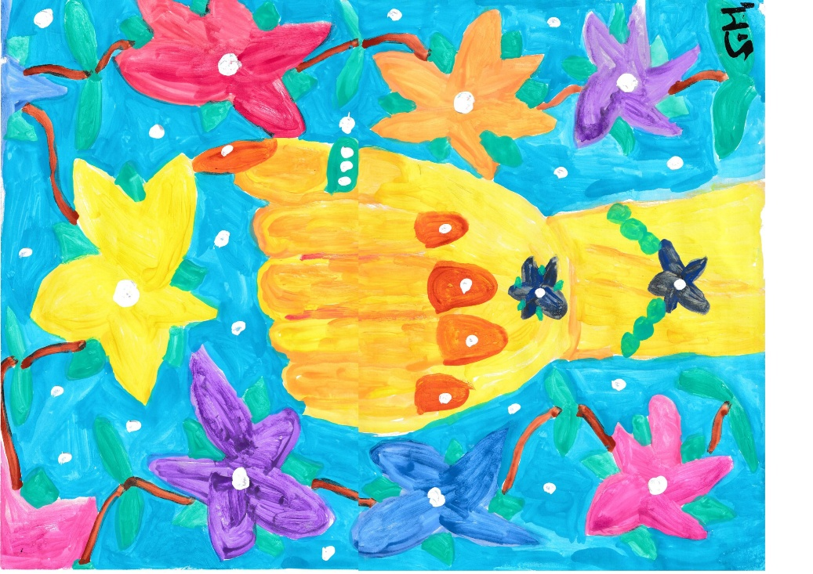

Meine Ansichten
Kampf:
___________________________________________________________
___________________________________________________
_______________________________________________________
___________________________________________________________
________________________________________________________
_______________________________________________________
______________________________________________________
_________________________________________________________
____________________________________________________________
__________________________________________________
___________________________________________________________
_____________________________________________
_____________________________________________________
Tod:
________________________________________________
_____________________________________________
________________________________________
_____________________________________________
_______________________________________________
___________________________________________
_________________________________________
________________________________________
___________________________________________________________
_______________________________________________
___________________________________________
______________________________________
______________________________________________
________________________________________
_________________________________________________
__________________________________________
_____________________________________

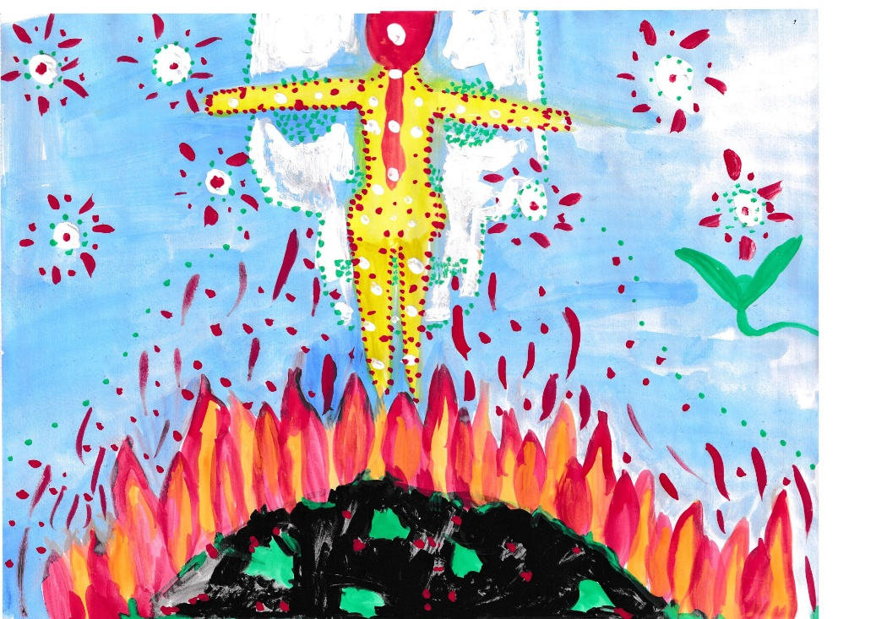
_____________________________________________
__________________________________________________
__________________________________________
________________________________________________
____________________________________________
__________________________________________________________
Geben:
_____________________________________________________
________________________________________________________
_________________________________________________
_____________________________________________________
_______________________________________________
______________________________________________________
________________________________________________
__________________________________________________
_________________________________________________________
__________________________________________________
______________________________________________________
_________________________________________________
___________________________________________
_____________________________________________________
________________________________________________
______________________________________________________

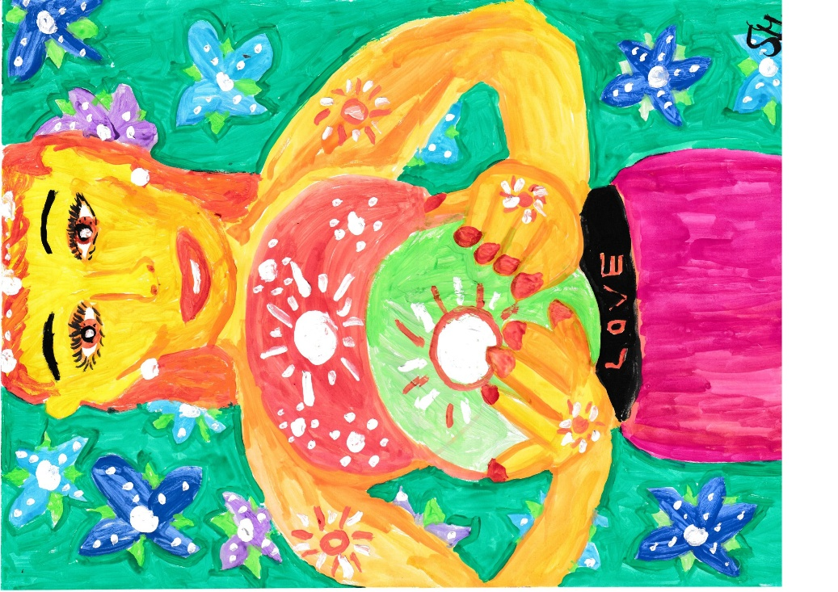

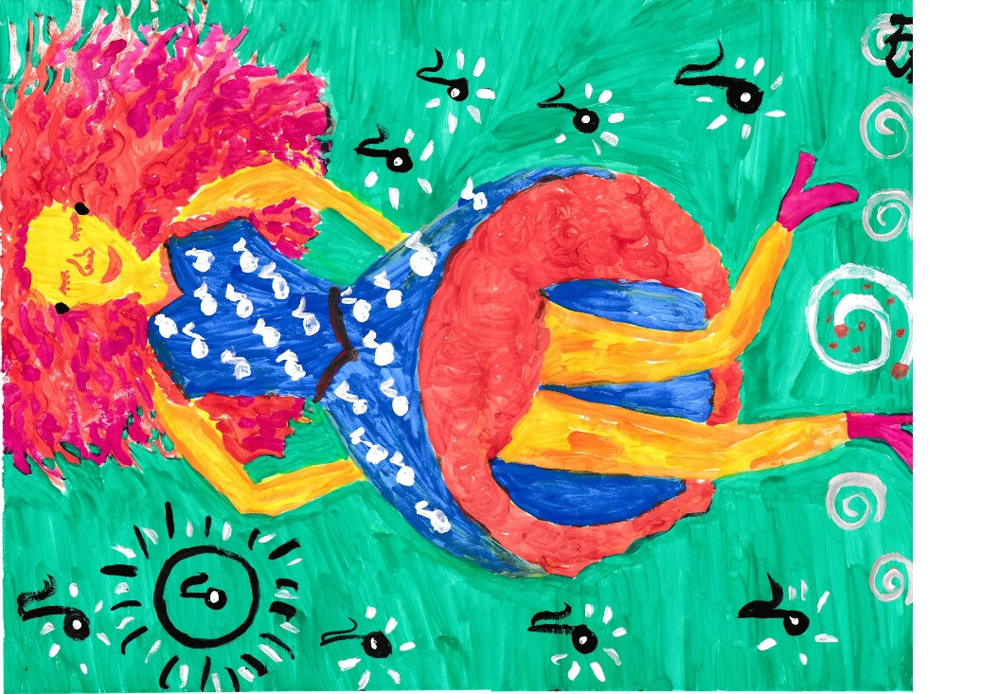

Nehmen:
______________________________________________________
_____________________________________________________
_____________________________________________________________
_______________________________________________________
____________________________________________________________
_______________________________________________________
___________________________________________________________
________________________________________________________
____________________________________________________________
__________________________________________________
_____________________________________________________
_____________________________________________________________
______________________________________________________
________________________________________________
__________________________________________________________
____________________________________________________
_________________________________________________________
Moderne Mythen:
________________________________________________
________________________________________________
_________________________________________
______________________________________________________
______________________________________________
______________________________________________
___________________________________________________
_________________________________________
______________________________________________
_________________________________________________
________________________________________________
__________________________________________
__________________________________________________
__________________________________________
_____________________________________________

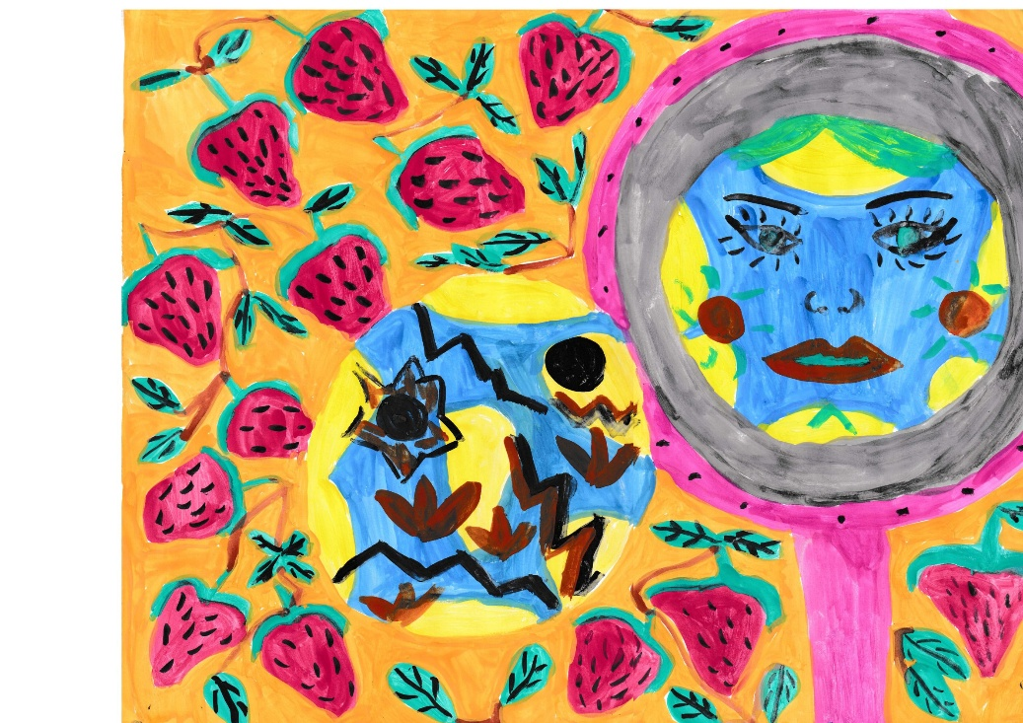

Optimismus

______________________________________________
__________________________________________________
___________________________________________________
_________________________________________________
___________________________________________
____________________________________________
_______________________________________________
___________________________________________
_______________________________________________
Pessimismus

_________________________________________________
________________________________________________________
_______________________________________________
__________________________________________

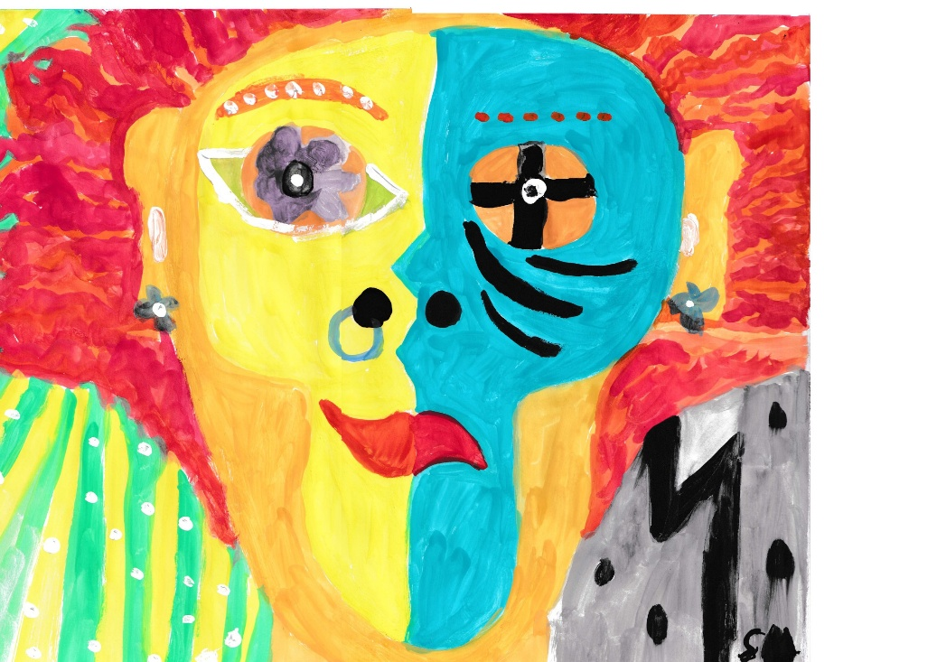

Auflehnung:

______________________________________________
_________________________________________________
___________________________________________
____________________________________________________
_________________________________________________
______________________________________________________
_______________________________________________
_______________________________________________
_____________________________________________________
________________________________________________
______________________________________
______________________________________________
____________________________________________________
________________________________________________
_____________________________________________________

___________________________________________________
________________________________________________
__________________________________________
______________________________________

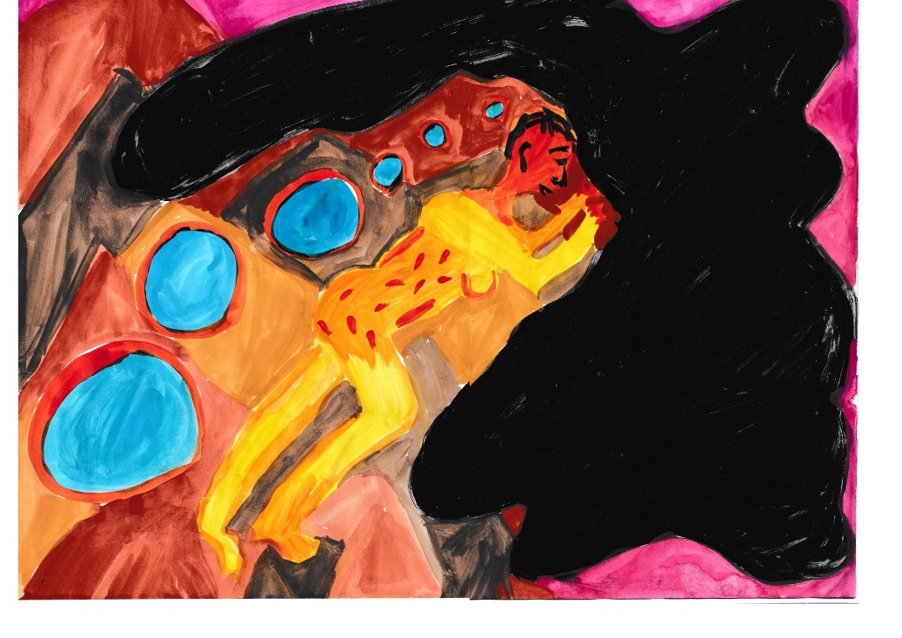
____________________________________________

Verantwortung:

________________________________________________
_____________________________________________________
______________________________________________
_________________________________________________
__________________________________________
____________________________________________
_________________________________________________
_________________________________________
_____________________________________________
________________________________________
__________________________________________
__________________________________________
_____________________________________________
_______________________________________
______________________________________________
_____________________________________________________
_______________________________________________________
_________________________________________________
________________________________________________________
______________________________________________________
________________________________________________________
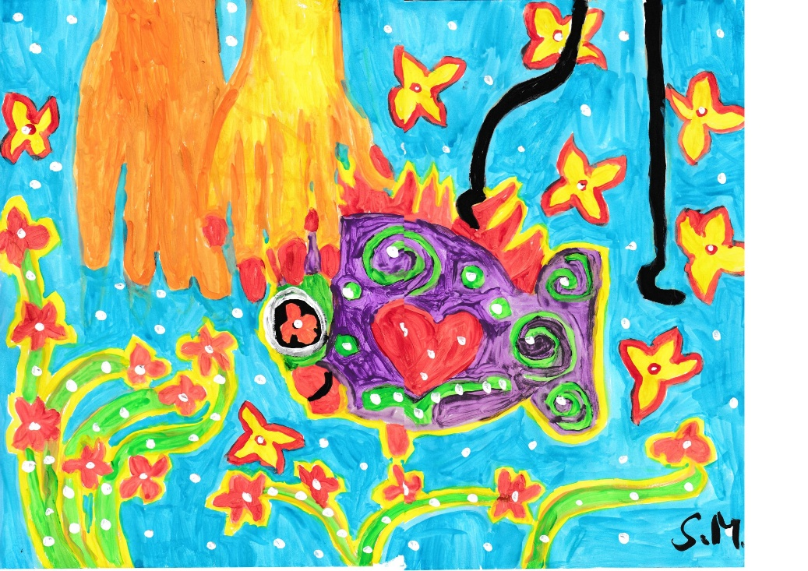
Krieg:
_____________________________________________
___________________________________________________
_____________________________________________

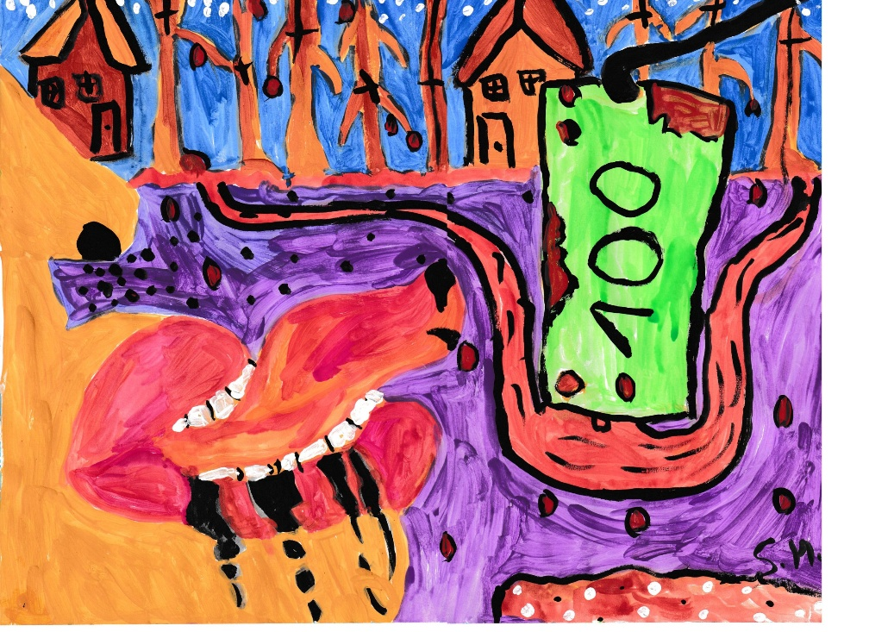
__________________________________________________
________________________________________________________
________________________________________________________
___________________________________________________________
____________________________________________________________
_______________________________________________________
____________________________________________________________
_____________________________________________________
_____________________________________________________________
___________________________________________________
________________________________________________________
____________________________________________________
____________________________________________________________
______________________________________________
_________________________________________________________
______________________________________________________
____________________________________________________________
__________________________________________
______________________________________________________
___________________________________________________
Vorfreude:
__________________________________________
______________________________________
_______________________________________________
_________________________________________
_____________________________________
_________________________________
_______________________________
____________________________________________
___________________________________________
_______________________________________
____________________________________________
_____________________________________
_________________________________________
______________________________________________
__________________________________________
_______________________________________________
__________________________________________________

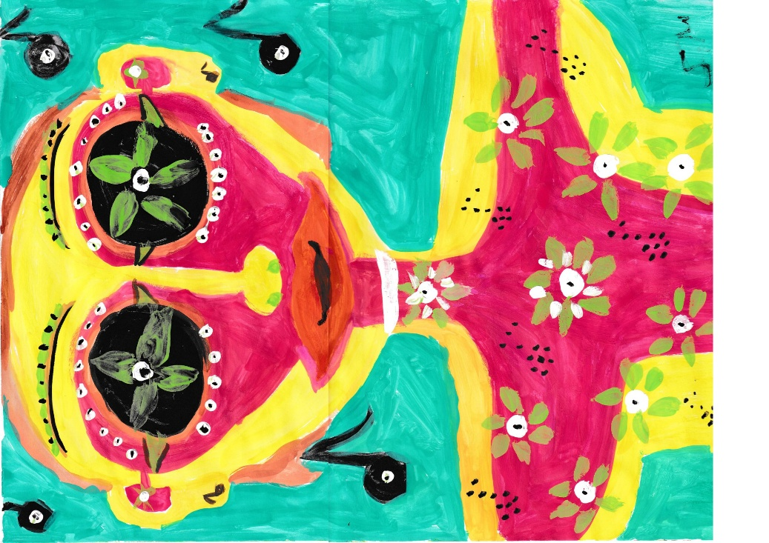

Geld:
___________________________________________
________________________________________
_____________________________________
____________________________________________________
_________________________________________________________
_____________________________________________
____________________________________________
_________________________________________
________________________________________
_____________________________________________
______________________________________________
_______________________________________________
__________________________________________
____________________________________________
_______________________________________
_____________________________________________
__________________________________________
______________________________________________
____________________________________________
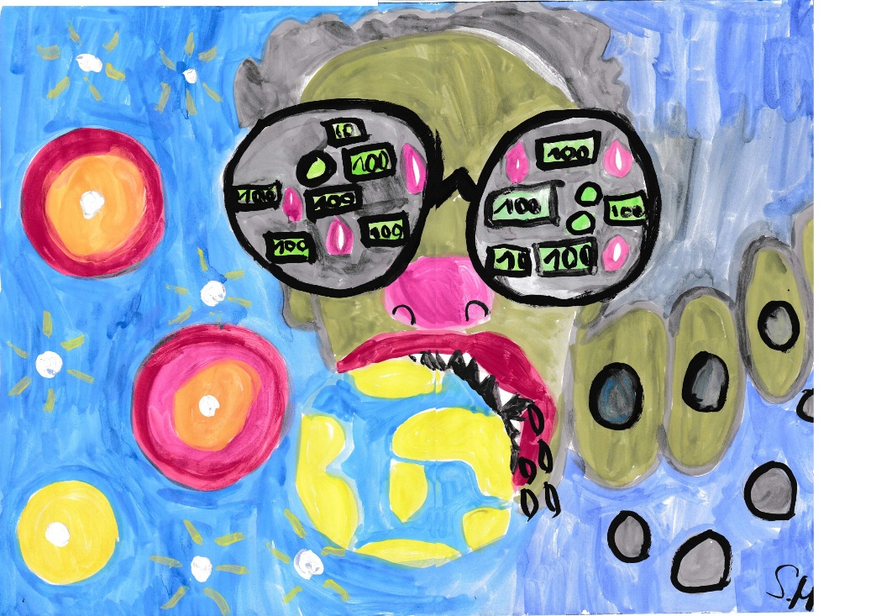

____________________________________________
____________________________________________________
_____________________________________
__________________________________
Macht:
______________________________________________
____________________________________________
________________________________________________
__________________________________________
__________________________________________
________________________________________
_____________________________________________
____________________________________________
______________________________________________
___________________________________________
____________________________________________
____________________________________________
__________________________________________
________________________________________
________________________________________
______________________________________________
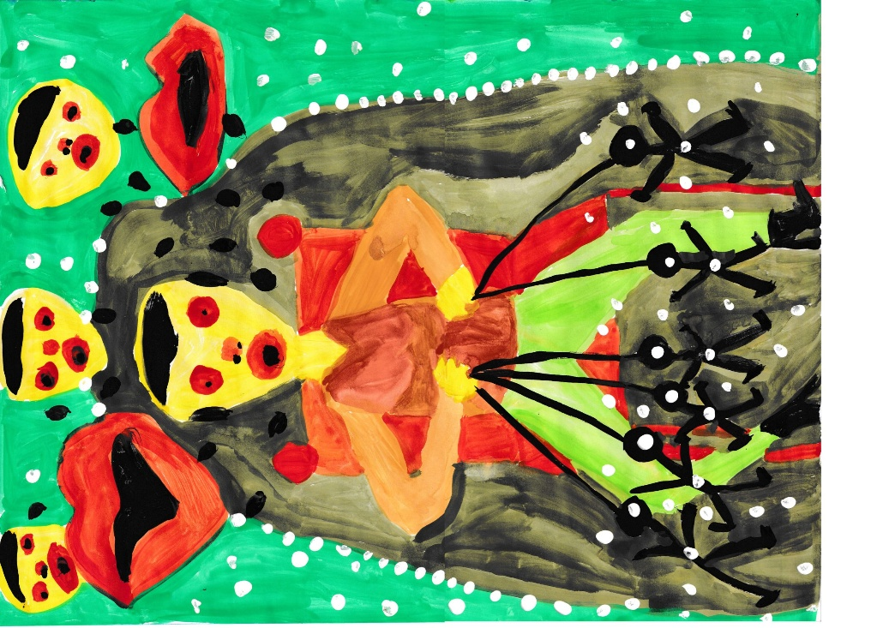
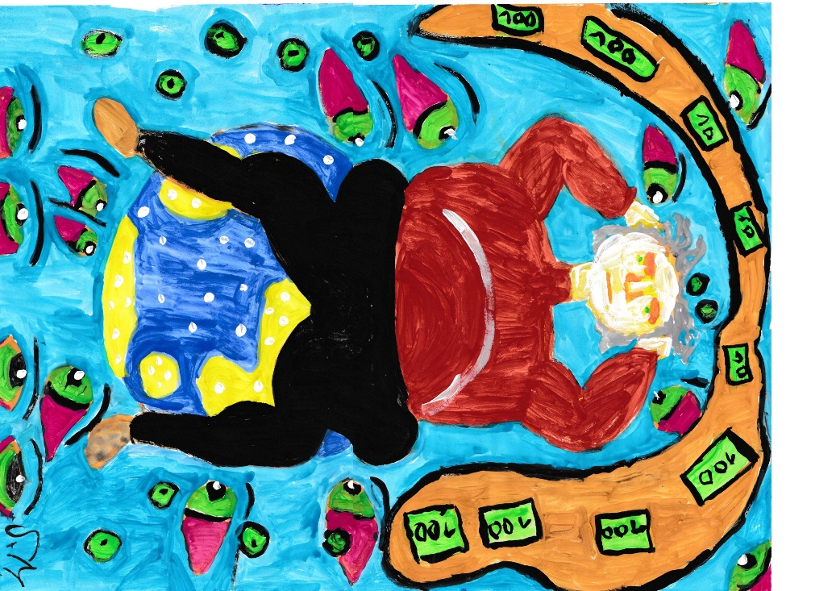

Machthaber:

________________________________________________________
_____________________________________________________
____________________________________________
___________________________________________________
______________________________________________________
___________________________________________________
________________________________________________
____________________________________________
____________________________________________________
____________________________________________________________
___________________________________________
__________________________________________________
___________________________________________________________
__________________________________________________
__________________________________________

Mein einziger Wunsch für die Welt:

_____________________________________________
_______________________________________________
_________________________________________
_______________________________________
________________________________________________
___________________________________________
___________________________________________
__________________________________________________
_______________________________________________
_________________________________________________
__________________________________________
___________________________________________________
_________________________________________________
__________________________________________________
_____________________________________
_________________________________________________
_______________________________________________
_____________________________________________________

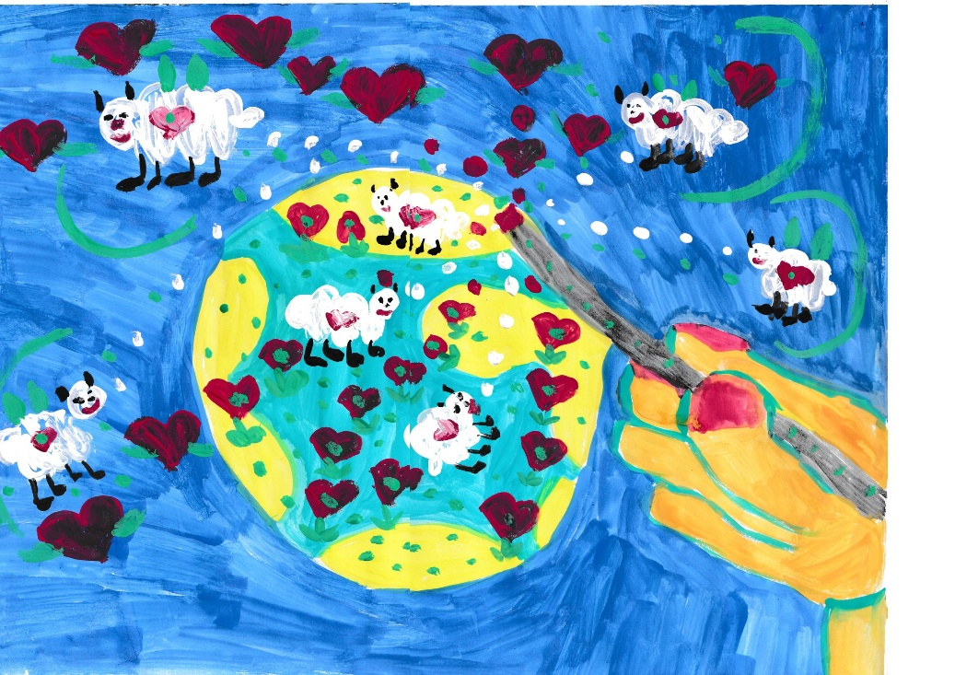

____________________________________________________
__________________________________________________
________________________________________________________
Nicht jammern, machen, und zwar:

_________________________________________________
_____________________________________
____________________________________________
_______________________________________________
____________________________________________
___________________________________________________
_________________________________________________
_____________________________________________
________________________________________________
___________________________________________________
_________________________________________________
___________________________________________________
______________________________________________
___________________________________________________
_______________________________________________



