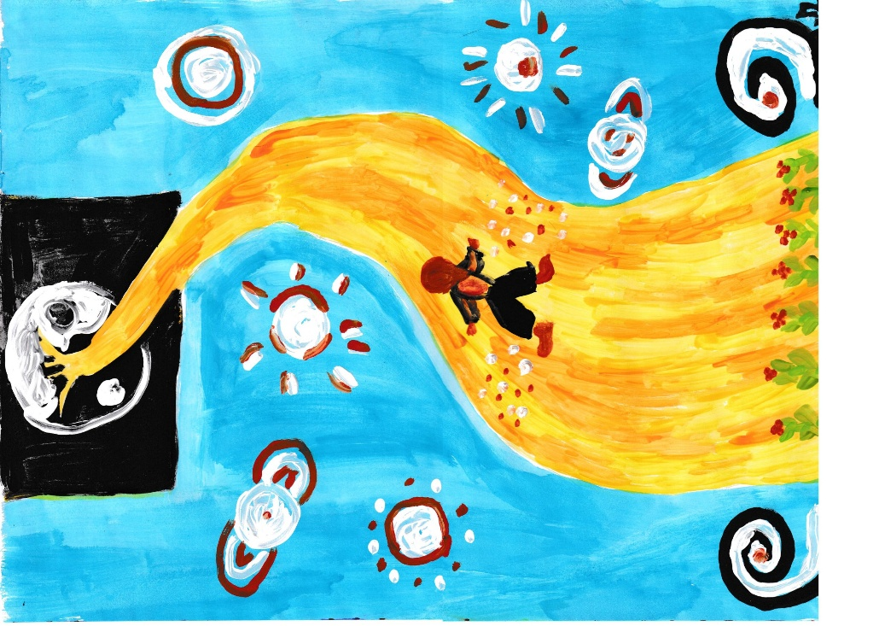

Auf dem Weg
Euer Buch für eure Entscheidungen im und für das Leben

Ich habe bisher erreicht: _________________________________________
___________________________________________________
__________________________________________________
____________________________________________________
________________________________________________
______________________________________________________
__________________________________________________
______________________________________________
______________________________________________________
___________________________________________________

Ich lasse hinter mir: ______________________________________________
__________________________________________
_____________________________________________
________________________________________________
_____________________________________________
____________________________________________
________________________________________
______________________________________
___________________________________________
_______________________________________
_______________________________________
_____________________________________
__________________________________
_____________________________
___________________________________________
___________________________________________
________________________________________
_________________________________
___________________________________________________
____________________________________________

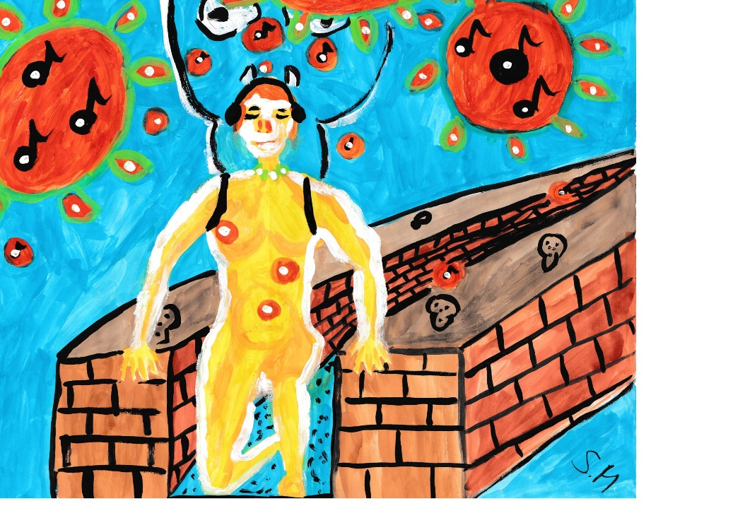

_____________________________________________________
Meine Optionen: _______________________________________________
____________________________________________________________

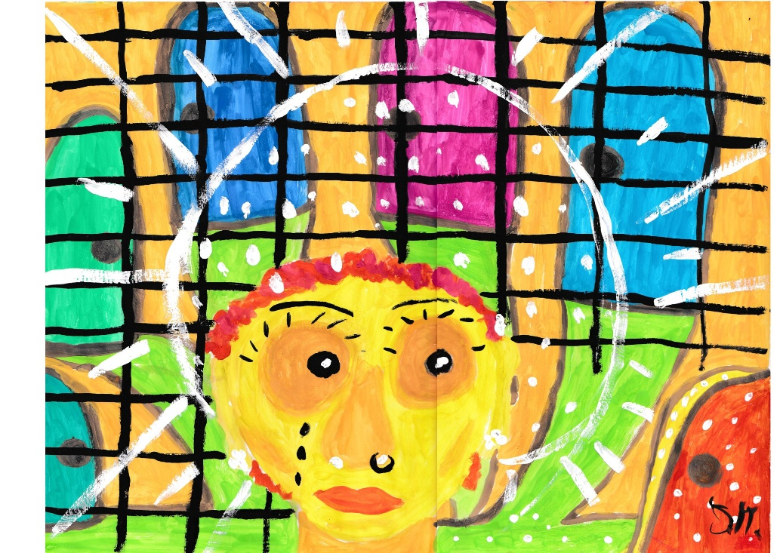

__________________________________________________________
______________________________________________________

________________________________________________________
__________________________________________________________
________________________________________________________
__________________________________________________
______________________________________________________
_________________________________________________
___________________________________________________
_______________________________________________
________________________________________________________
_______________________________________________________
____________________________________________________
_____________________________________________________
___________________________________________________
_________________________________________________
________________________________________________
Das liegt nicht in meiner Hand; _______________________________________________
______________________________________________
______________________________________
___________________________________________________________
______________________________________________
________________________________________________________
_____________________________________________________
__________________________________________________
_______________________________________________
____________________________________________________
_________________________________________________
_______________________________________________
___________________________________________
________________________________________________
___________________________________________
____________________________________________
_________________________________________
_____________________________________________-
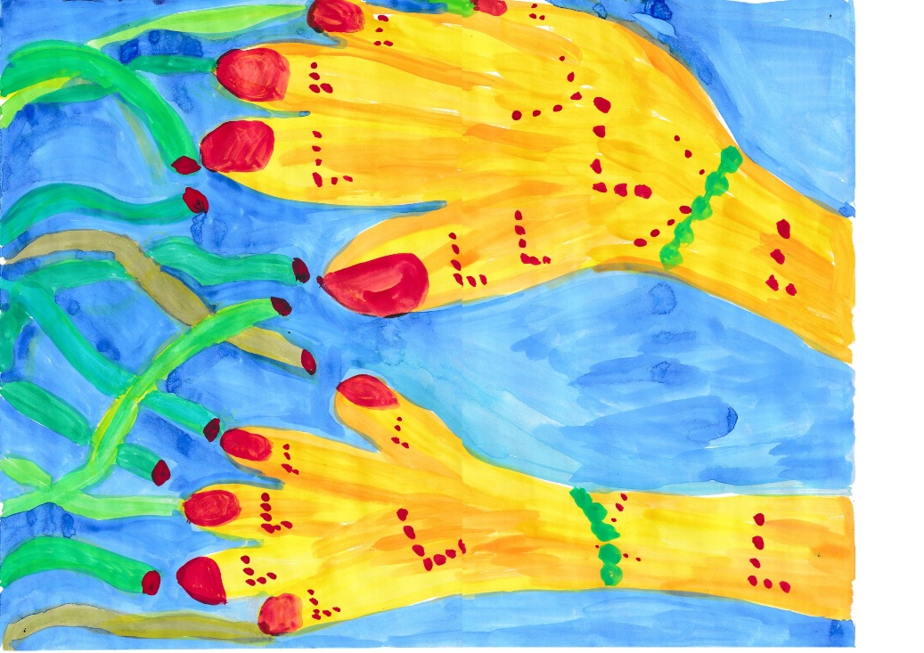
_____________________________________________
______________________________________________________
________________________________________
______________________________________________________
____________________________________________
Ich bewundere:

______________________________________________
______________________________________________
_____________________________________________
___________________________________
____________________________________________
_________________________________________
_________________________________________
______________________________________
___________________________________________
_____________________________________________
_________________________________________________
______________________________________________
__________________________________________
___________________________________________
___________________________________
_______________________________________________________
__________________________________________________
_______________________________________________________
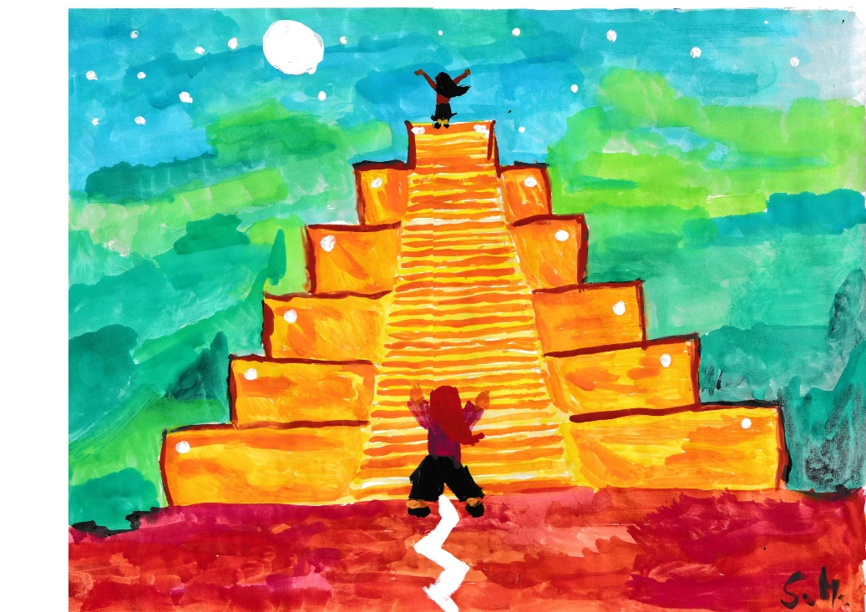

___________________________________________________
___________________________________________________
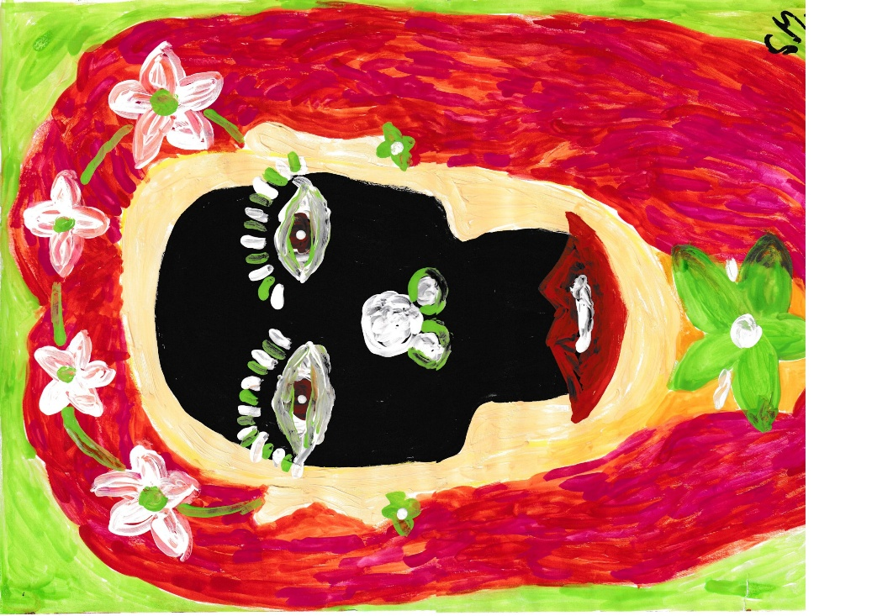

So sehe ich mich in Zukunft:
___________________________________________________________
_______________________________________________________
__________________________________________________
_____________________________________________________
______________________________________________
_______________________________________________________
___________________________________________
_____________________________________________
__________________________________________________
__________________________________________________
________________________________________________________
__________________________________________________________
___________________________________________________
____________________________________________
____________________________________________________
_____________________________________________________
__________________________________________
Wenn ich Musik höre, möchte ich am liebsten:

________________________________________________
_________________________________________________
_______________________________________________
____________________________________________
______________________________________________________
__________________________________________________
____________________________________________________
________________________________________________
_______________________________________________
__________________________________________
__________________________________________
_____________________________________________
_________________________________________________
_______________________________________________
__________________________________________
_______________________________________________
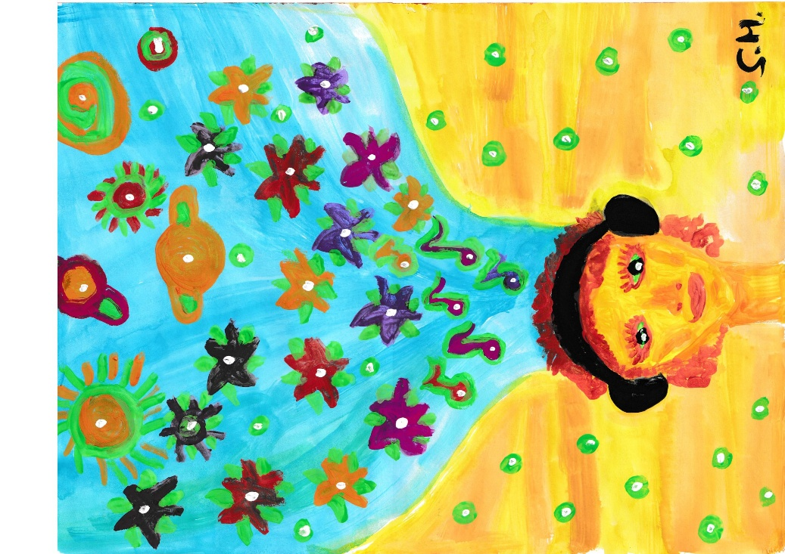
Diese Wege will ich nicht gehen:

______________________________________________
____________________________________________
___________________________________________
_________________________________________
________________________________________
____________________________________
________________________________________
________________________________________
____________________________________________________
_________________________________________
_____________________________________
_________________________________________
____________________________________
____________________________________
_____________________________________
___________________________________

_________________________________________________
______________________________________________________

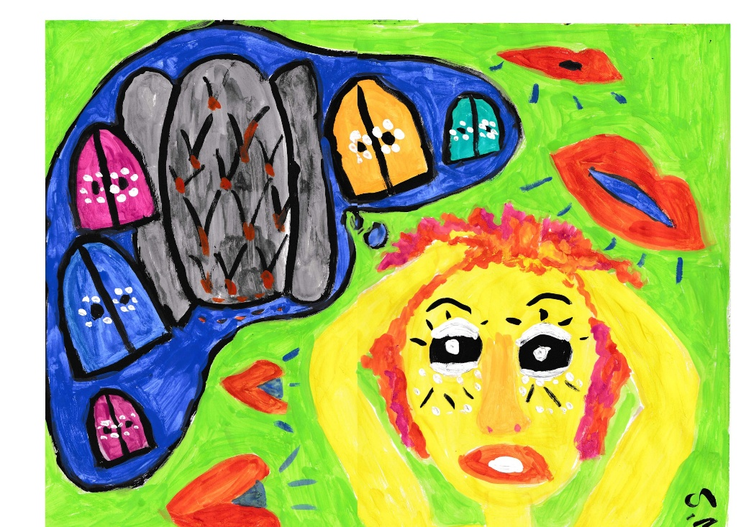
__________________________________________________
____________________________________________________________
Daran will ich langfristig arbeite, indem:
_______________________________________
_________________________________________
___________________________________________
________________________________________________
________________________________________________
________________________________________________
_____________________________________________
______________________________________________
____________________________________________
___________________________________
__________________________________________
____________________________________________
______________________________________
______________________________________
__________________________________________
_____________________________________________
___________________________________
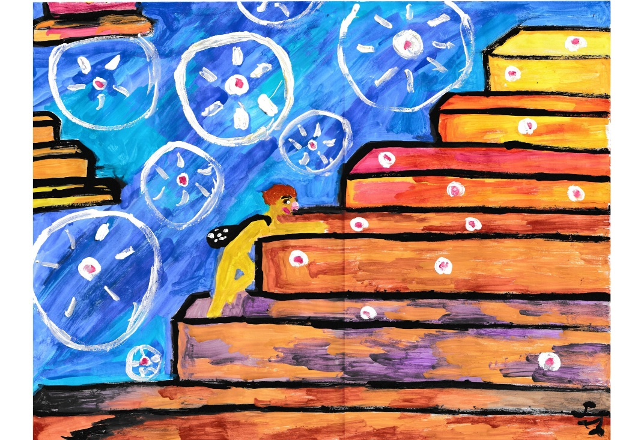
___________________
____________________________________________________
_________________________________________________
______________________________________
_________________________________________________
______________________________________________
____________________________________________________
Meine Hindernisse muss ich überwinden um:

__________________________________________________
______________________________________________
___________________________________________________
________________________________________________
_____________________________________________
___________________________________________
______________________________________________
____________________________________________________
____________________________________________________
____________________________________________
___________________________________
________________________________________
_____________________________________________
_________________________
___________________________________________

_____________________________________________________
_______________________________________________
_________________________________________
___________________________________________

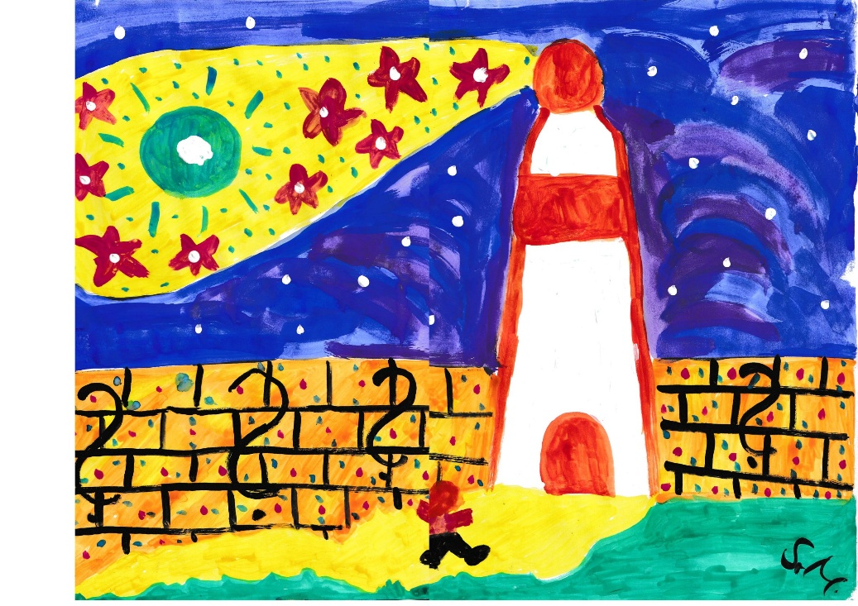

__________________________________________________

Das Schönste für mich ist:

_______________________________________________
____________________________________________
_______________________________________
__________________________________________
________________________________________
___________________________________________
_______________________________________________
________________________________________
____________________________________
____________________________________
___________________________________
____________________________________
_________________________________
_________________________________________________
_______________________________________________
_________________________________________

______________________________________________
_____________________________________________
________________________________________________________
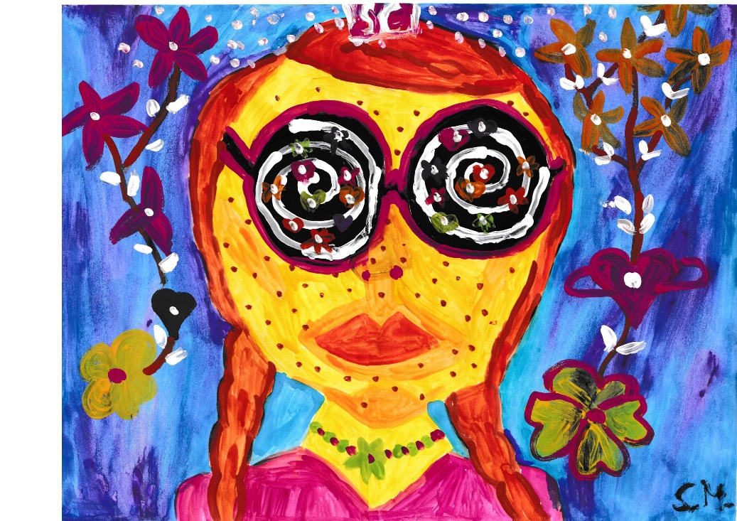
___________________________________________
______________________________________________________
_______________________________
Ich will lange Zeit:
____________________________________________
_________________________________________
_______________________________________________
__________________________________________________
______________________________________________________
_________________________________________________
___________________________________________
______________________________________________
_____________________________________________
__________________________________________
____________________________________________
_______________________________________________
__________________________________________
____________________________________________
______________________________________________
______________________________________________
__________________________________________________

_________________________________________________
__________________________________________
________________________________________________

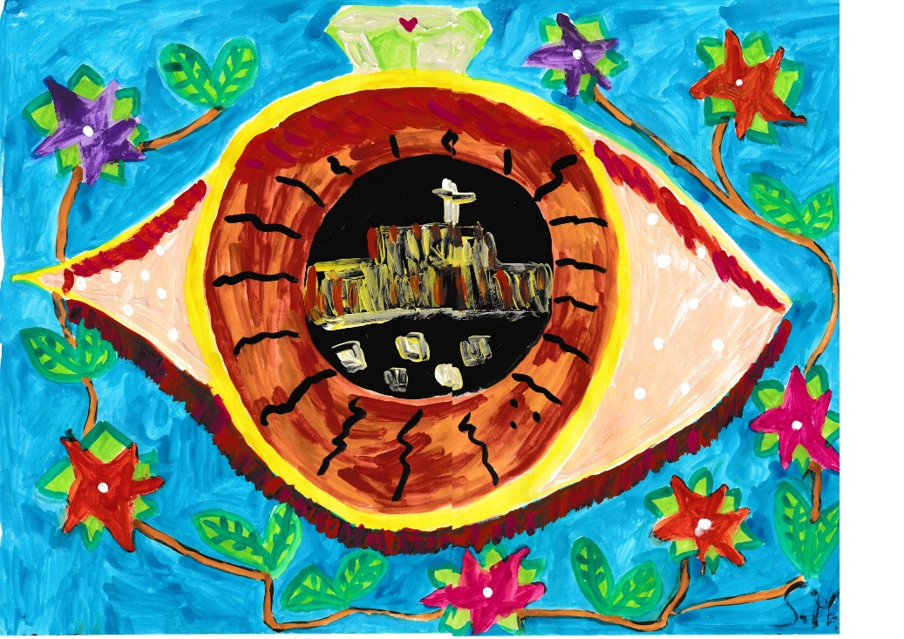

____________________________________________________

Ich gehöre zu:

_____________________________________________
______________________________________________
_________________________________________
_________________________________________
____________________________________________
____________________________________
_________________________________
__________________________________________
_______________________________________
____________________________________
_______________________________________
______________________________________
__________________________________
___________________________________________
___________________________________
____________________________________________________

_____________________________________

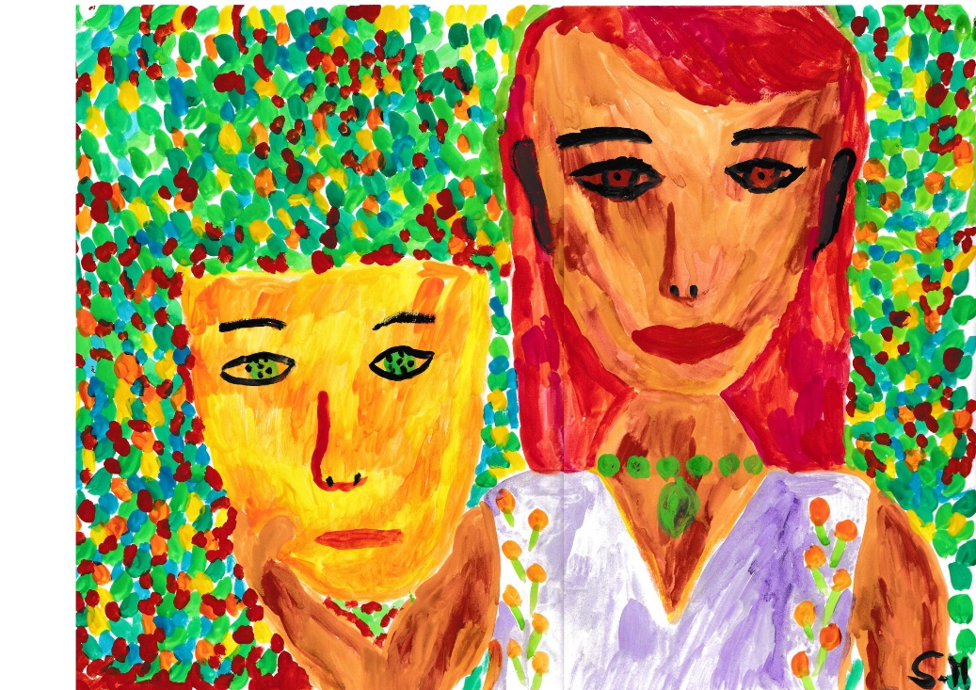

___________________________________________________
__________________________________________

Der Ort an dem ich leben will:

____________________________________________________
_____________________________________
_______________________________________________
________________________________________________
__________________________________________
______________________________________________
______________________________________________
________________________________________________
_________________________________________
_______________________________________
_____________________________________
______________________________________________
________________________________________________
_______________________________________________
_________________________________________________
_______________________________________________________

