^{Argentinien}

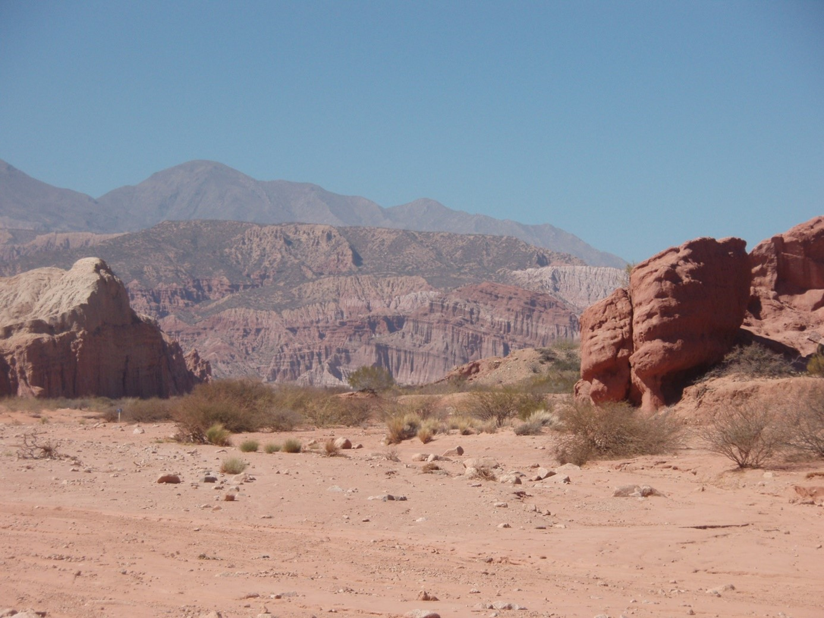
Es zieht mich nach Argentinien denn
_____________________________________
________________________________________________________________________________________________________________________________________________________________
_______________________________________________________________________________________________________________________________________________________________________________________________________________________________________________________________________________________________________________________________________________________________________________________________________________-
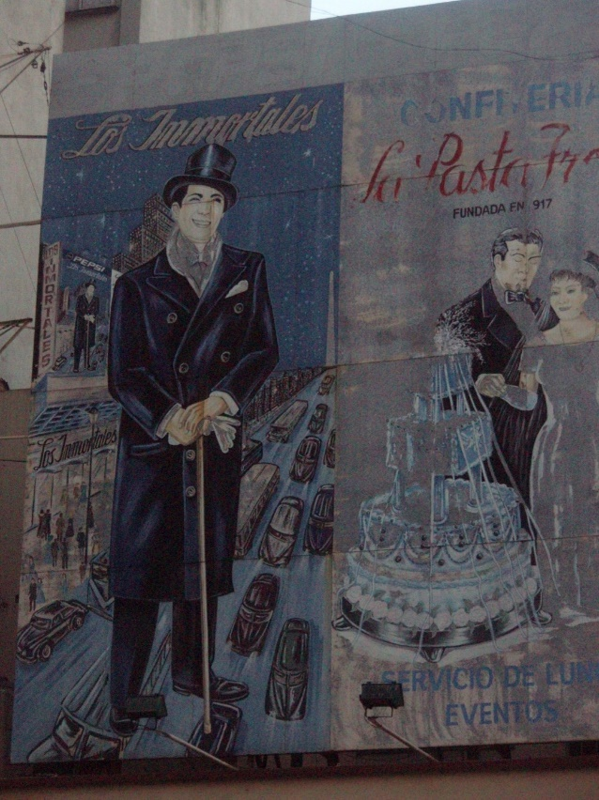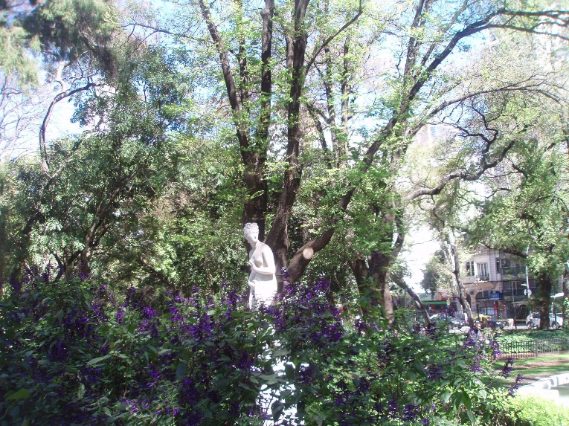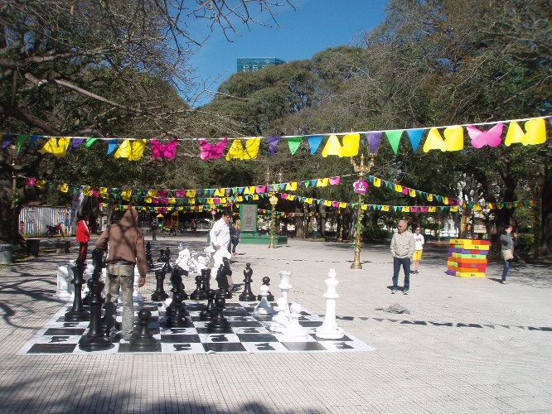
Reiseplan: In dieser Reise werde ich
______________________________________________________________________________________________________________________________________________________________________________________________________________________________________________________________________________________________________________________________________________________________________________________________________________________________________________________________________________________________________________________________________________________________________________________________________________________________________________________________________________________________________________________________________________________________________________________________________

Ich habe heute gegessen

Was, wann, wo…..? | Und wie war es?
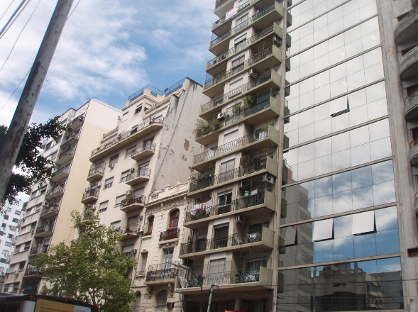

 | 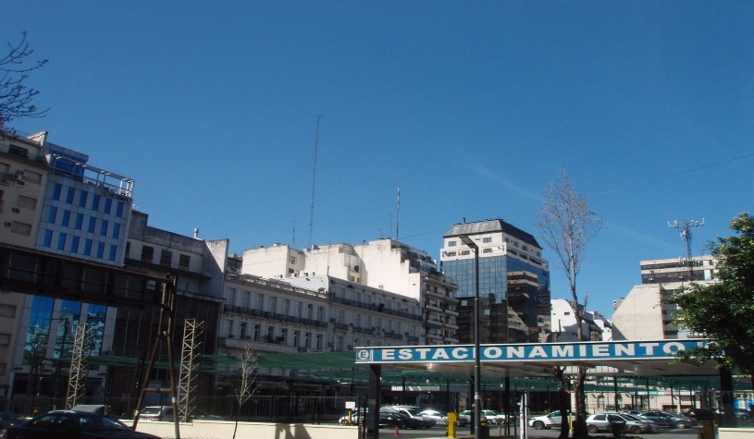

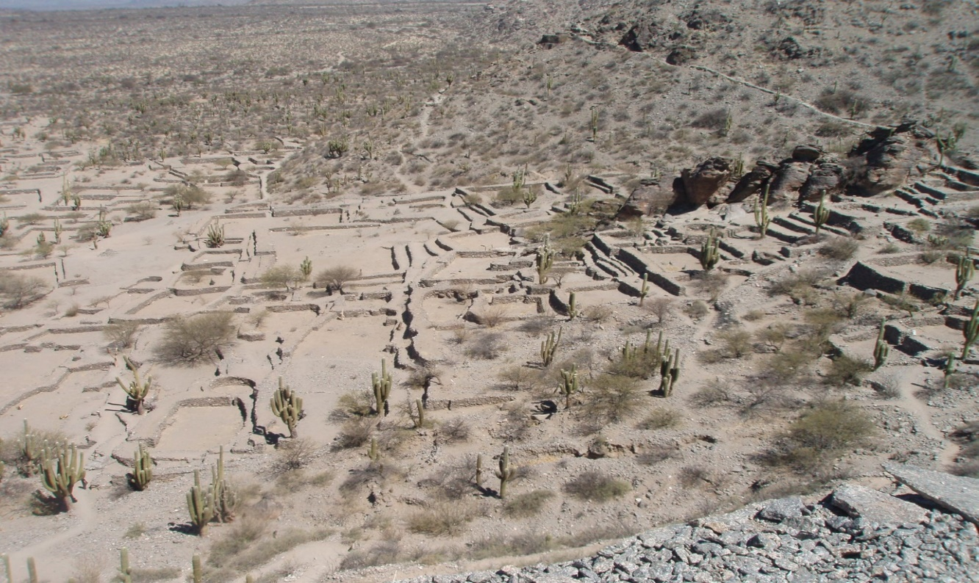

Ich war heute zusammen mit

Bei:
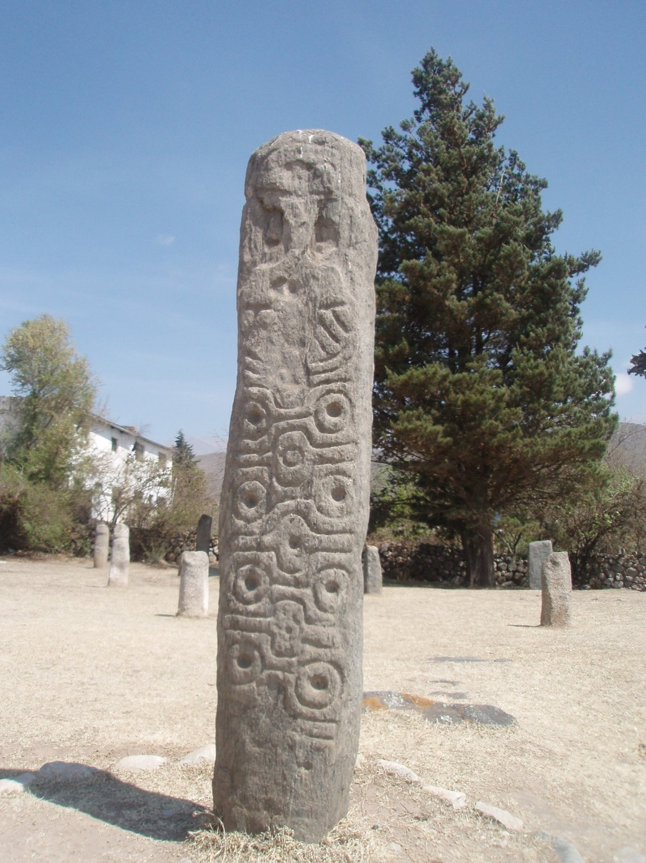

Bei:

Heute habe ich gesehen:

____________________
______________________
___________________
_______________________
___________________________
_______________________________________________________________________________________________
_________________________________________________________________________________
_________________________________________________________________________________-______
_____________________________________________________________________________________
______________________________________________________________________________________________
_______________________________________________________________________________________________
__________________________________________________________________________________________
_______________________________________________________________________________________________
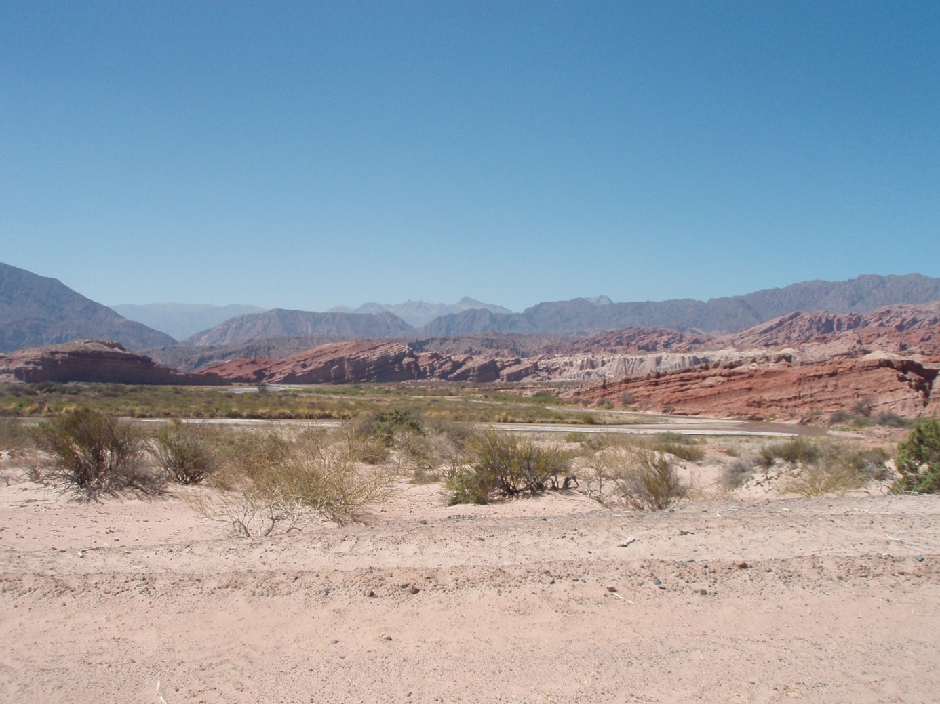

_________
______________
_______________________________
______________________________________________
__________________________________________________________
_________________________________________________________________________________
______________________________________________________________________________________________
____________________________________________________________________________________________
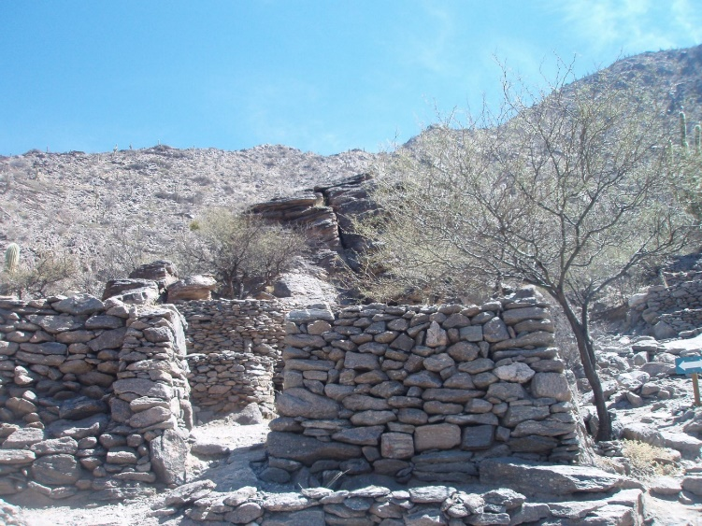
________________________
_______________________________
________________________________
____________________________________
_______________________________
___________________________________
________________________________
____________________________________
________________________________

____________________
___________________________________________________-
___________________________________________________________________________________
____________________________________________________________________________
______________________________________________________________________________________--

Die Erfahrung schlechthin

___________________________________________________________________________________________________________________________________________________________________________________________________________________________________________________________________________________________________________________________________________________________________________________________________________________________________________________________________________________________________________________________________________________________________________________________________________________________________________________________________________________________________________________________________________________________________________________________________________________________________________________________________________________________________________________________________________________________________________________________________________________________________________________________________________________________________________________________________________________________________________________________________________________________________________________________________________________________________________________________________________________________________________________________________________________________________________________________________________________________________________________________________________________________________________________________________________________________________________

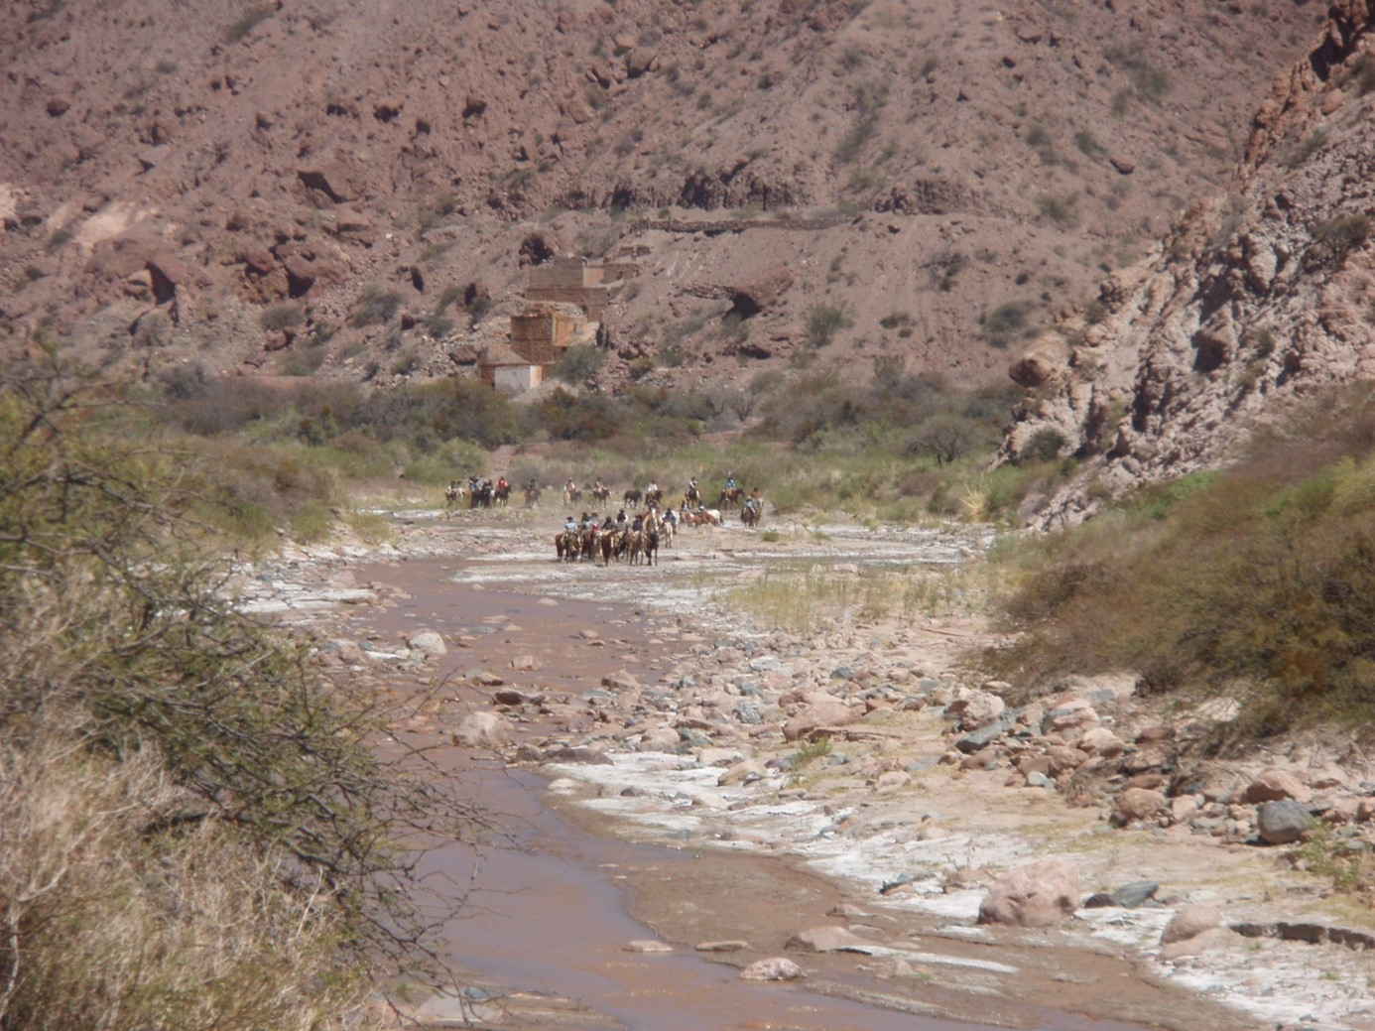
____________________________________________________________-
___________________________________________________________________________________
______________________________________________________________________________________________
______________________________________________________________________________________-
____________________________________________________________________________________-
____________________________________________________________--________________________________
__________________________________________________________________________
______________________________________________________________________________-
__________________________________________________________________________________
_____________________________________________________________________________________-
_________________________________________________________________________
_______________________________________________________________
_________________________________________________
________________________________________________

______________-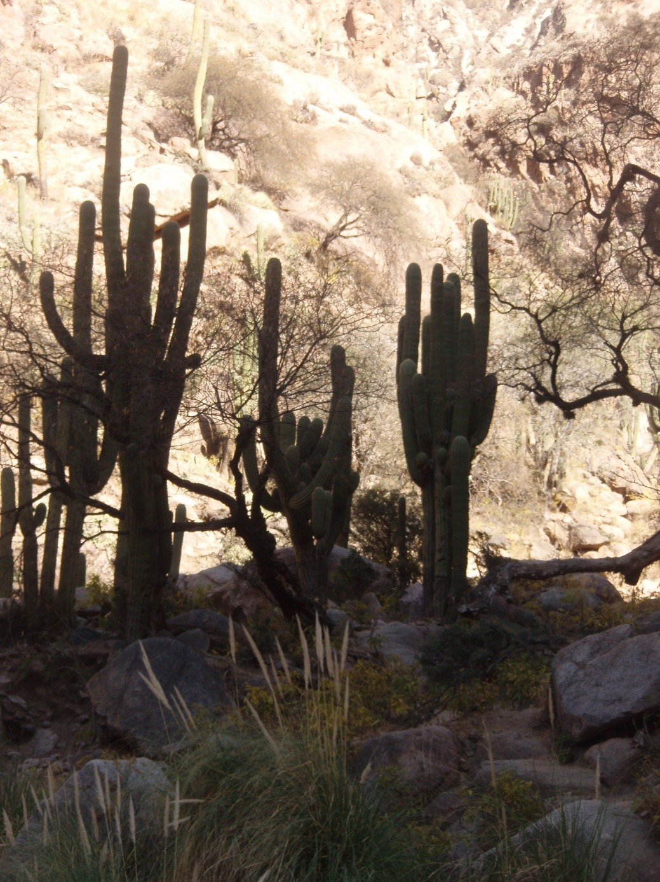
____________________________________________________________________________________________________________________________________________________________________________________________________________________________________________________________________________________________________________________________________________________________________________________________________________________________________________________________________________________________________________________________________________________________________________________________-_______________________________________________________________________________________________________________________________________________
_________________________________________________________________________________________-__________________________________________________________________________________________________________________________________________________________________________________________________________________________________________________________________________________________________________________________________________________

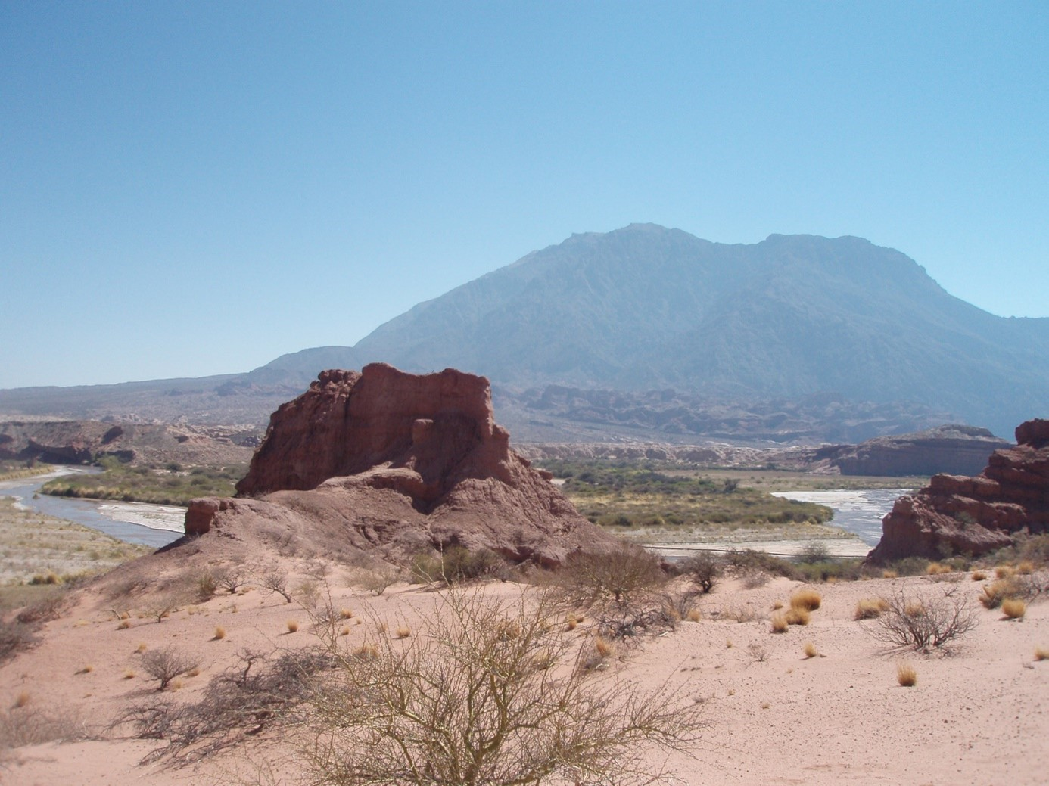

Ich habe heute zum ersten Mal probiert

___________________________________________________
_____________________________________________________
___________________________________________
__________________________
__________________________________________________
______________________________________________
______________________________________________________________

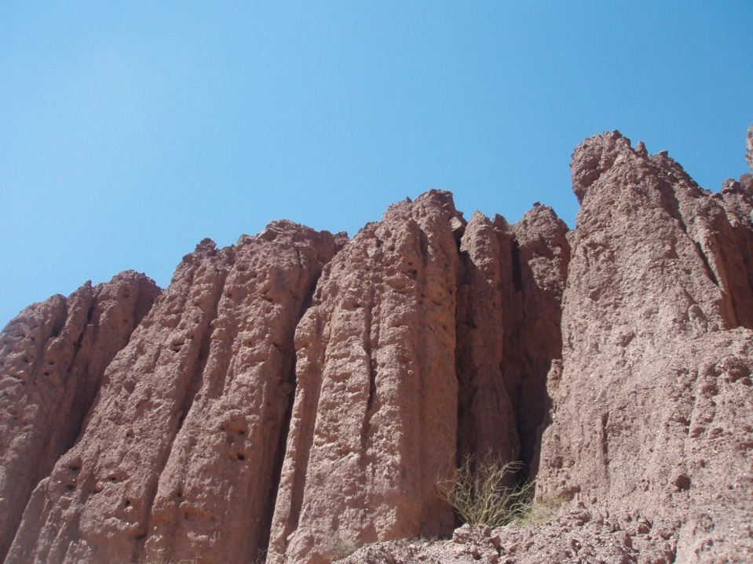
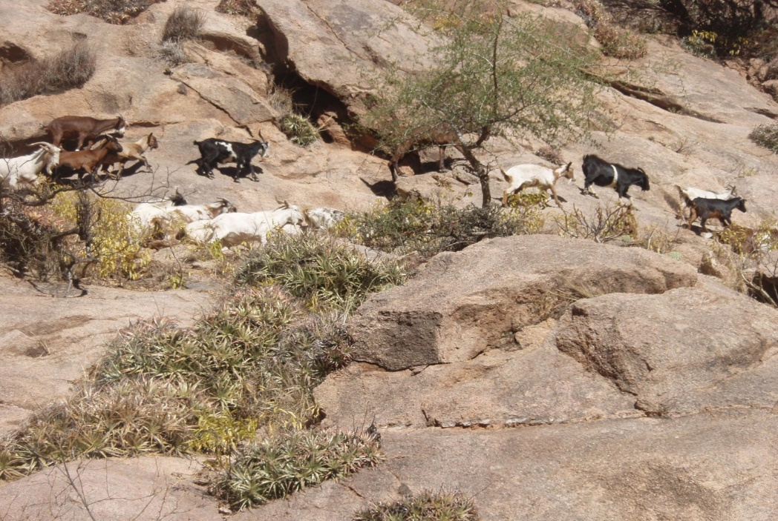

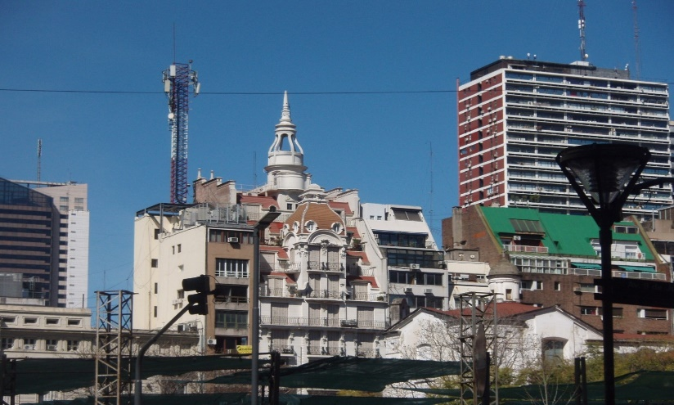

Ich habe heute verstanden
______________________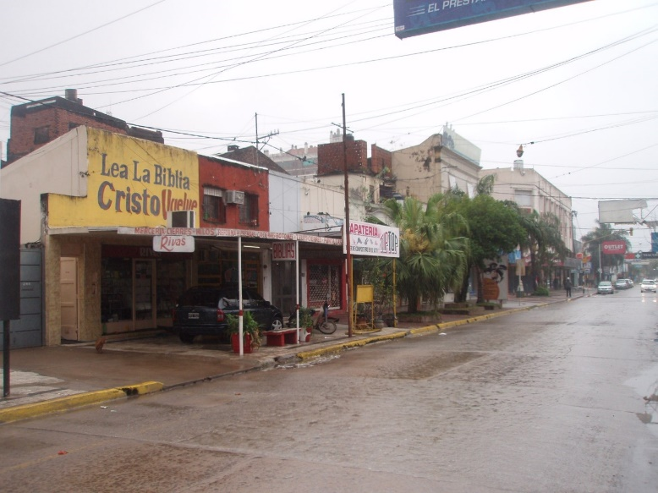
_________________________________________________________________________________________________________________________________________________________________________________________________________________________________________________________________________________________________________________________________________________________________________________________________________________________________________________________________________________________________
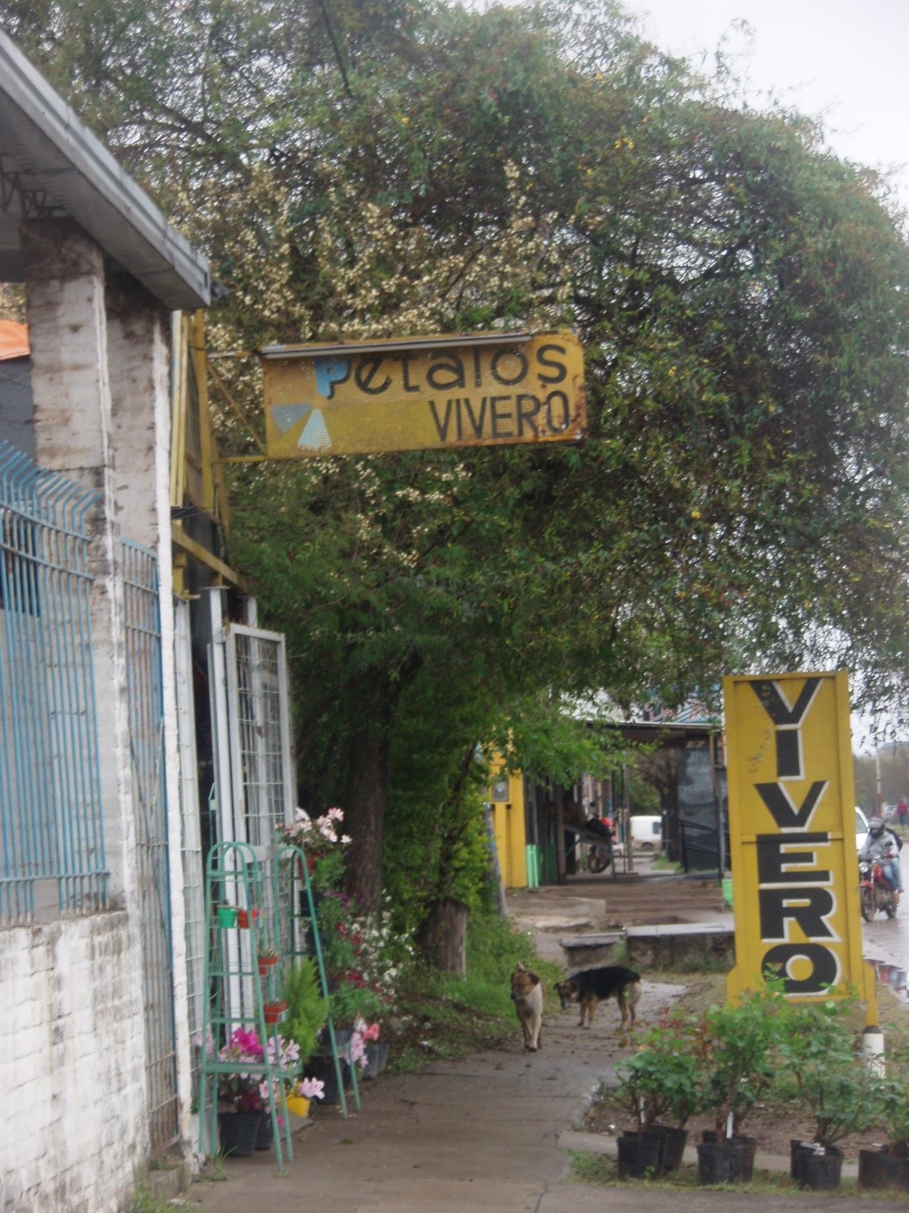
________________________________________________________________________________________________________________________________________________________________________________________________________________________________________________________________________________________________________________________________________________________________________________________________________________________________________________________________________________________________________________________________________________________________________________________________________________________________________________________________________________________________________________________________________________________________________________________________________________

Mein Highlight heute war

____________________________________________________
_____________________________________________________________________
___________________________________________________

________________________________________
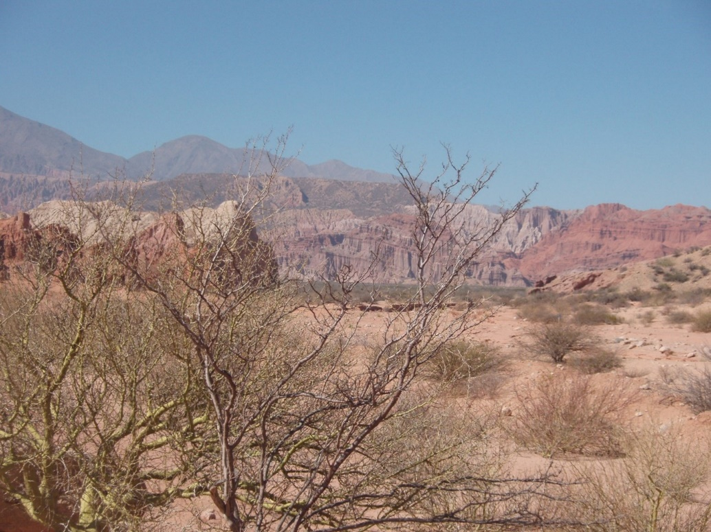
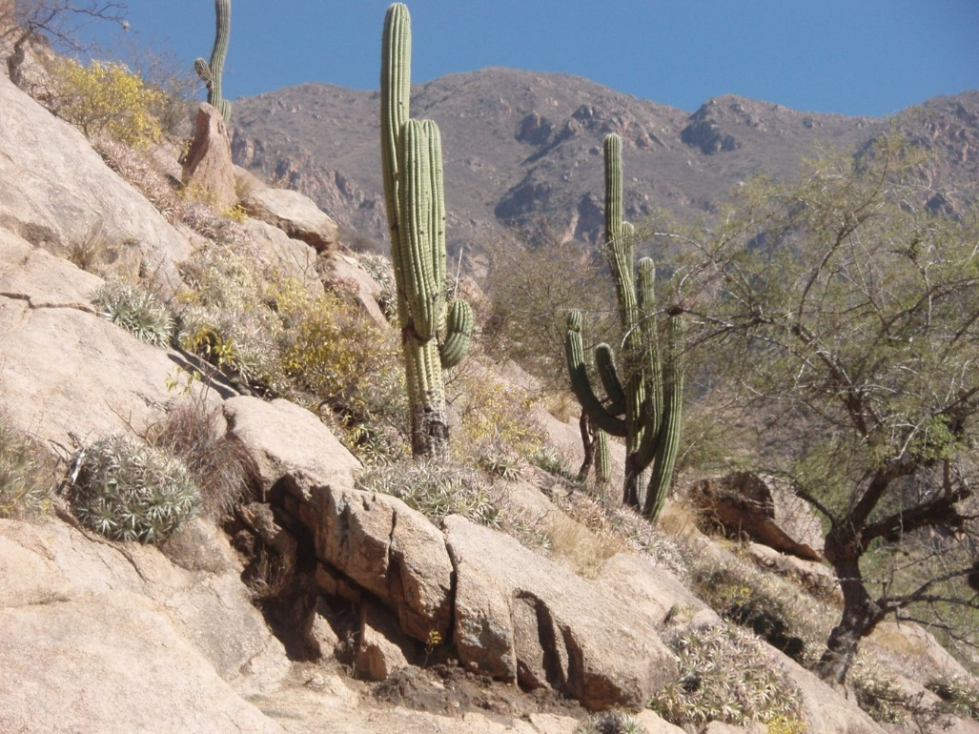
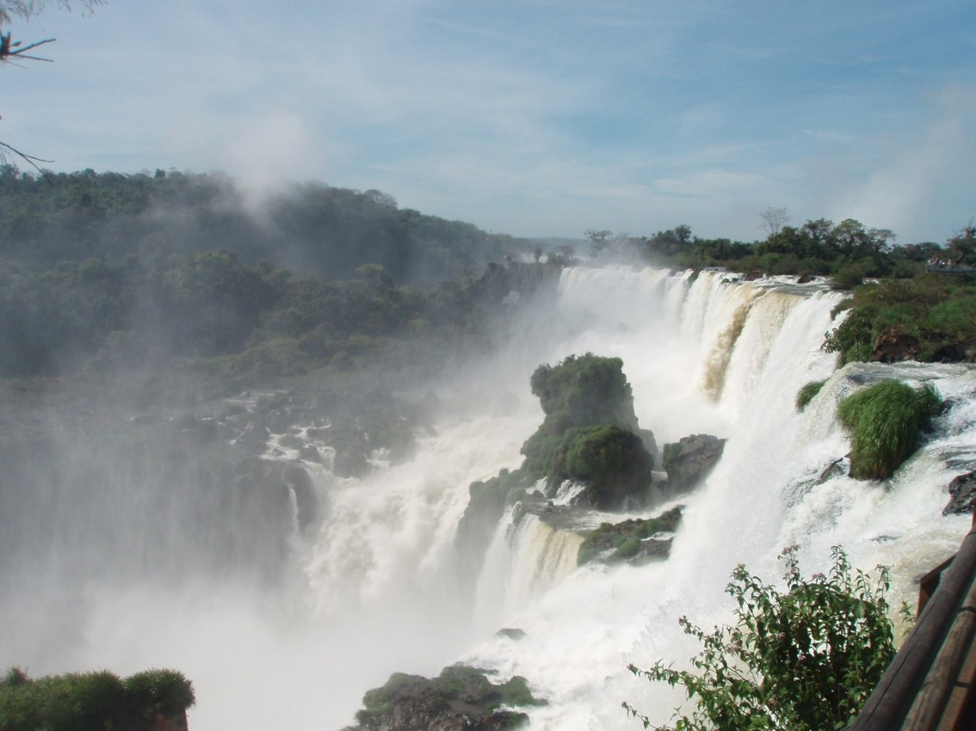

___________________________________________________
________________________________________________________________________________________
______________________________________________________________________________________
_____________________________________________________________________________________
_____________________________________________________________________________________-
_______________________________________________________________________________
_______________________________________________________________________________________
________________________________________________________________________________________________
______________________________________________
______________________________________________________

Ich war heute mutig, weil:
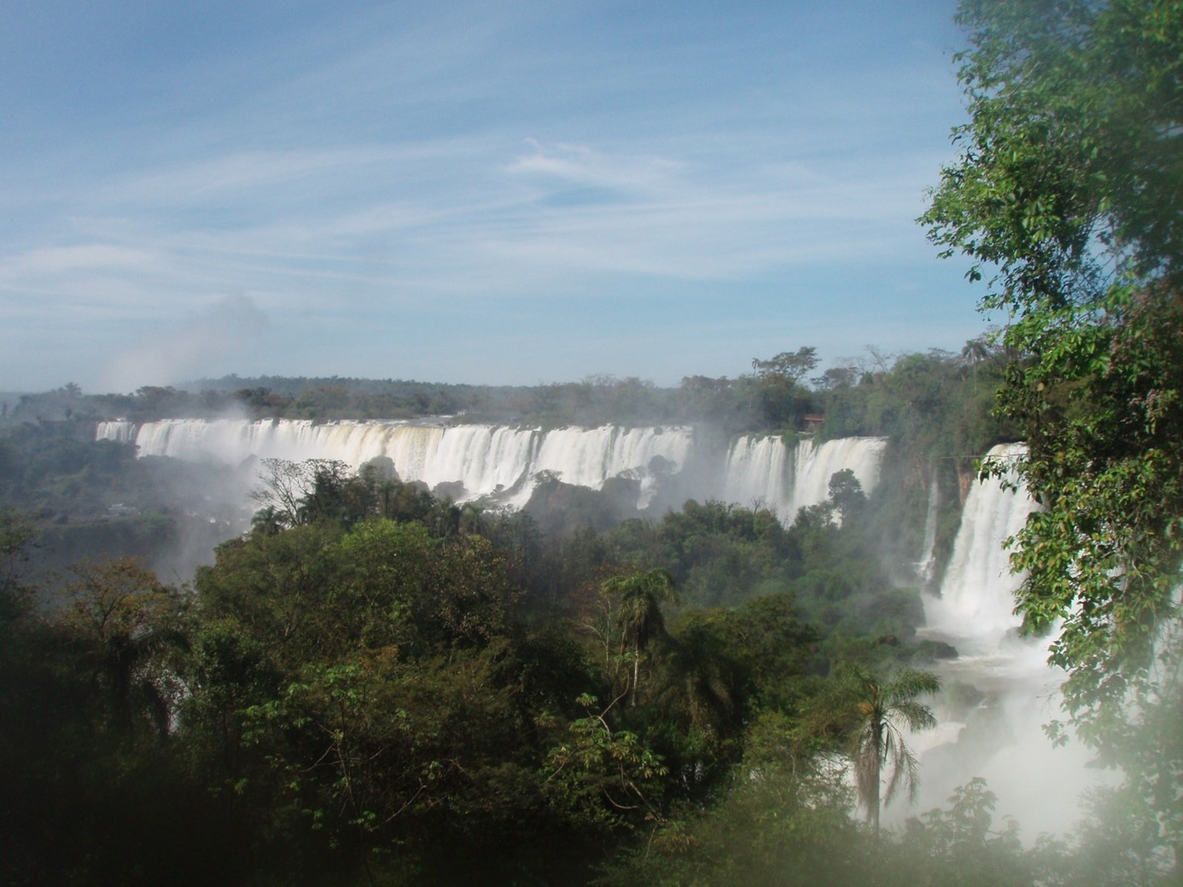

_________________________________________________________________________________________-
_______________________________________________________________________________________
_____________________________________________________________________________________________
_______________________________________________________________________________________________
_______________________________________________________________________________________________
_______________________________________________________________________________________________
________________________________________________________________________________________
_______________________________________________________________________________________________
____________________________________________________________________________________________
________________________________________________________________________________________
_______________________________________________________________________________________________
________________________________________________________________________________________
_______________________________________________________________________________________________
_______________________________________________________________________________________
_______________________________________________________________________________________________
_____________________________________________________________________________________-
________________________________________________________________________________________
___________________________________________________________________________________
___________________________________________________________________________________
___________________________________________________________________________________-
____________________________________________________________________________________
________________________________________________________________________________________
____________________________________________________________________________-

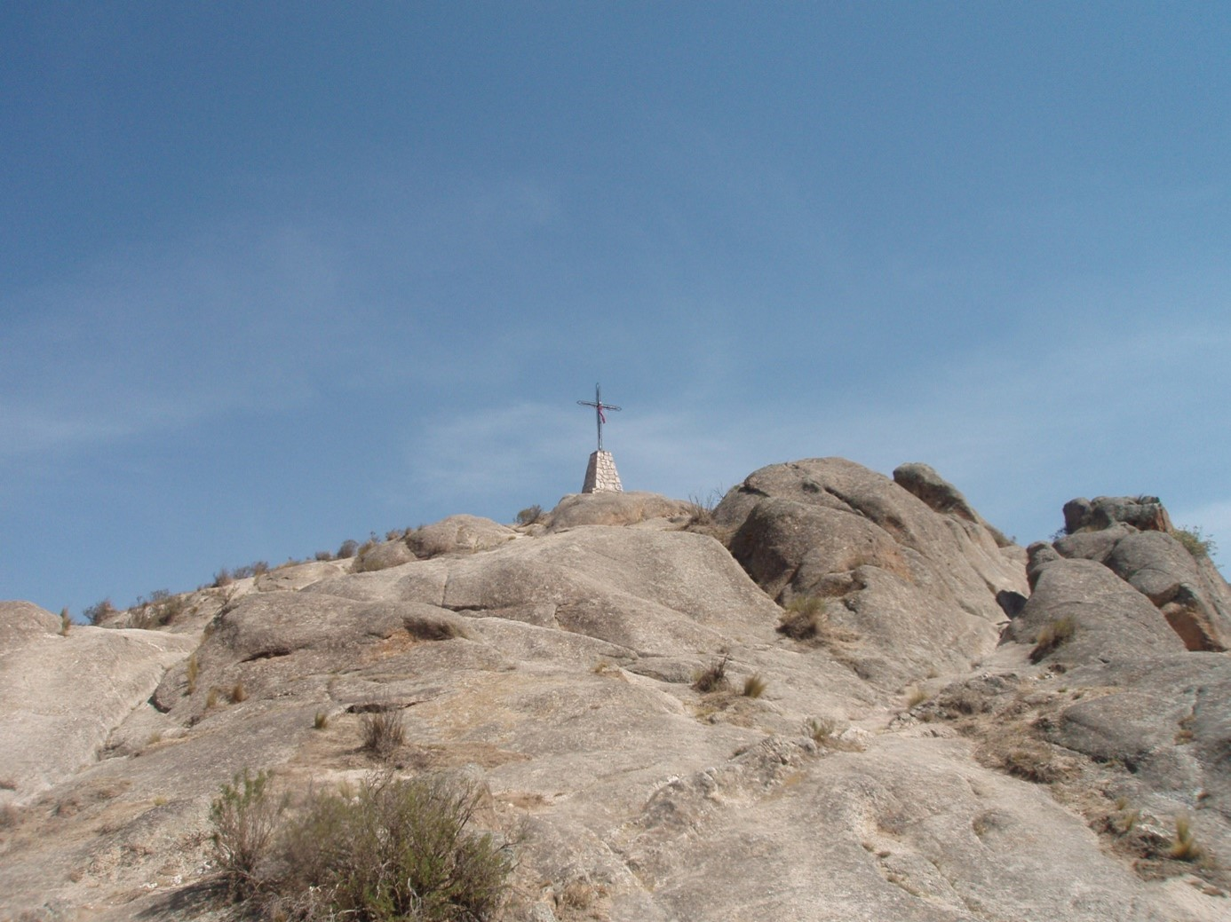
Zeichnungen und Fotos

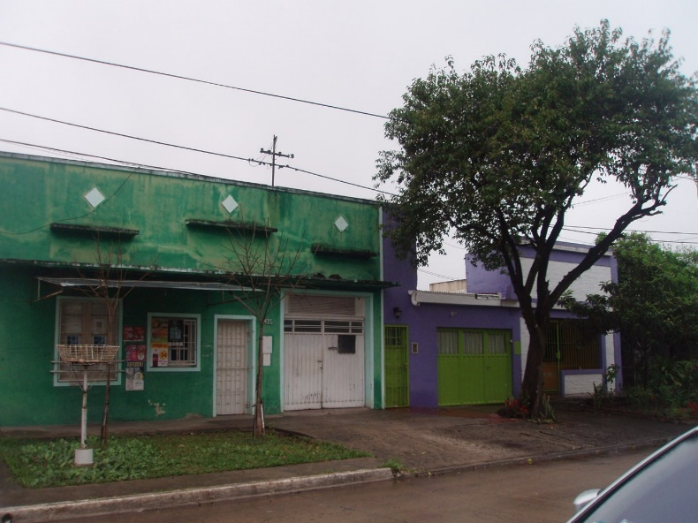
Meine Reise war gut, weil
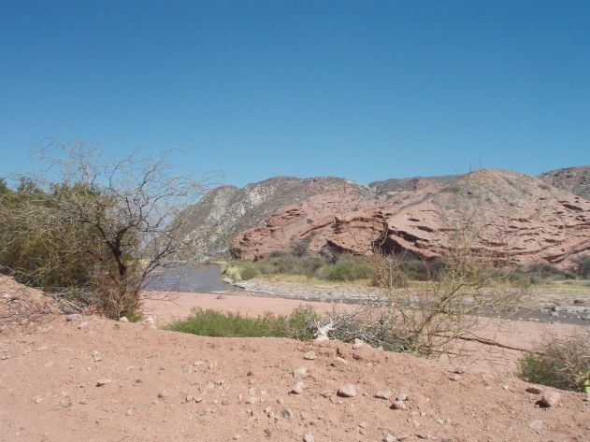

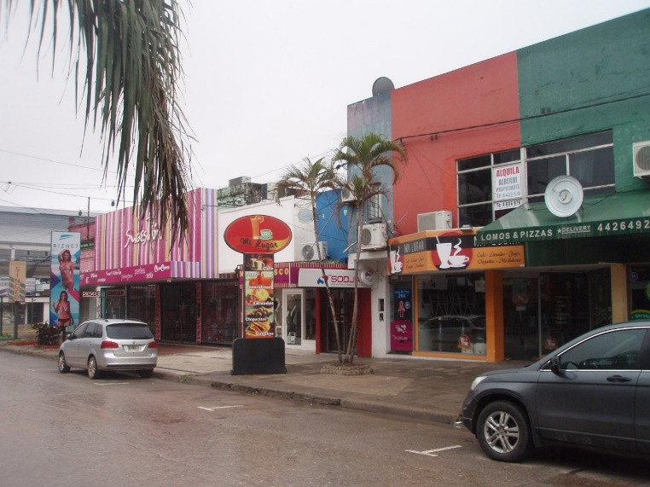

_______________________
_________________________________________
________________________________________________________
______________________________________________________________________
_________________________________________________________________________________
______________________________________________________________________________________
_______________________________________________________________________________________________
___________________________________________________________________________________________-
_________________________________________________________________________________________
____________________________________________________________________________________________
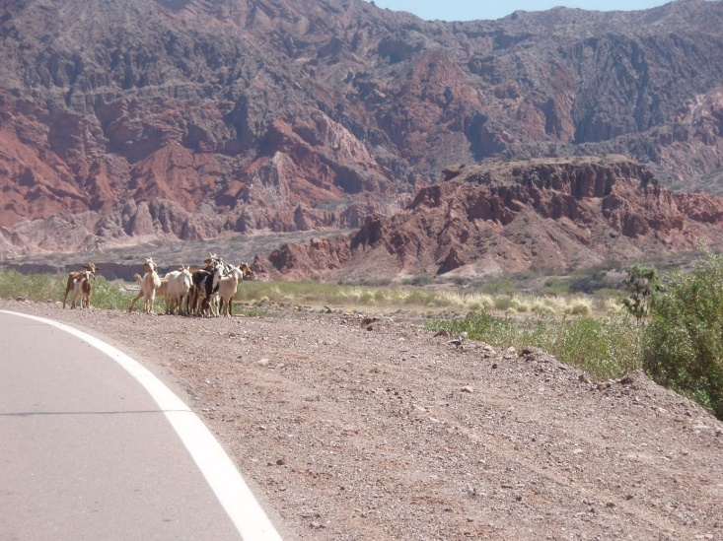
__
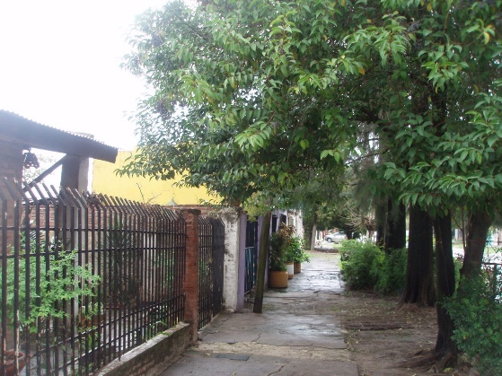

In Deutschland zurück werde ich

_______________________________________________________________________________
____________________________________________________________________
______________________________________________________________
__________________________________________________________________________
______________________________________________________________________
____________________________________________________________________
_____________________________________________________________
___________________________________________________________
_________________________________________________________________________
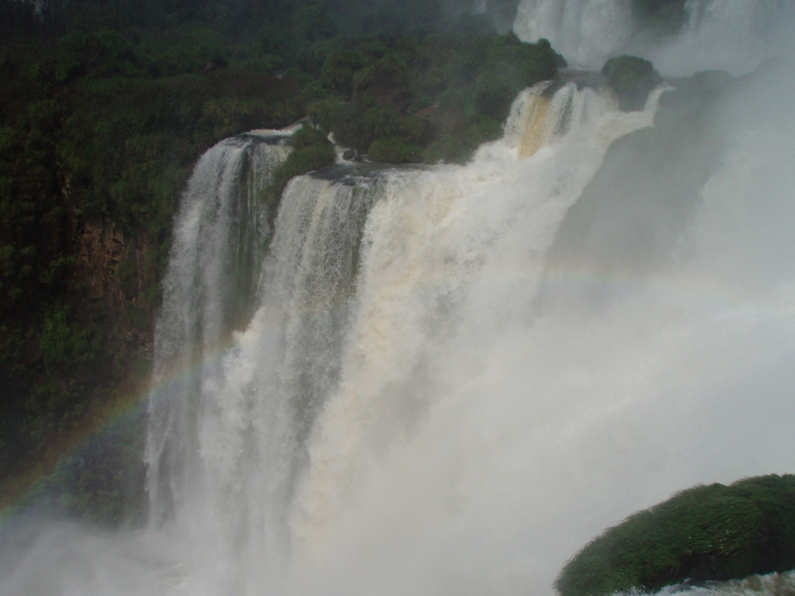
Meine nächste Reise geht nach

