**Bolivien**

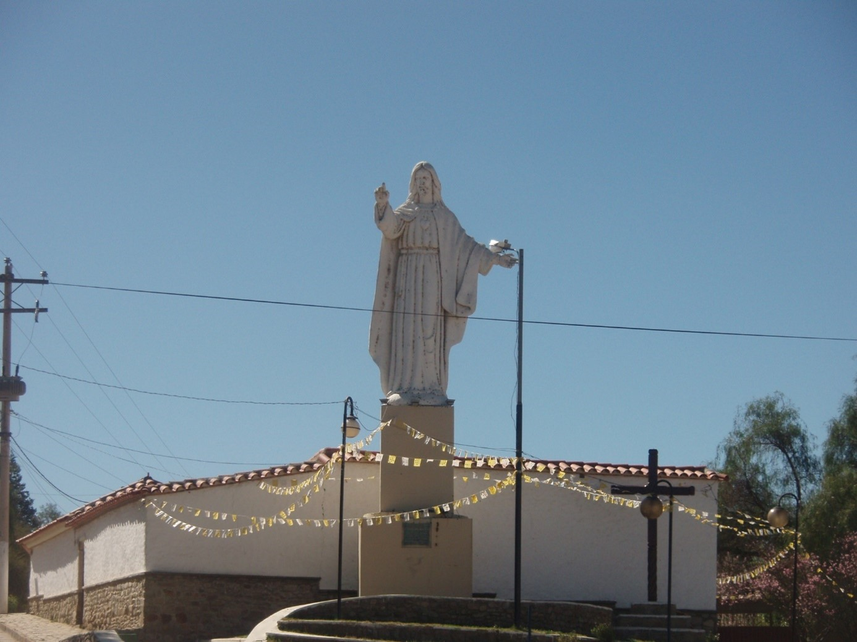

**Ich reise nach** **Bolivien, denn ich hoffe dort**

______________________________________________________________________________________

_______________________________________________________________________________

________________________________________________________________________________________

___________________________________________________________________________________

_____________________________________________________________________________________

________________________________________________________________________________

_________________________________________________________________________________

__________________________________________________________________________________________

_________________________________________________________________________________________

**In dieser Reise will ich … sehen, machen**

_________________________________________________________________________

_______________________________________________________________________________

____________________________________________________________________________

_______________________________________________________________________________

_____________________________________________________________________________

____________________________________________________________________________

______________________________________________________________________________

______________________________________________________________________________

________________________________________________________________________________

_____________________________________________________________________________

_____________________________________________________________________________

_________________________________________________________________________

____________________________________________________________________________

_____________________________________________________________________________

____________________________________________________________________________

________________________________________________________________________

______________________________________________________________________

___________________________________________________________________________

__________________________________________________________________________

_____________________________________________________________________________

_________________________-

___________________

______________________

___________________

________________

____________________

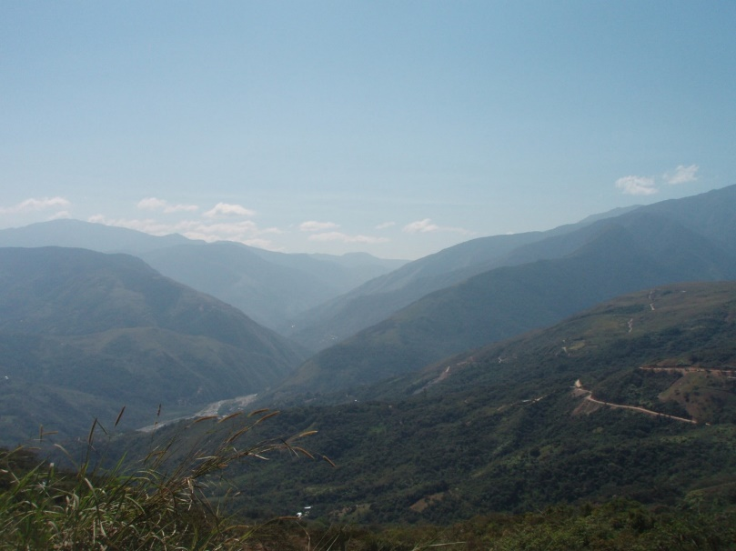

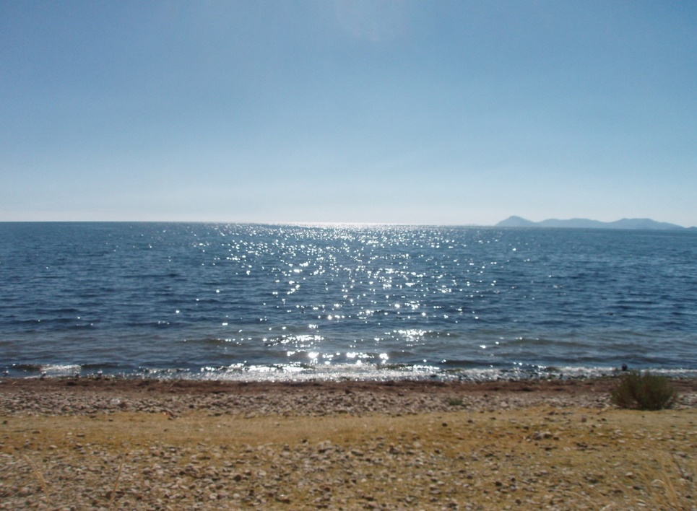

**Ich habe heute gegessen**

___________________________________

______________________

_____________-

________

_________

_______________________________

_______________________________________________________

**Ich habe heute kennengelernt**

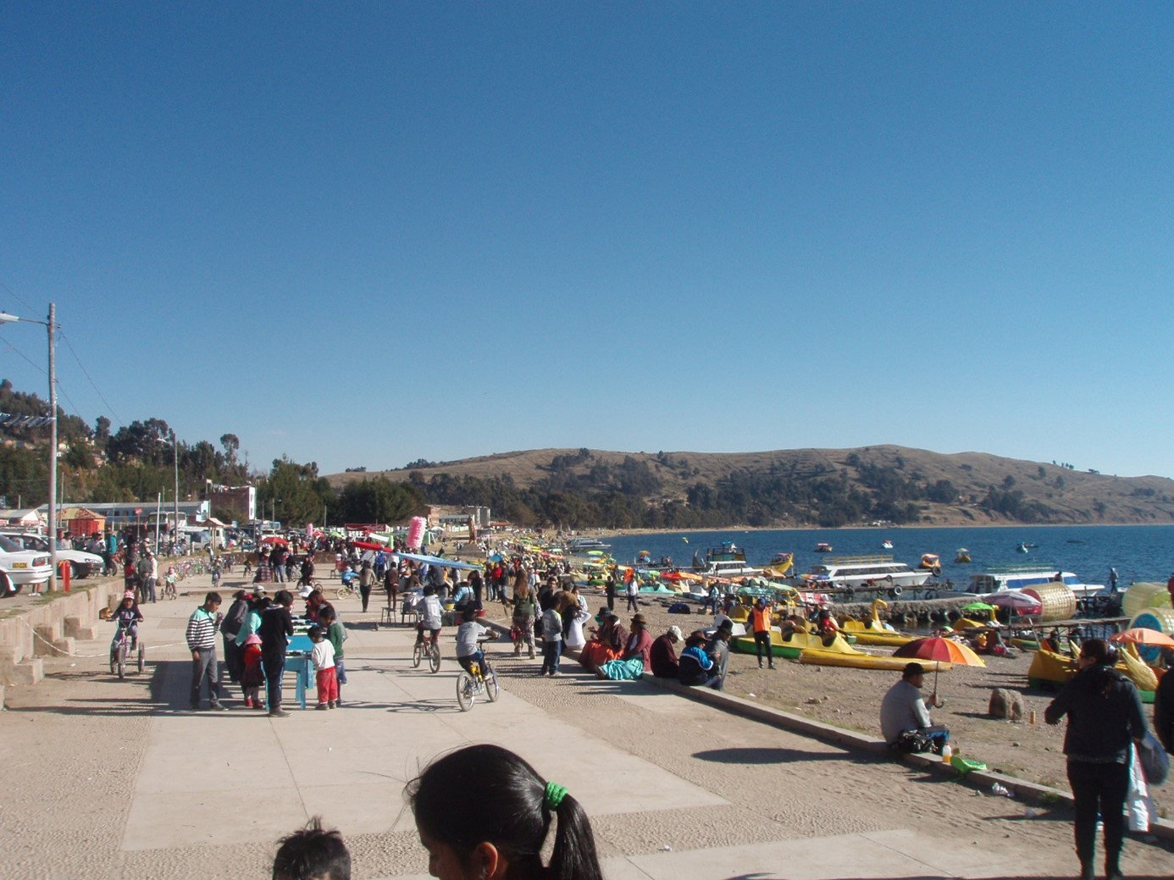

_______________________________________________________________________________________

___________________________________________________________________________________

____________________________________________________________________________________

__________________________________________________________________________________

_________________________________________________________________________________

_____________________________________________________________________________________

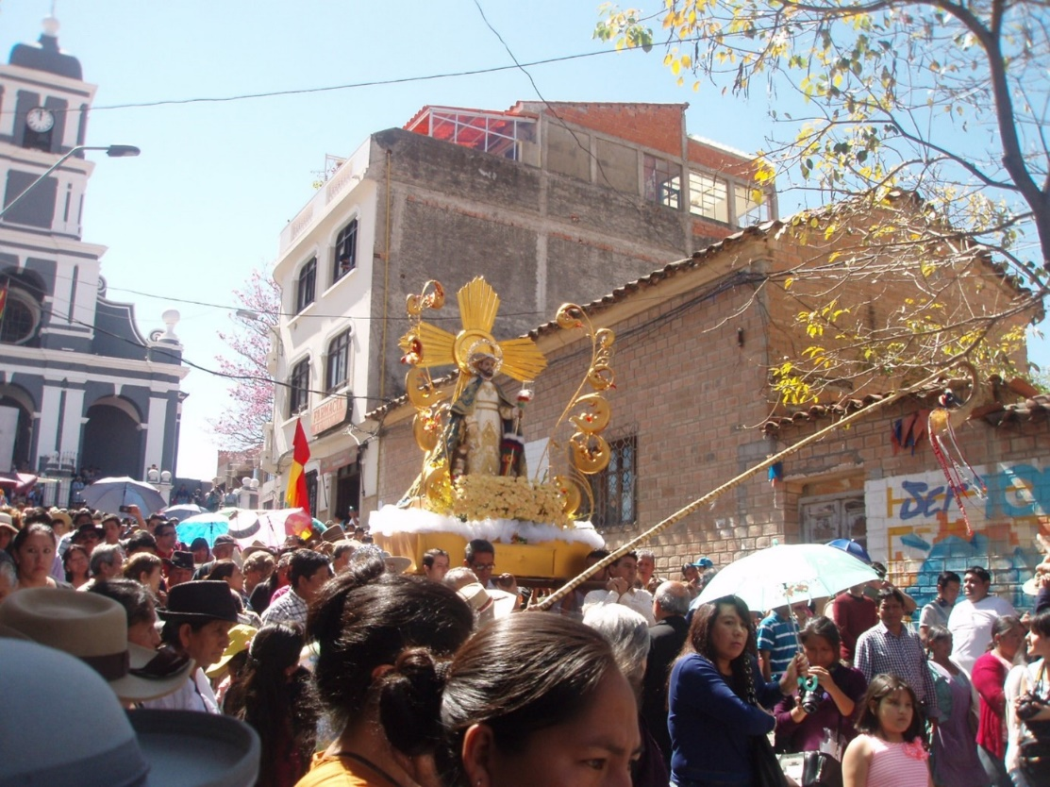

________________________

_______________________

____________________

_____________________

_______________________

____________________

______________________

____________________

______________________

_____________________

______________________

____________________

_______________________________________________________________________________________________

__________________________________________________________________________________________

__________________________________________________________________________________________

___________________________________________________________________________________________

__________________________________________________________________________________________

__________________________________________________________________________________________

_______________________________________________________________________________________

_____________________________________________________________________________________________

_____________________________________________________________________________________

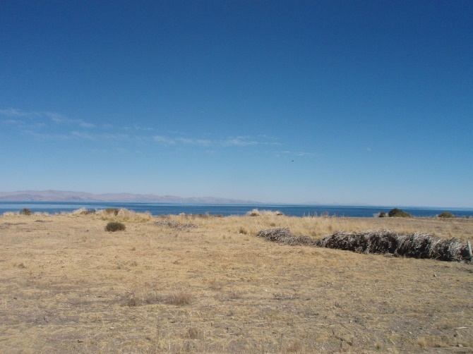**Ich habe heute gesehen**

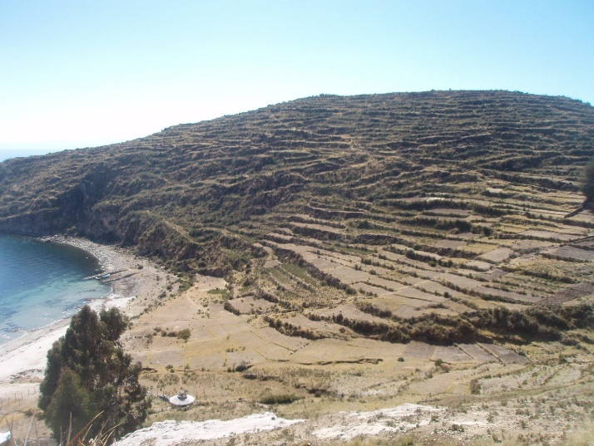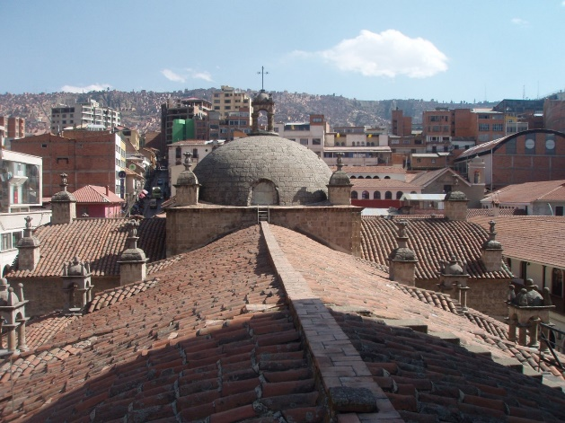

_____________________________________________________________________________________________

______________________________________________________________________________________________

_____________________________________________________________________________________________

____________________________________________________________________________________________

__________________________________________________________________________________________

____________________________________________________________________________________________

____________________________________________________________________________________________

____________________________________________________________________________________________

_________________________________________________________________________________________

______________________________________________________________________________________

_______________________________________________________________________________________

______________________________________________________________________________________

________________________________________________________________________________

____________________________________________________________________________________

__________________________________________________

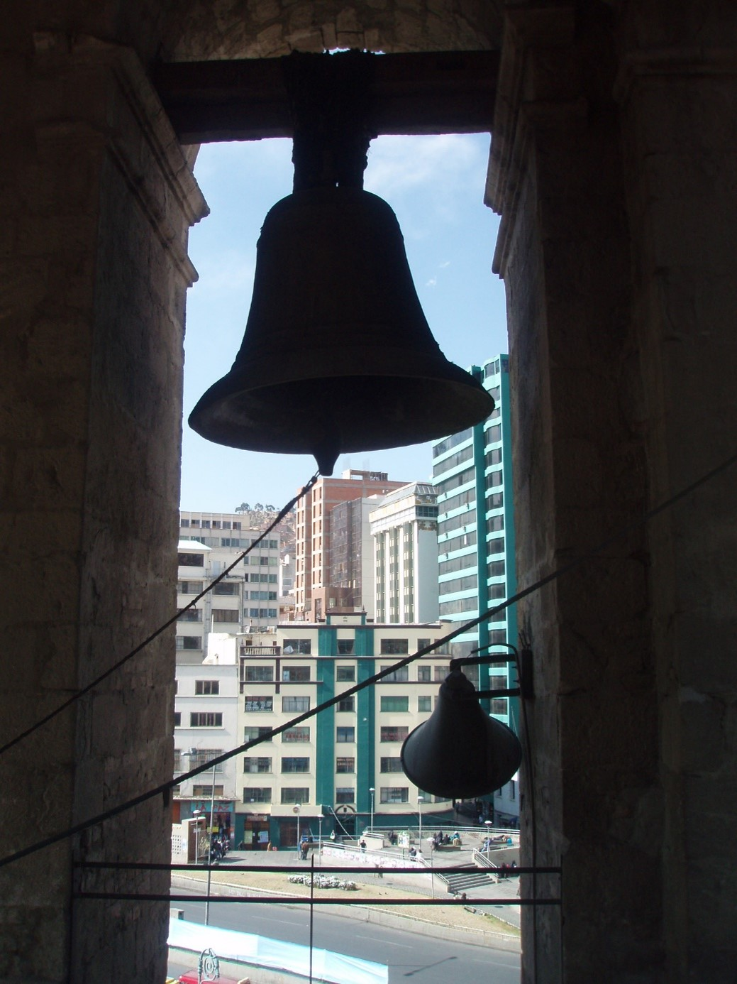**Ich habe heute verstanden**

______________

________________

_______________

_____________

_______________

_________________

_________________

________________

______________

_________________

_______________

_________________

_______________

_______________

_____________

________________

_____________

_______________

_______________

_________________

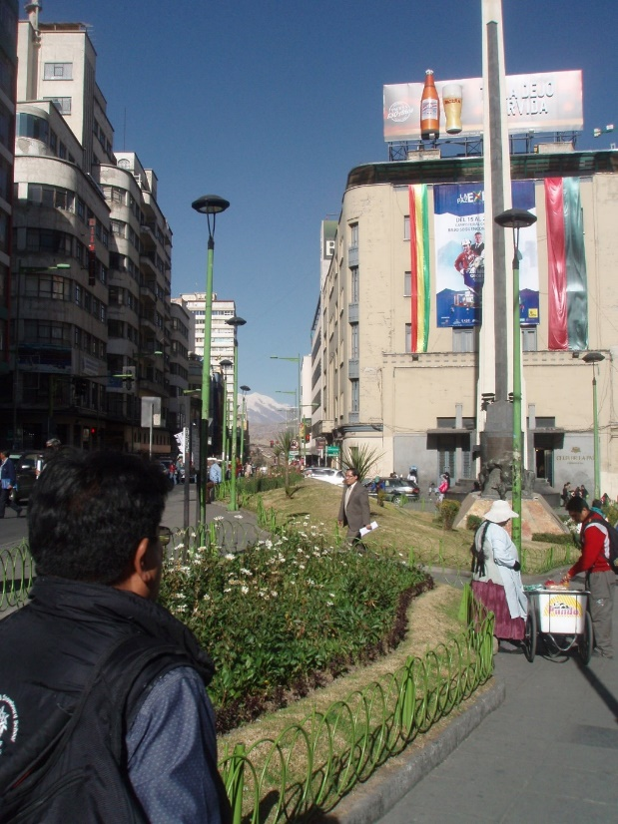

___________________________

_____________________

_______________________

_________________________

____________________________

_______________________

___________________________

______________________

____________________________

___________________________

______________________

______________________

________________________

________________________________

____________________________

______________________________

____________________________

___________________________

_________________________________

**Ich habe heute zum ersten mal probiert**

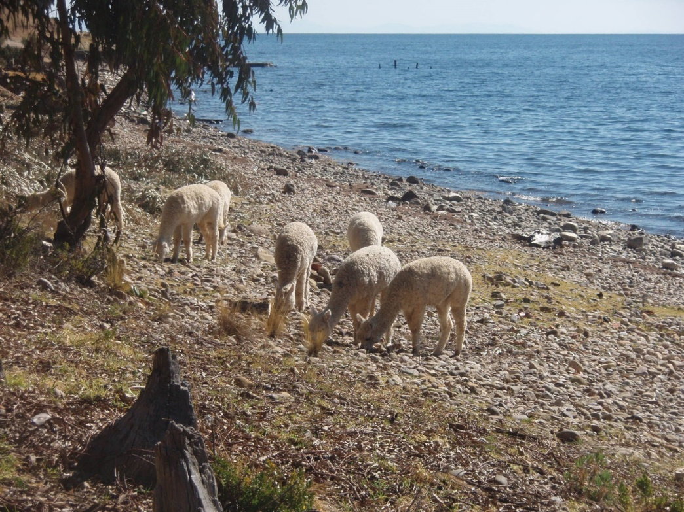

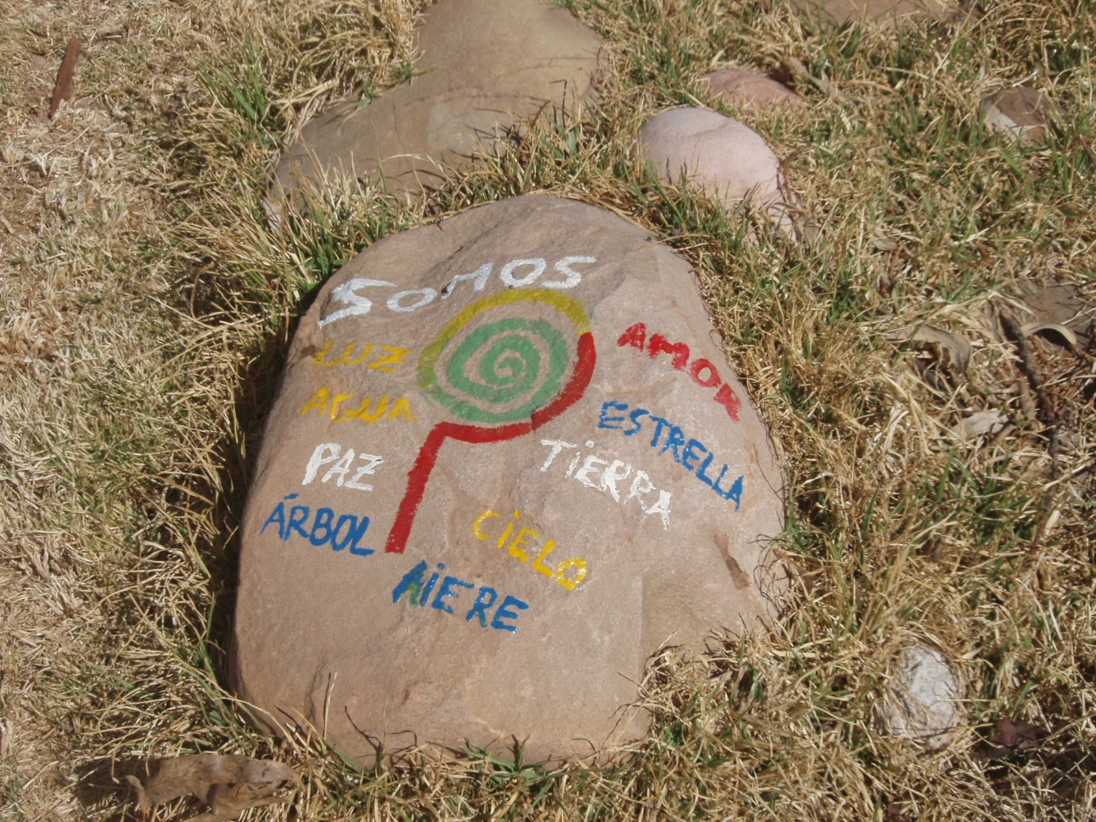

___________________________________________________________________________________

____________________________________________________________________________________

__________________________________________________________________________________

_______________________________________________________________________________

_______________________________________________________________________________

__________________________________________________________________________________

__________________________________________________________________________________

_______________________________________________________________________________

______________________________________________________________________________________

__________________________________________________________________________________

_______________________________________________________________________________

_______________________________________________________________________________

____________________________________________________________________________________

______________________________________________________________________________

_________________________________________________________________________________

__________________________________________________________

________________________________________________________

_________________________________________________

______________________________________________________

**Mein Highlight heute war**

__________________________________________________________________________________________

________________________________________________________________________________________

________________________________________________________________________________________

___________________________________________________________________________________________

_____________________________________________________________________________________

__________________________________________________________________________________

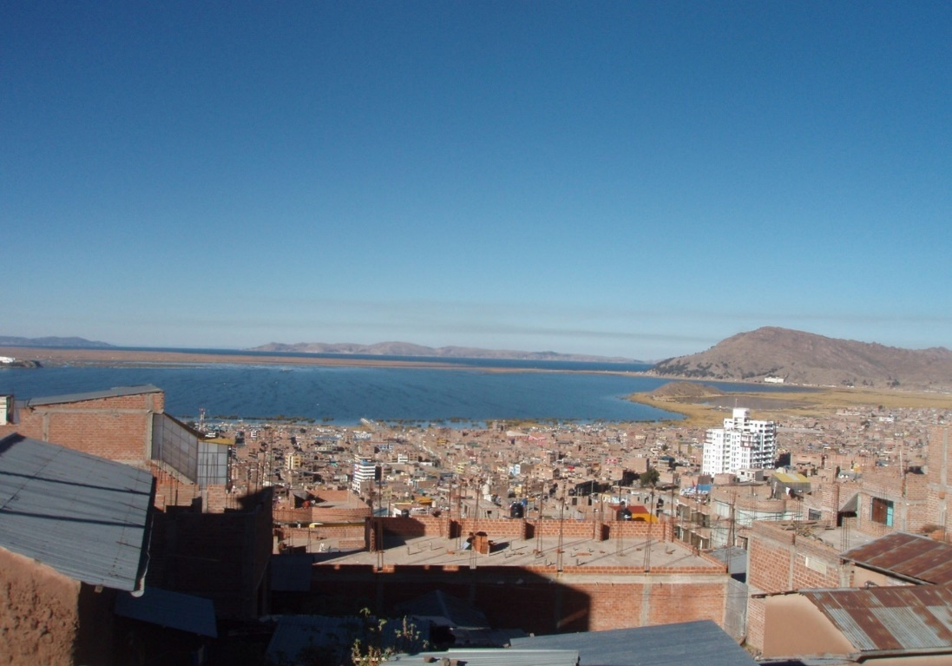

_________________________________________________________________________________________

____________________________________________________________________________________

_______________________________________________________________________________________

_______________________________________________________________________________________

__________________________________________________________________________________

___________________________________________________________________________________________

__________________________________________________________________________________________

_______________________________________________________________________________________

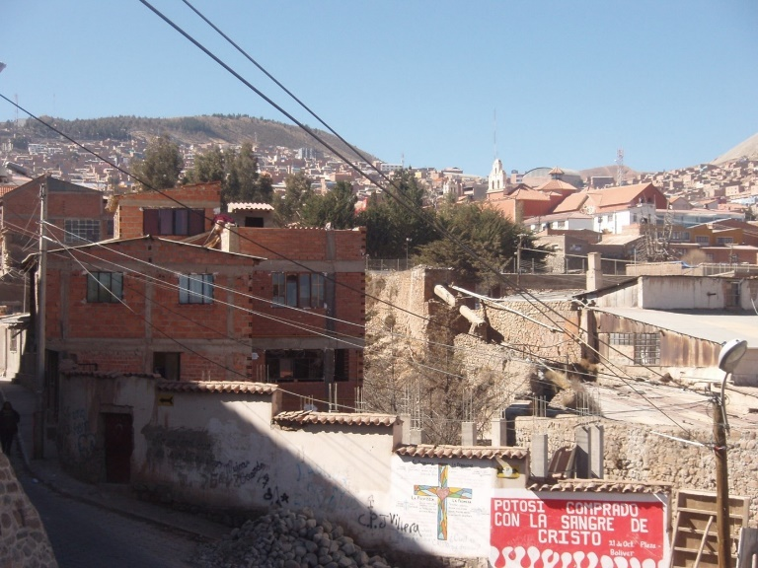

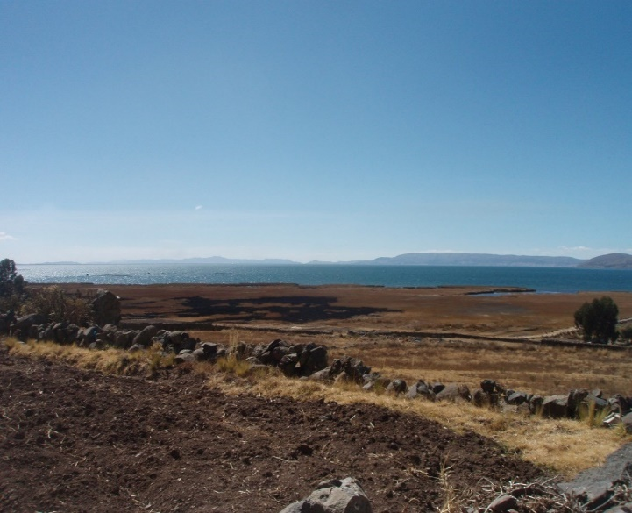

**Ich war heute glücklich, bei:**

_______________________________________________________________________________________

____________________________________________________________________________________

______________________________________________________________________________________

_______________________________________________________________________





________________________

_________________________

_______________________

________________________

________________________

______________________

_______________________

_______________________

_____________________

_________________________

_____________________________-

__________________________-

_____________________________-

_________________________

__________________________

____________________________

_________________________

______________________________

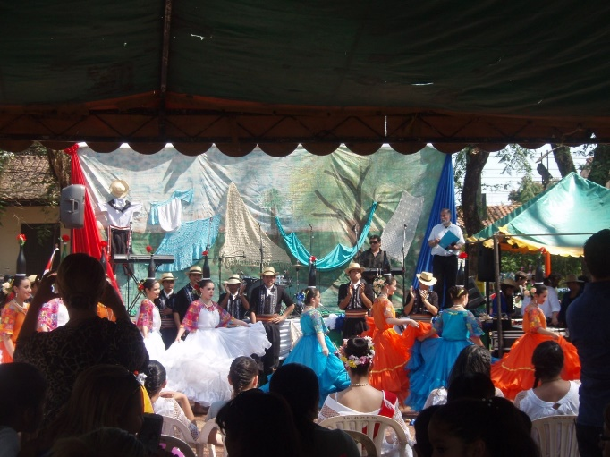

**Ich war heute mutig, weil**

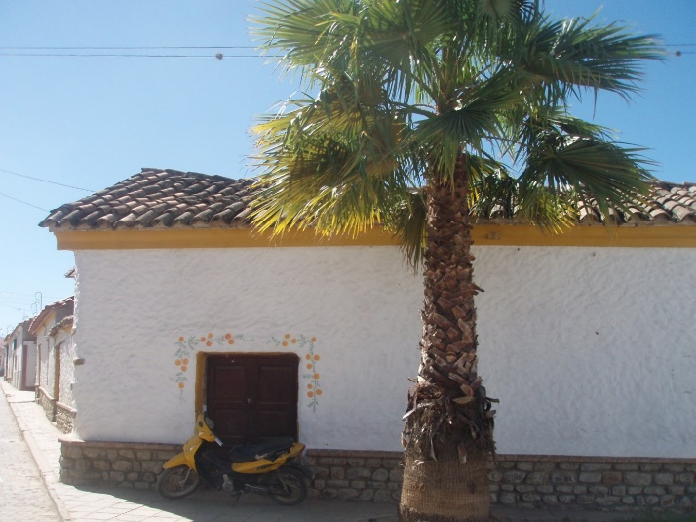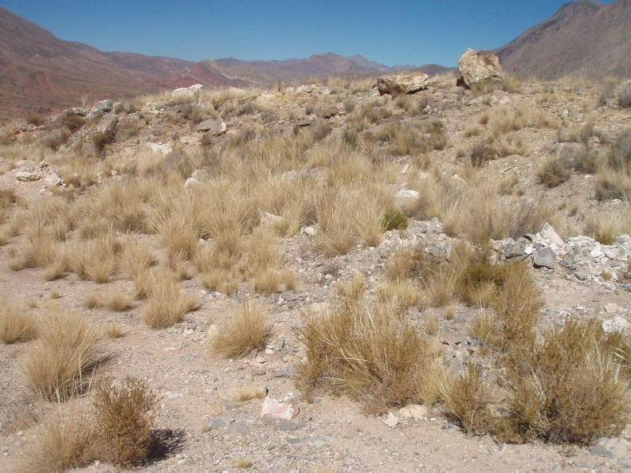

_________________________________________________________

_______________________________________________________

_________________________________________________________

___________________________________________

________________________________

_________________________________

_____________________________

_______________________________

_____________________________

_______________________________

________________________________

___________________________

________________________________

_______________________________

____________________________

_____________________

________________________________________________________________________________________

_____________________________________________________________________________________

___________________________________________________________________________________

______________________________________________________________________________________

___________________________________________________________________________________

__________________________________________________________________________________________

_____________________________________

_________________________________

_____________________________________

____________________________________

______________________________-

____________________________

___________________________

______________________________-

__________________________

___________________________________________________________________

________________________________________________________________

______________________________________________________________

________________________________________________________________

________________________________________________________________-

________________________________________________________________-

___________________________________________________________

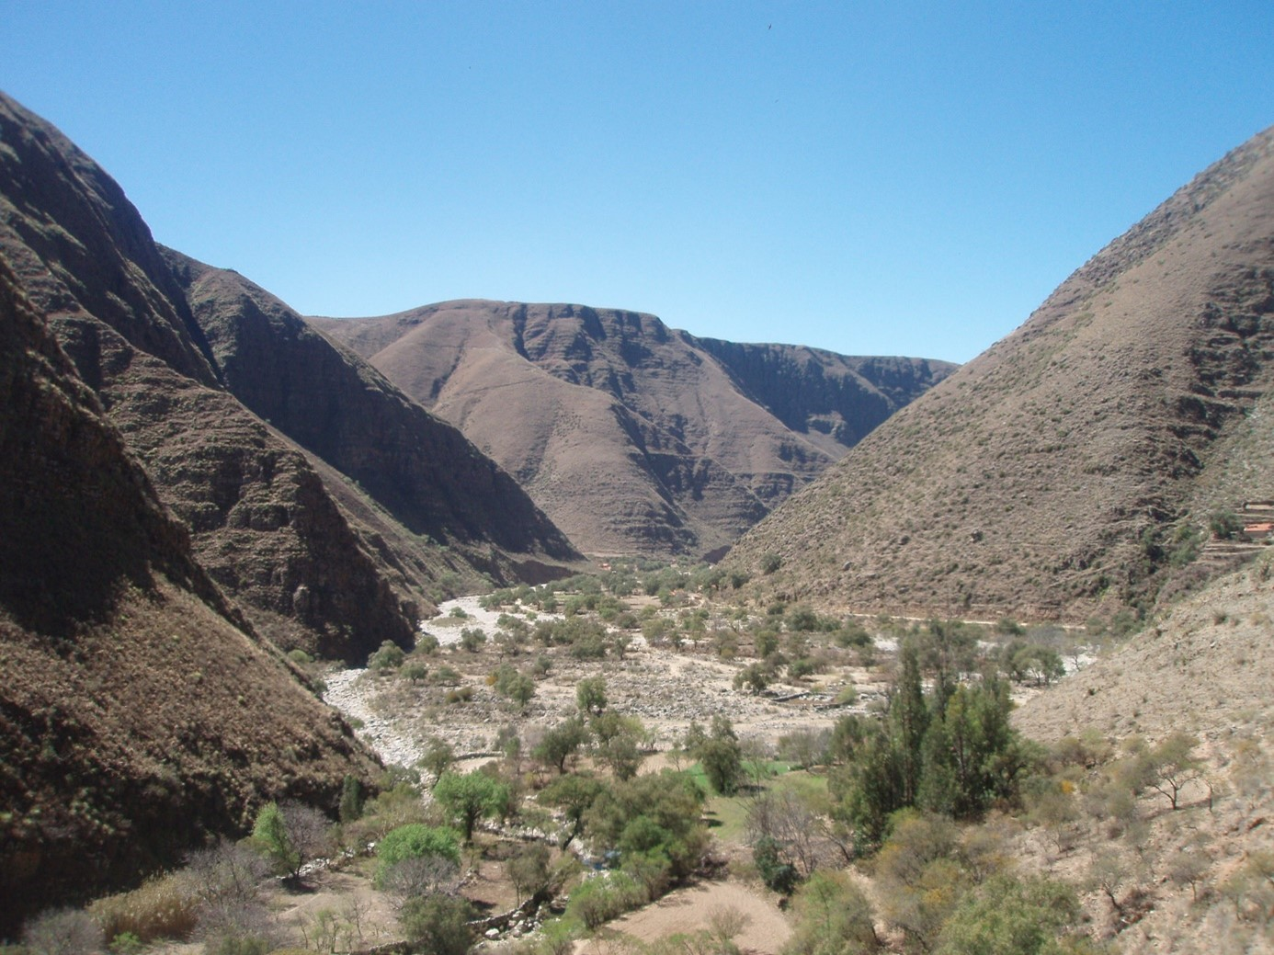

_________________________________________________________________________________________

_____________________________________________________________________________________

_________________________________________________________________________________________

_______________________________________________________________________________________

_____________________________________________________________________________________________

_________________________________________________________________________________________

**Platz für Zeichnungen und eigene Fotos**

**Meine Reise war gut, da**

________________________________________________________________________________

_______________________________________________________________________________

_____________________________________________________________________________________

_______________________________________________-

___________________________________________-

_______________________________________________-

_________________________________________



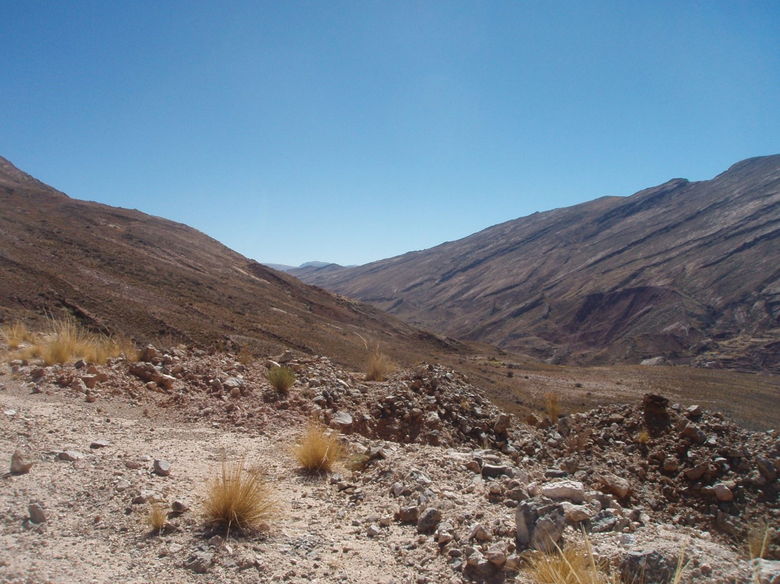

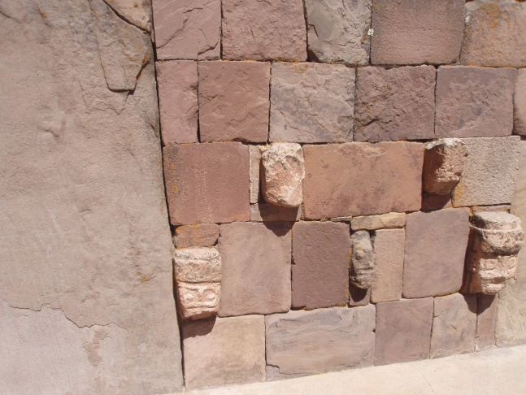

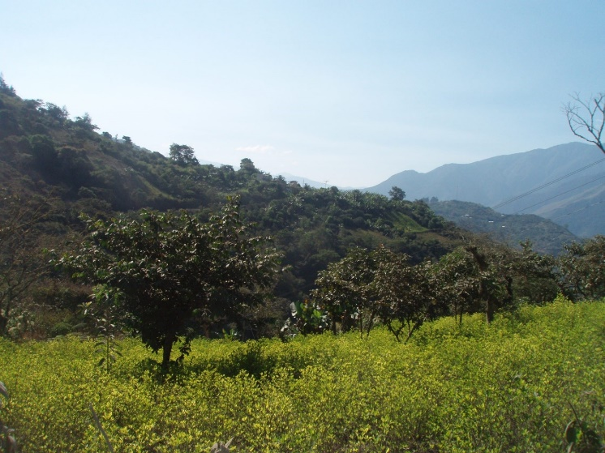

_________________________________________________________________-

________________________________________________________________________________________

____________________________________________________________________________________________

_________________________________________________________________________________________

____________________________________________________________________________________

_______________________________________________________________________________________________

__________________________________________________________________________________________

_____________________________________________________________________________________________

__________________________________________________________________________________

___________________________________________________________________________________________

______________________________________________________________________________________

_______________________________________________________________________________________________

_________________________________________________________________________________________

________________________________________________________________________________________

___________________

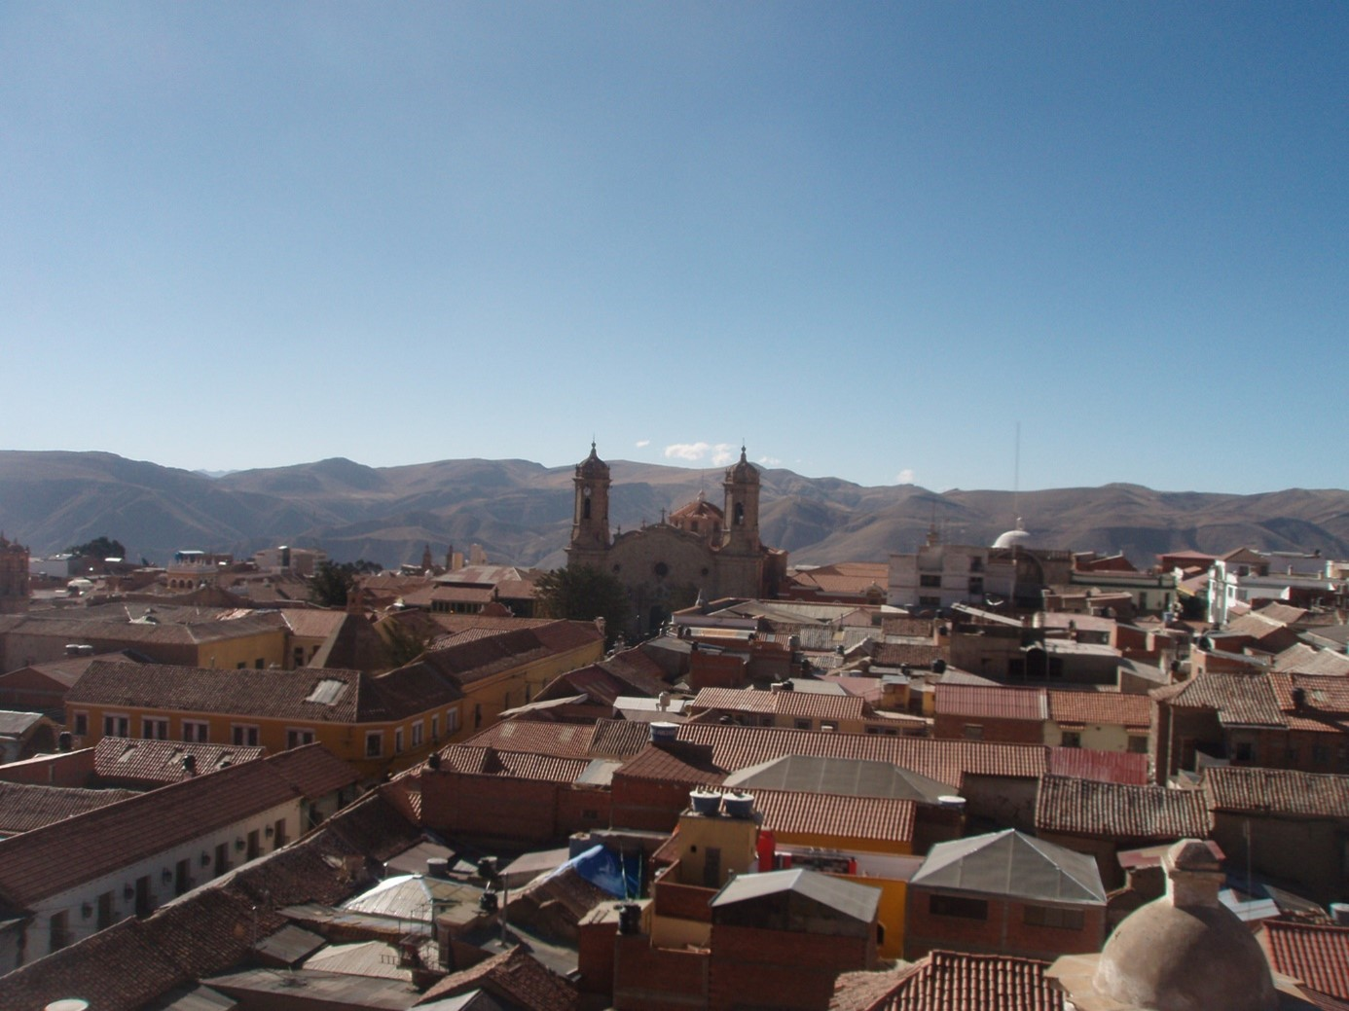

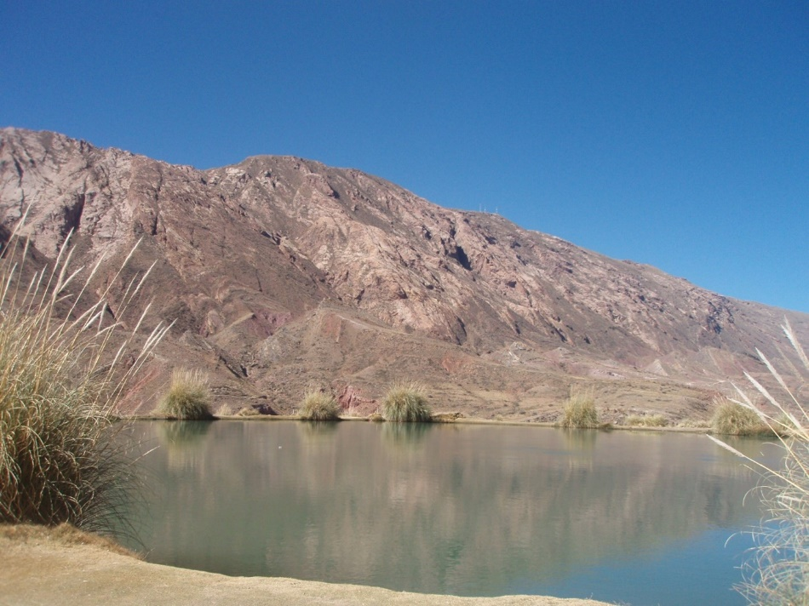

**In Deutschland zurück werde ich**

__________________________________

______________________________

_________________________________

__________________________________

________________________________

________________________________

_______________________________

_____________________________

_________________________________

__________________________________

_________________________________________________________________________________

_________________________________________

__________________________________________

_________________________________________

________________________________________

______________________________________

__________________________________________

__________________________________________

______________________________________

__________________________________________

_________________________________________

__________________________________________

_____________________________________

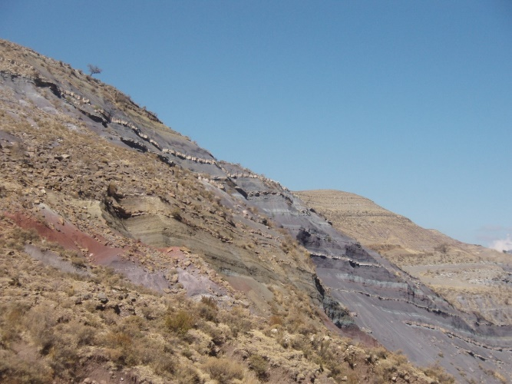

**Meine nächste Reise geht nach:**

________________________________________