Reisetagebuch
Ich reise nach Ägypten und Marokko, denn ich hoffe dort:
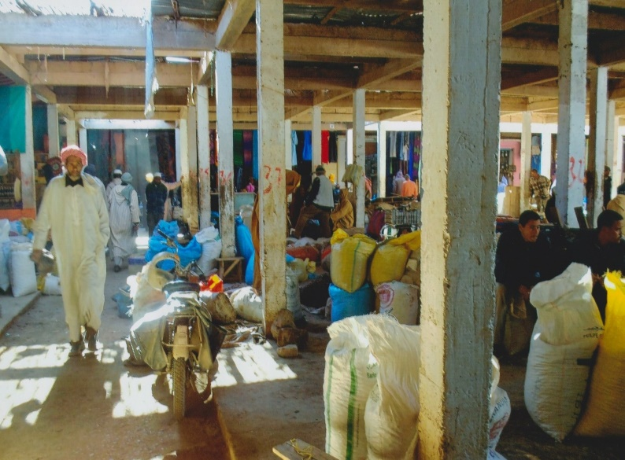

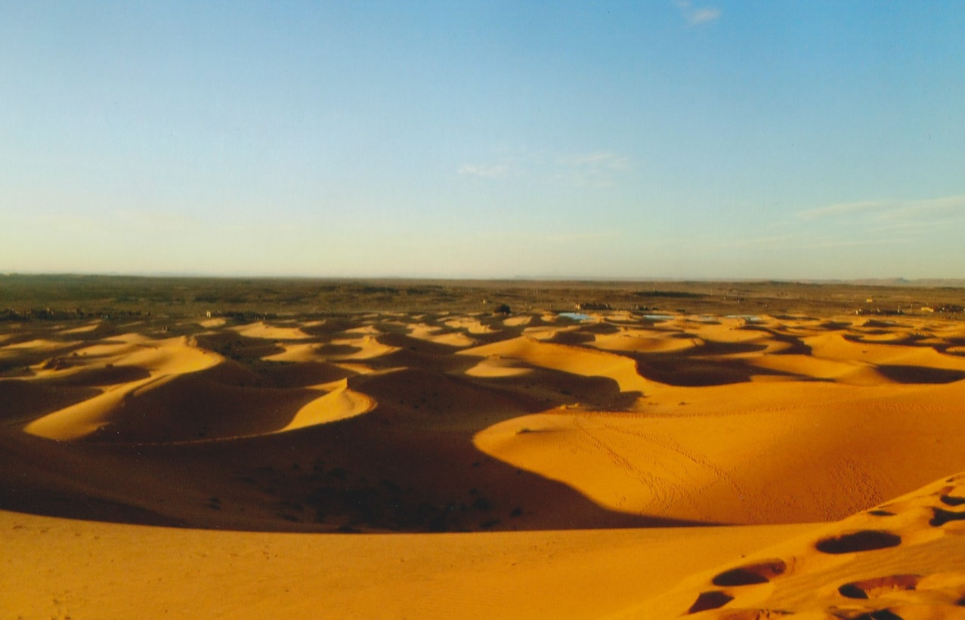

Ich will In dieser Reise will unbedingt sehen:

___________________________________________________________________________________
___________________________________________________________________________________
_____________________________________________________________________________________
________________________________________________________________________________________
_______________________________________________________________________________________
__________________________________________________________________________________-
______________________________________________________________________________________
______________________________________________________________________________________
_________________________________________________________________________________________

Gesehen habe ich:

________________________________________________________________________________________
_______________________________________________________
_________________________________________________________
_____________________________________________________________
______________________________________________________________
________________________________________________________________
__________________________________________________________________
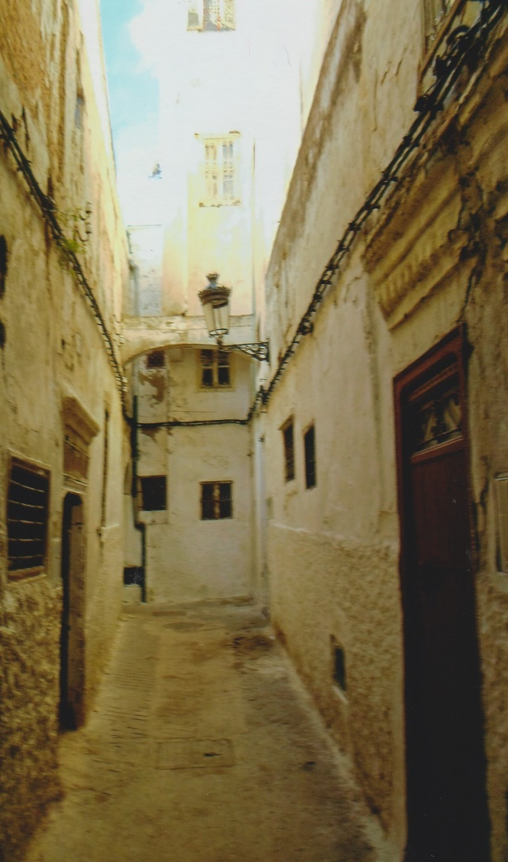____________________________

Foto
___________________________________________________________________________________
____________________________________________________________________________________
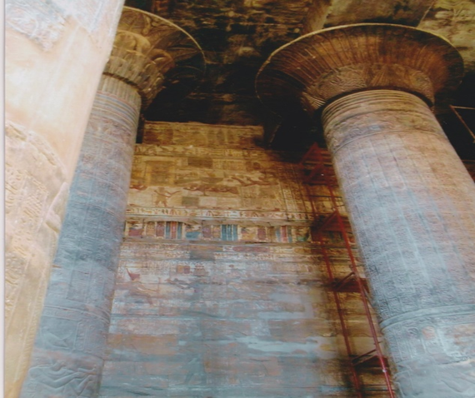______________________________________________________

Foto

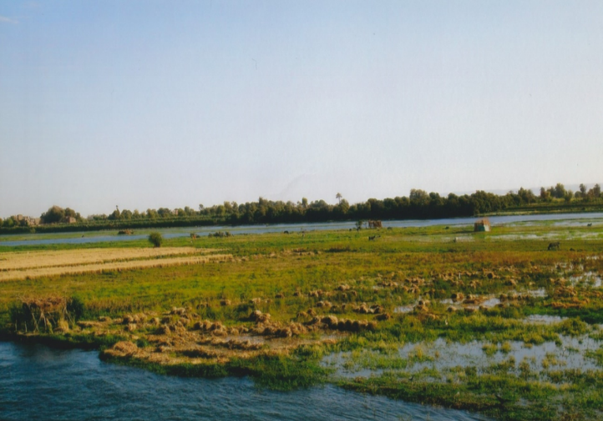__________________________________________

Essen:
Jeden Tag etwas anderes:
_____________________________________________________________________________________

__________________

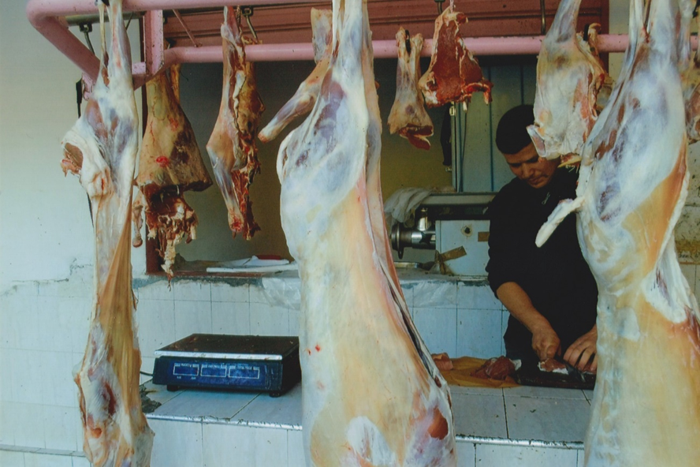

________________________________________________________________________
_____________________________________________________________________________________
__________________________________________________________________________________
________________________________________________________________________________
___________________________________________________________________________
_______________________________________________________________________
_______________________________________________________________________________________
___________________________________________________________________________________
Habe kennengelernt
______________________________________________
___________________________________________ 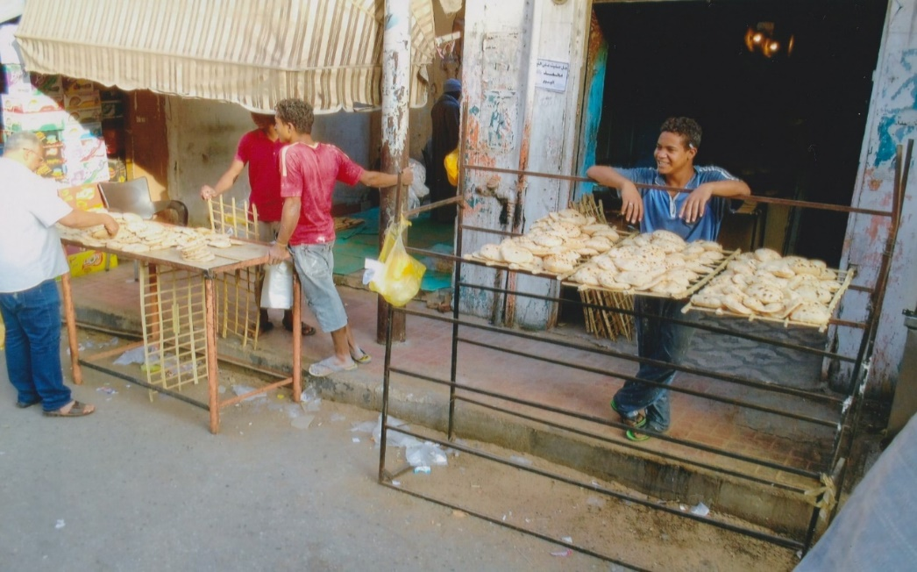

__________________________________________

_________ __________________________________________

_________________________________________

Auf einmal kapiert habe ich

_______________________________________________________________________________________________
______________________________________________________________________________________________
______________________________________________________________________________________________
______________________________________________________________________________________________
_______________________________________________________________________________________________
_________________________________________________________________________________________
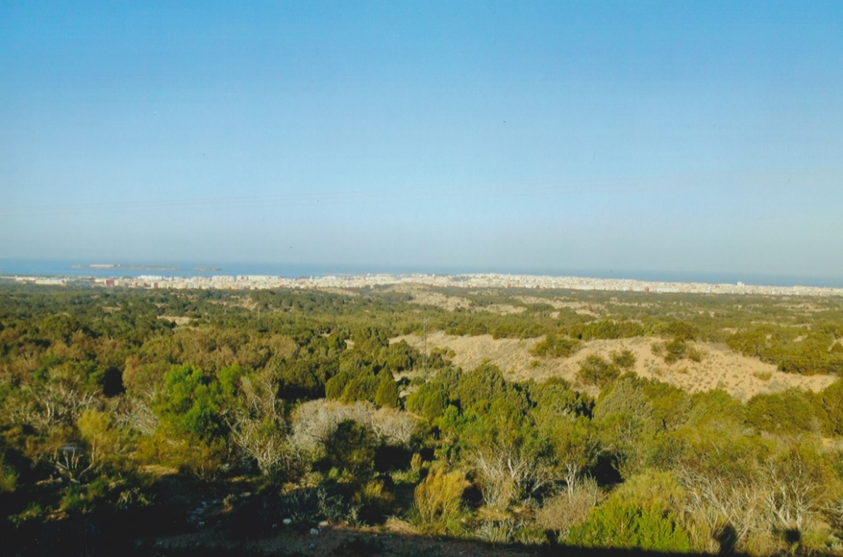
__________________________________________________________________________________________
______________________________________________________________________________________________
______________________________________________________________________________________________
______________________________________________________________________________________________
_______________________________________________________________________________________________
______________________________________________________________________________________________
________________________________________________________________________________________________
_______________________________________________________________________________________________
_________________________________________________________________________________________
_____________________________________________________________________________________________
________________________________________________________________________________________
______________________________________________________________________________________________
___________________________________________________________________________________________
___________________________________________________________________________________________
______________________________________________________________________________________________
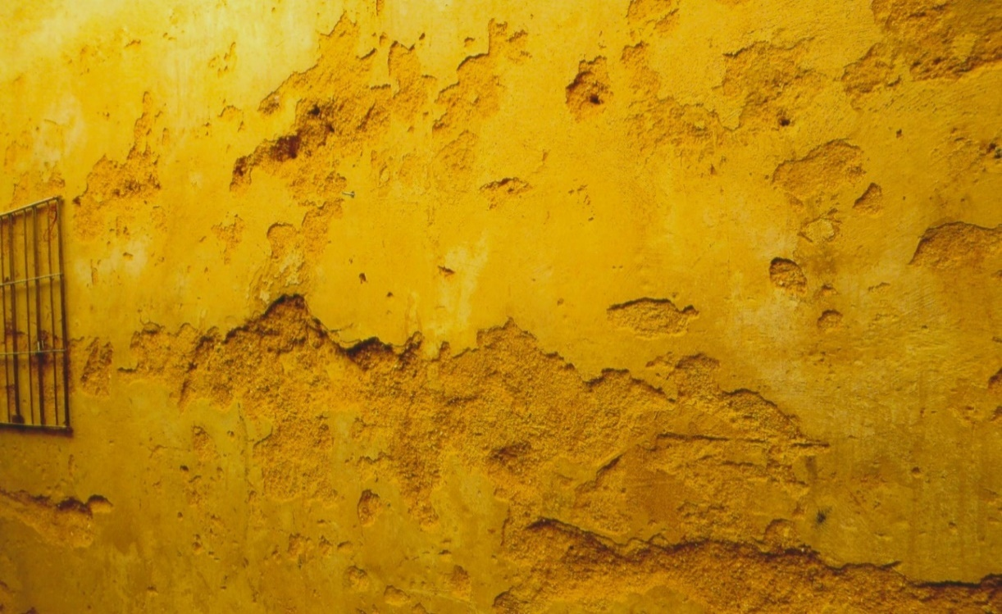
___________________________

Zum ersten mal im Leben habe ich:
________________________________________

_______________________________________
_______________________________________________
__________________________________________________
____________________________________________________

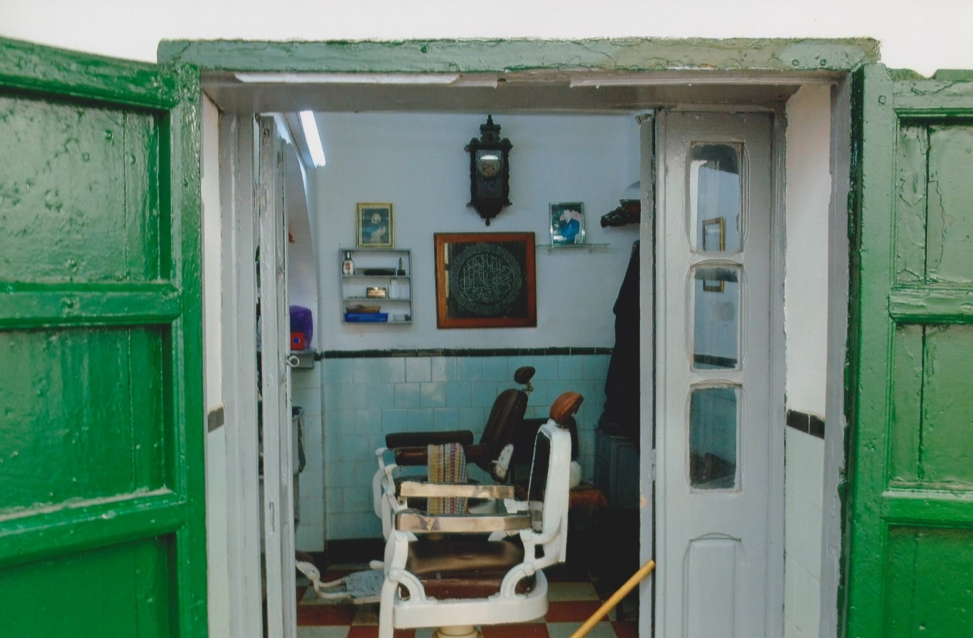

_________________________________________________
__________________________________________
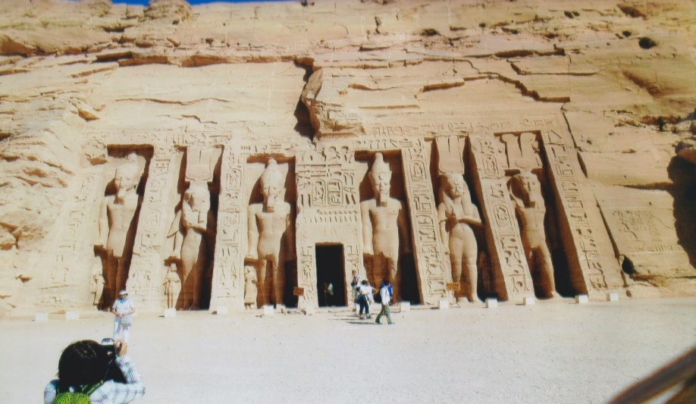
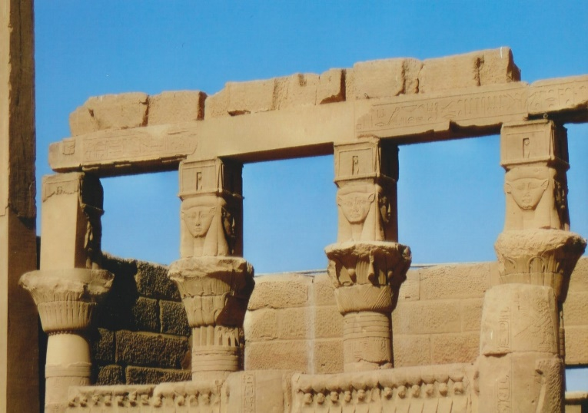

Meine ersten Vokabeln
Deutsch | Arabisch

Mein Lieblingserlebnis

_______________
______________________________________________________________________________________
______________________________________________________________________________________________
____________________________________________________________________________________________

__________________________________________________________________________________
___________________________________________________________________________________
_____________________________________________________________________________________
___________________________________________________________________________________________
_________________________________________________________________________________________
_______________________________________________________________________________________________
_______________________________________________________________________________________________
___________________________________________________________________________________________

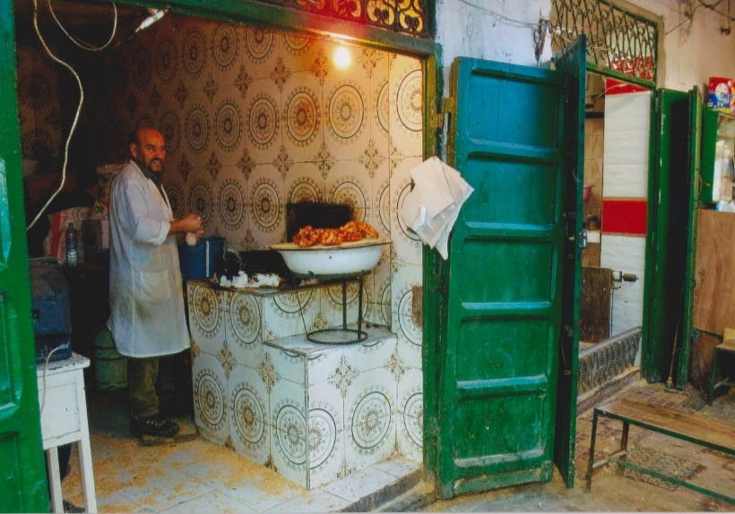
Glücklich war ich bei
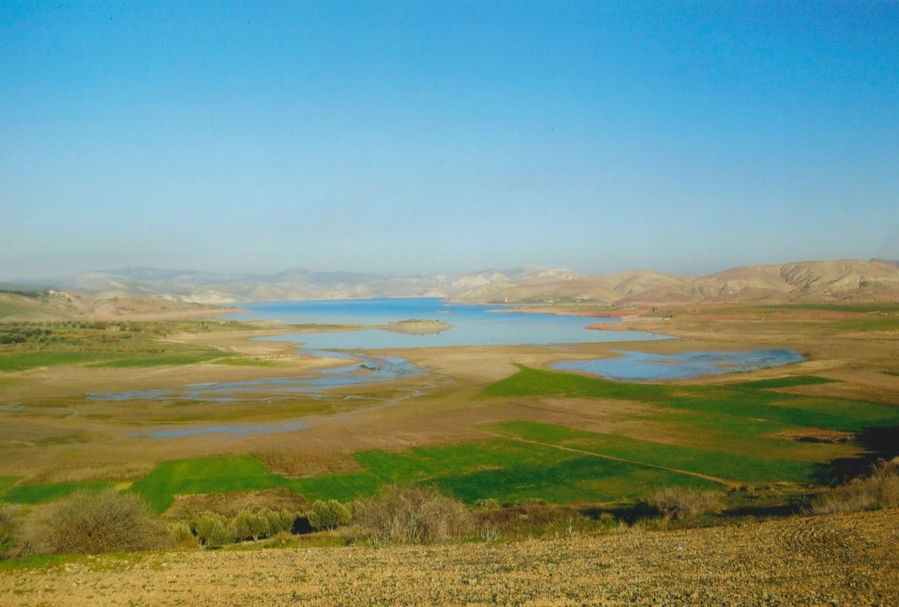

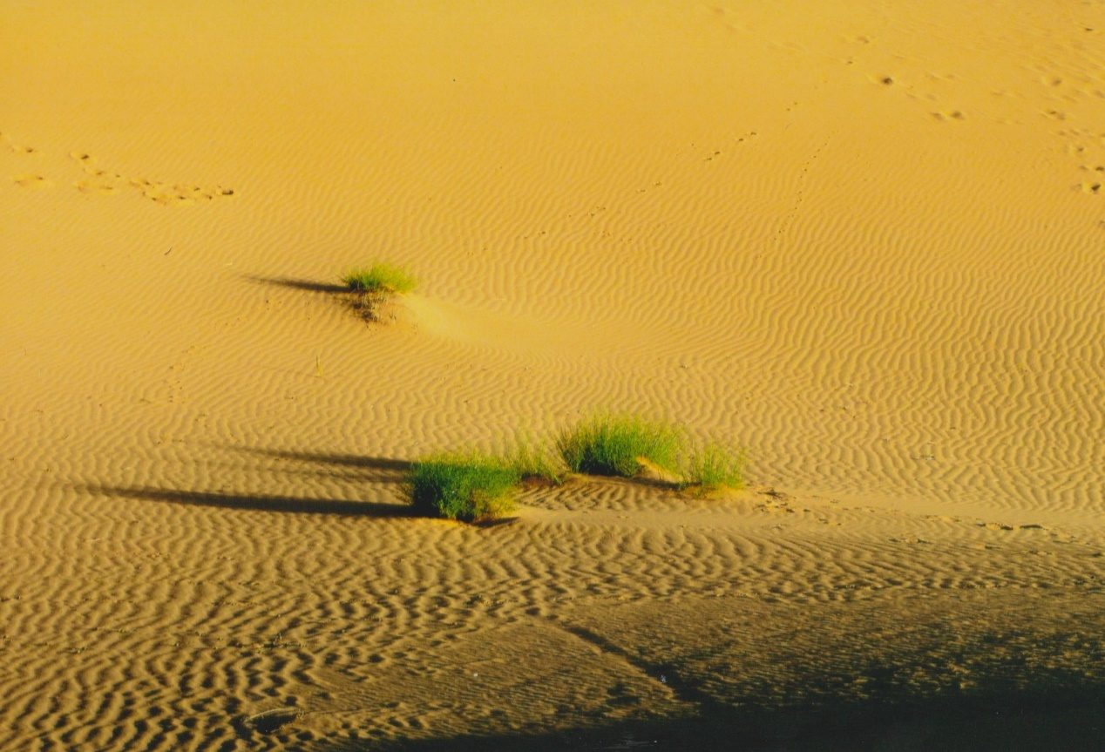
Mutig war ich, weil
_______________________________________________________________________________________________
_____________________________________________________________________________________________
______________________________________________________________________________________________--
_______________________________________________________________________________________________
___________________________________________________________________________________________
__________________________________________________________________________________________-____
___________________________________________________________________________________________--
_____________________________________________________________________________________________
____________________________________________________________________________________________-
_______________________________________________________________________________________
________________________________________________________________________________________-
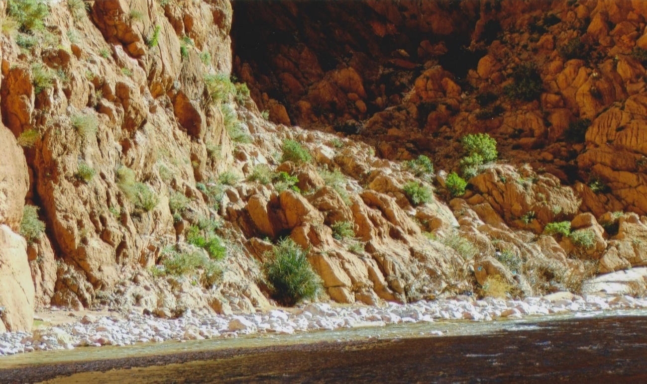
_______________________________________________________________________________________
_______________________________________________________________________________________

_________________________________________________________
Platz für Zeichnungen und fotos

Meine schönsten Reiseerlebnisse:
__________________________________________________
______________________________________________________________
______________________________________________________
__________________________________________________
______________________________
___________________________________________
____
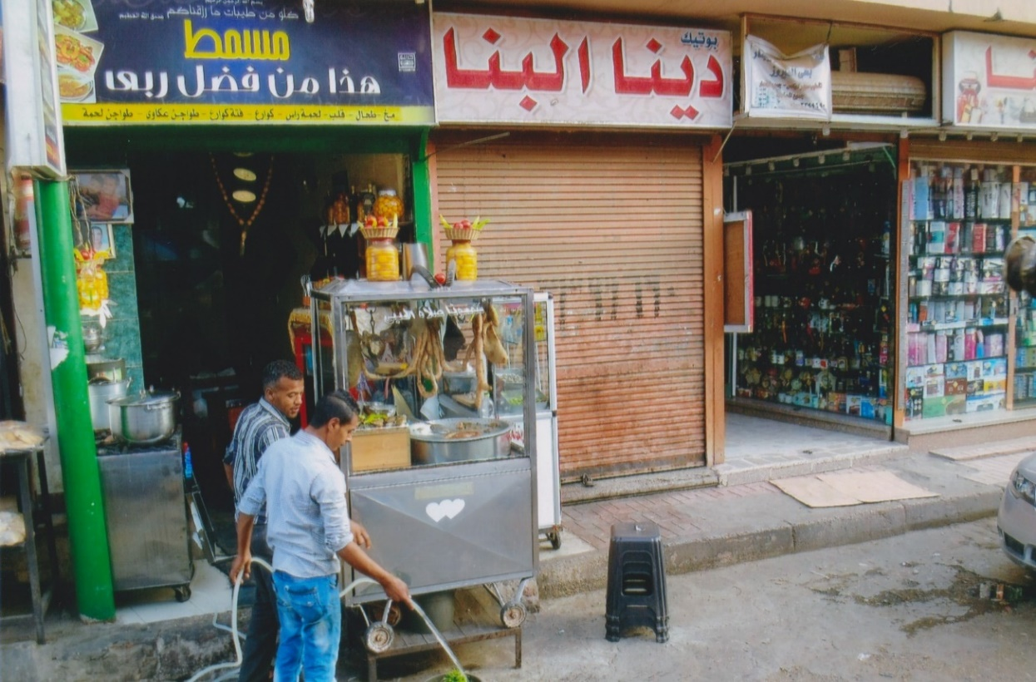

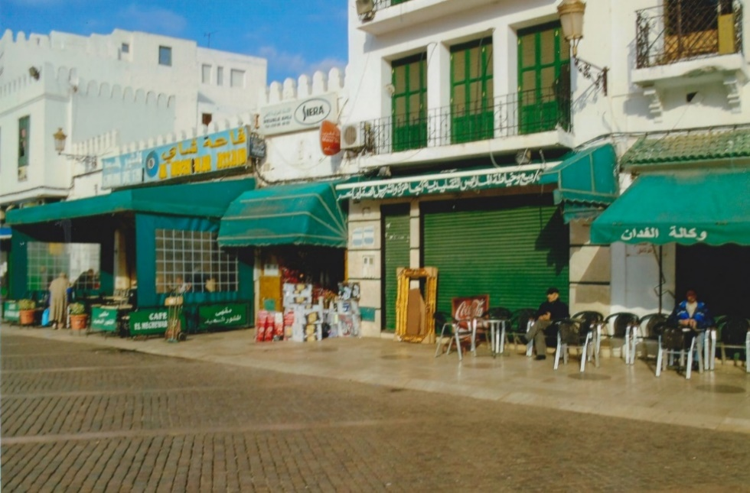
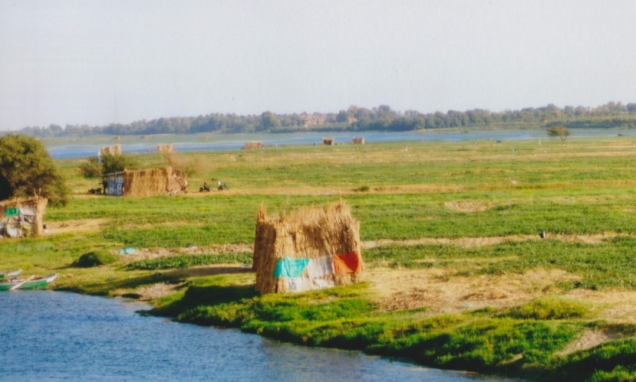
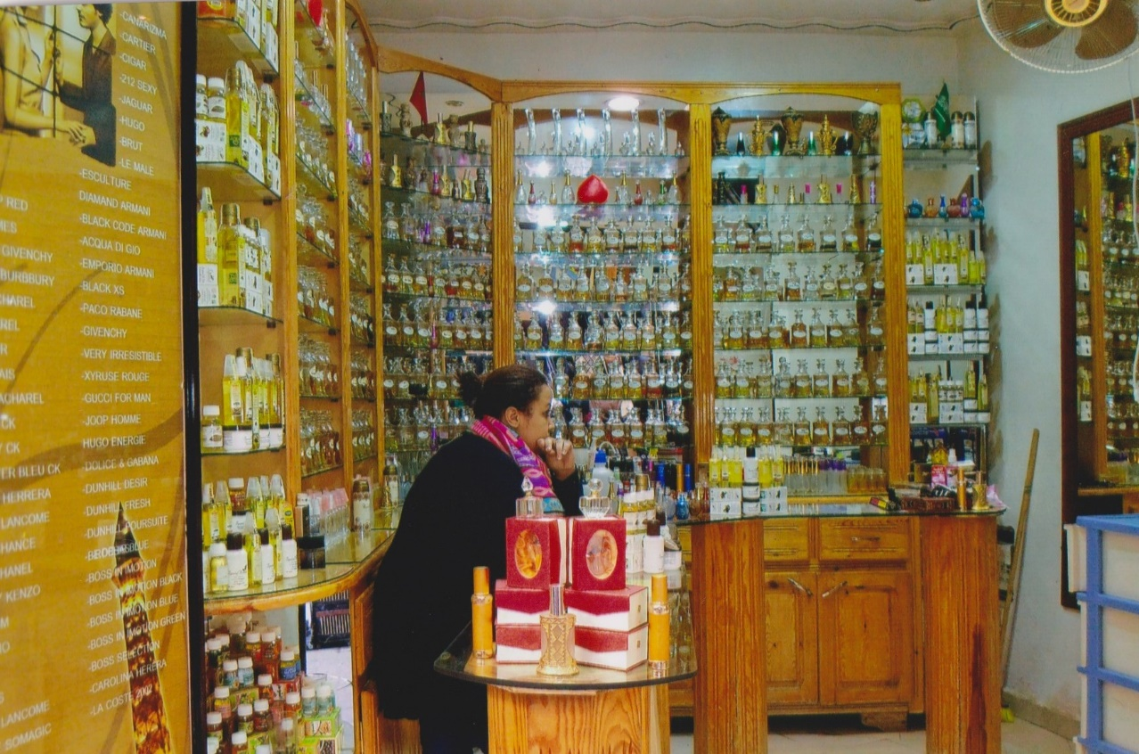

In Deutschland zurück werde ich

______________________________________________________________
________________________________________________
_________________________________________________________
_______________________________________________________
________________________________________
____________________________________________
________________________________________
___________________________________
___________________________________________________
_________________________________________________
_________________________________________________
________________________________________________

________________________________
__________________________________

Meine nächste Reise geht nach:

_________________________________________________

