Polen





Ich reise nach Polen, denn ich hoffe dort:

________________________________________________________________________________________

______________________________________________________________________________________

_____________________________________________________________________________

____________________________________________________________________________________

____________________________________________________________________________________

___________________________________________________________________________

_____________________________________________________________________________

____________________________________________________________________________________

____________________________________________________________________________________

_______________________________________________________________________________

________________________________________________________________________________

___________________________________________________________________________________

________________________________________________________________________________________

_____________________________________________________________________________________

______________________________________________________________________________

_____________________________________________________________________________________

___________________________________________________________________________________

______________________________________________________________________________

________________________________________________________________________________

____________________________________________________________________________

________________________________________________________________________________

_______________________________________________________

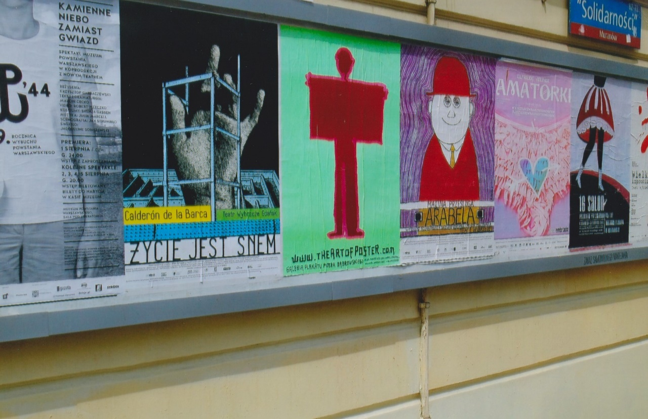



_________________________

_________________________

_________________________

_________________________

___________________________

________________________

________________________

__________________________

_________________________

____________________

_______________________

______________________

In dieser Reise will ich

sehen und machen:

_________________________________________________

_________________________________________________

_______________________________________________________

_______________________________________________

_______________________________________________________

______________________________________________________

_______________________________________________

____________________________________________________



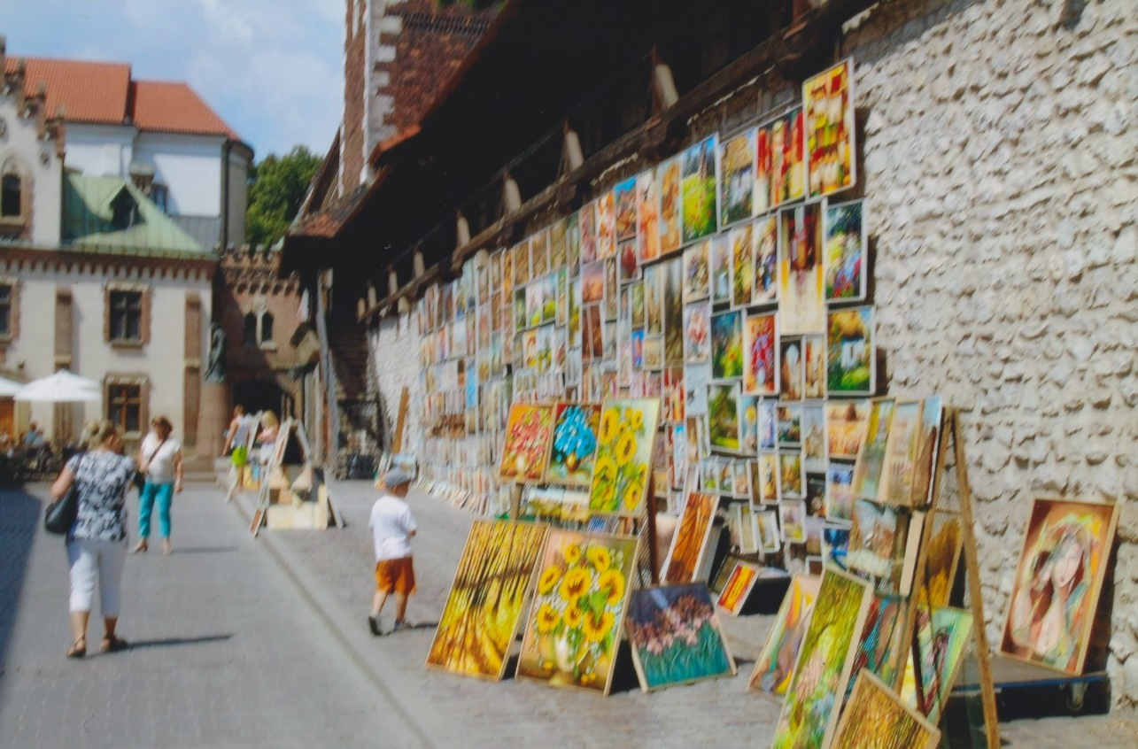



Reiseerlebnisse:

Ich habe heute gegessen

_____________________________

__________________________

_____________________________

____________________________

____________________________

__________________________

____________________________

_________________________

___________________________

__________________________

_________________________

____________________________

_______________________

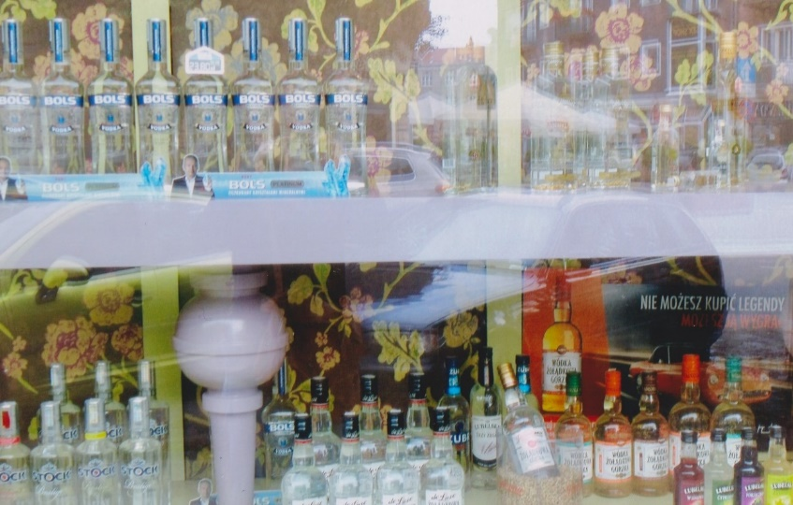

Ich habe heute kennengelernt:

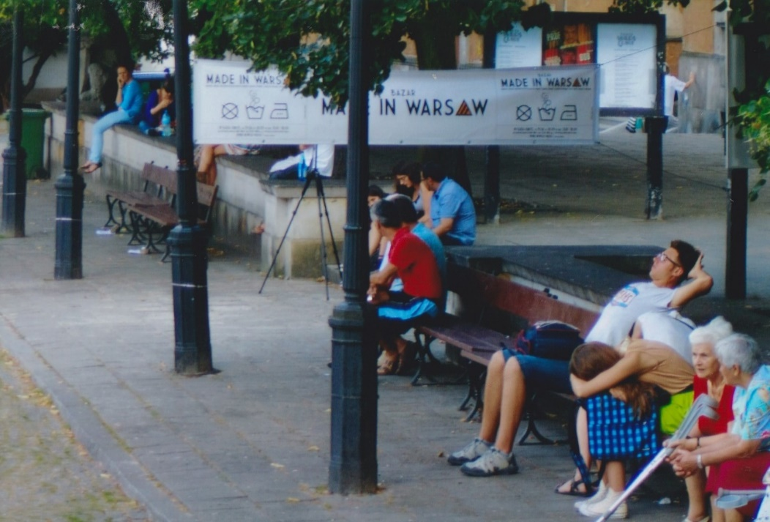

___________________________

_________________________

____________________________

__________________________

____________________________

________________________

___________________________

_________________________

____________________________

________________________

___________________________

Ich habe heute gesehen

____________________________________________________________

_______________________________________________________

__________________________________________________________

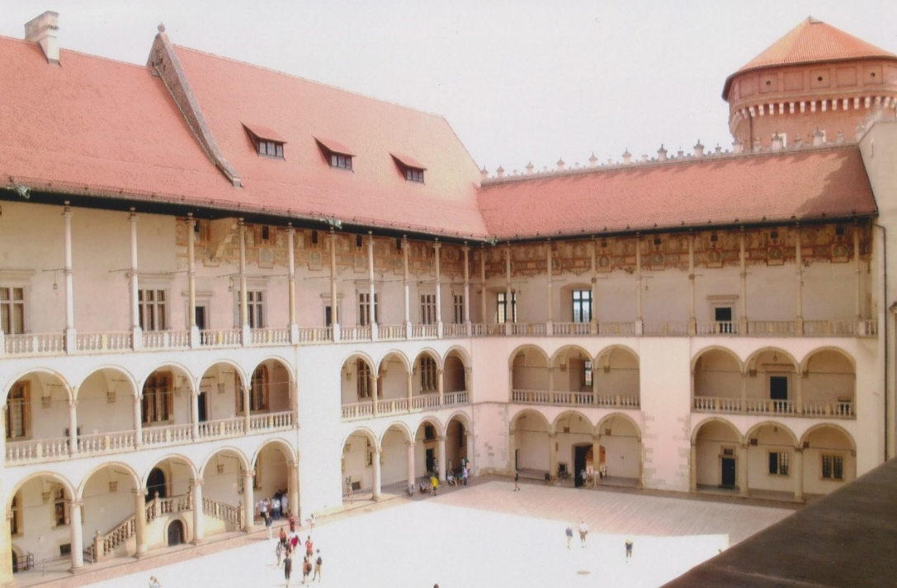



_________________________________________________________________________________________

_________________________________________________________________________________________

___________________________________________________________________________________

________________________________________________________________________________

______________________________________________________________________________________

_________________________________________________________________________________________

Ich habe heute dazugelernt:

_______________________________________________________________________________

______________________________________________________________________________________

___________________________________________________________________________________

______________________________________________________________________________________

____________________________________________________________________________________

________________________________________________________



____________________________________________

__________________________________________

______________________________________________

__________________________________________

____________________________________________

____________________________________________

________________________________________



Ich habe heute zum ersten Mal probiert

______________________________________

________________________________________

__________________________________

_______________________________________

________________________________________

______________________________

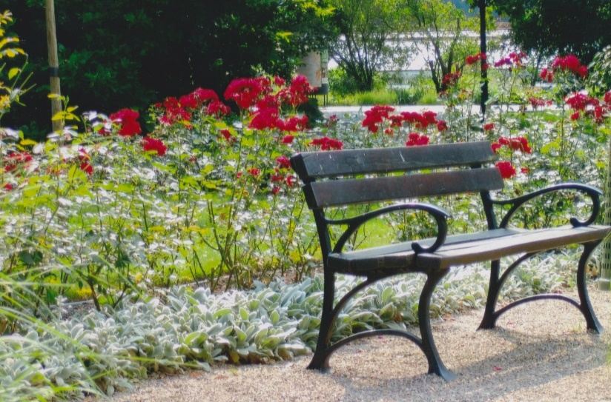

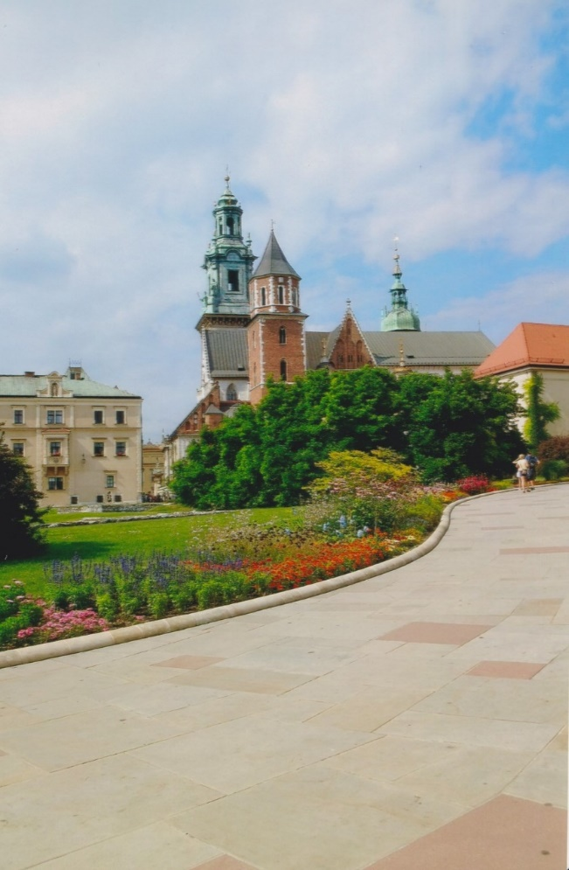

_____________________________________

______________________________________

_______________________________________

_____________________________________

________________________________________

_________________________________

_______________________________________

______________________________________

_________________________________________

______________________________________

_____________________________________

______________________________________

_______________________________________

_____________________________________

________________________________________

_________________________________

_______________________________________

______________________________________

_________________________________________

______________________________________-

Ich habe heute verstanden

_____________________________________________________________________________

_______________________________________________________________________________

_____________________________________________________________________________

______________________________________________________________________________

____________________________________________________________________________

_________________________________________________________________________________

________________________________________________________________________________

____________________________________________________________________________

_________________________________________________________________________________

_____________________________________________________________________________



Mein Highlight heute war:

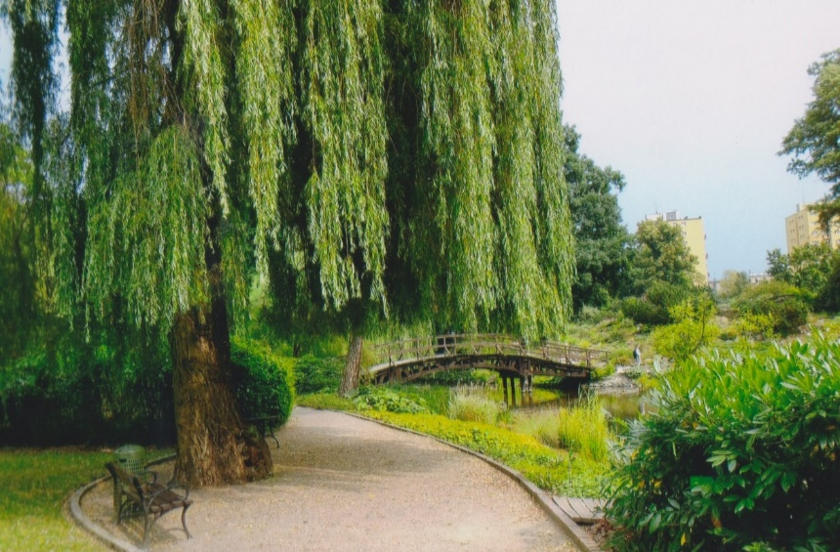



_____________________________________________________________________________________

___________________________________________________________________________________

______________________________________________________________________________________

____________________________________________________________________________________

__________________________________________________________________________________

___________________________________________________________________________________

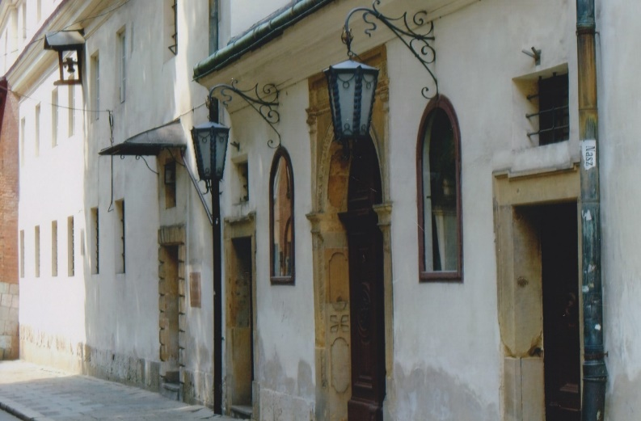





_______________________________________________________________________________________

________________________________________________________________________________________

_____________________________________________________________________________________

_______________________________________________________________________________

____________________________________________________________________________________

_________________________________________________________________________________

______________________________________________________________________________

Ich war heute mutig, denn:

_____________________________________

______________________________________

_______________________________________

_____________________________________-

________________________________________-

_________________________________-

_______________________________________-

______________________________________-

_________________________________________-

______________________________________-

______________________________________-

_______________________________________-

_____________________________________

________________________________________

_________________________________

_______________________________________

______________________________________

_________________________________________

______________________________________

___________________________________________

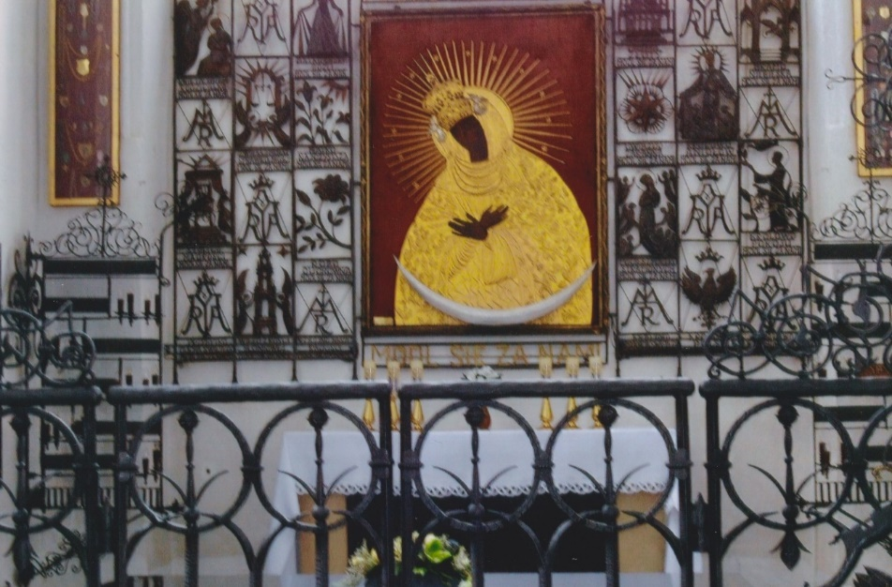

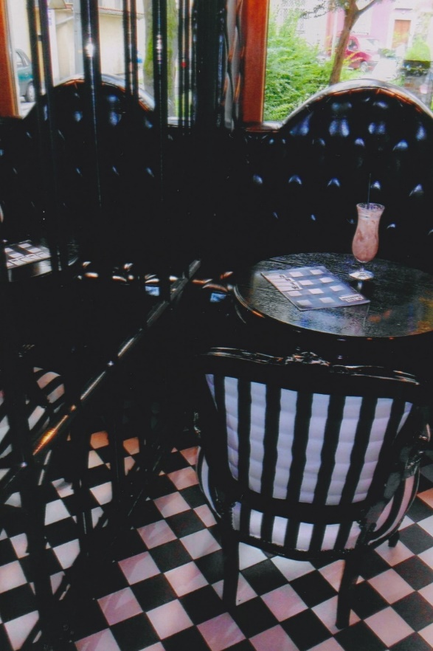

_________________________

_____________________

___________________

________________________

_______________________

__________________

________________________

___________________

______________________

_________________________





Platz für Zeichnungen und was immer ihr wollt:

Meine Reise war gut, denn:

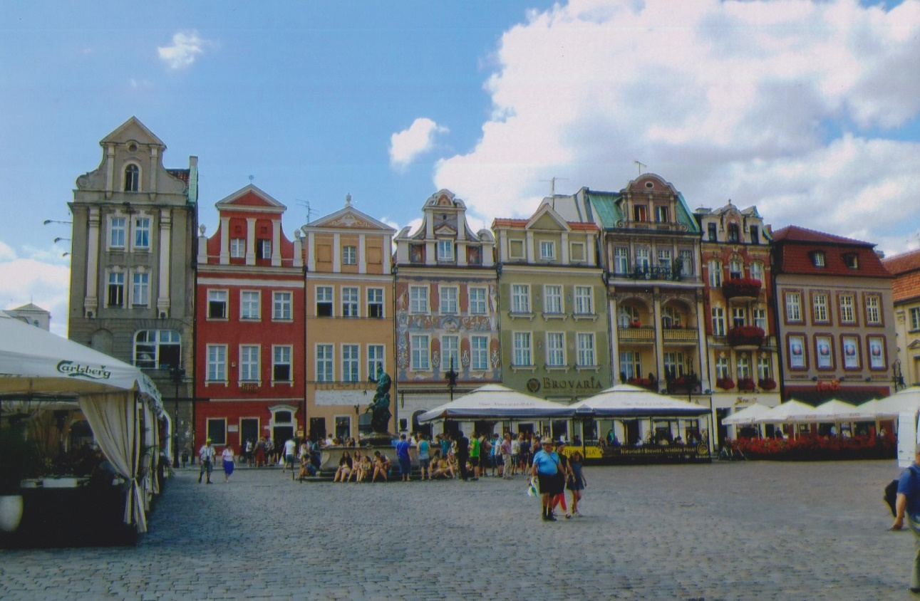



_____________________________________________________________________________

___________________________________________________________________________

______________________________________________________________________________

_______________________________________________________________________________

____________________________________________________________________________

________________________________________________________________________________

________________________________________________________________________________

_____________________________________________________________________________

_________________________________________________________________________________

______________________________________________________________________________

__________________________________________________________________________

_______________________________________________________________________________

______________________________________________________________________________

____________________________________________________________________________

__________________________________________________________________________

____________________________________________________________________________

____________________________________________________________________________

______________________________________-__________-

______________________________________-



________________________________________________________________________

________________________________________________________________________________

_________________________________________________________________________________

________________________________________________________________________________

______________________________________________________________________

____________________________________________________________________________

________________________________________________________________________________

________________________________________________________________________________

_____________________________________________________________________________

_____________________________________________________________________________

_____________________________________________________________________________

___________________________________________________________________________

______________________________________________________________________________

______________________________________________________________________________

_________________________________________________________________________________

________________________________________________________________________________

________________________________________________________________________________

In Deutschland zurück werde ich:

______________________________________________________________________________

______________________________________________________________________________________

_________________________________________________________________________________

_____________________________________________________________________________________

___________________________________________________________________________________

__________________________________________________________________________________

______________________________________________________________________________________

___________________________________________________________________________________

_____________________________________________________________________________

Meine nächste Reise geht nach:…, denn

__________________________________

__________________________________

__________________________________

__________________________________

__________________________________

_________________________________

__________________________________

__________________________________

__________________________________

_________________________________

______________________________

___________________________

_____________________________

______________________________

________________________________

________________________________________________