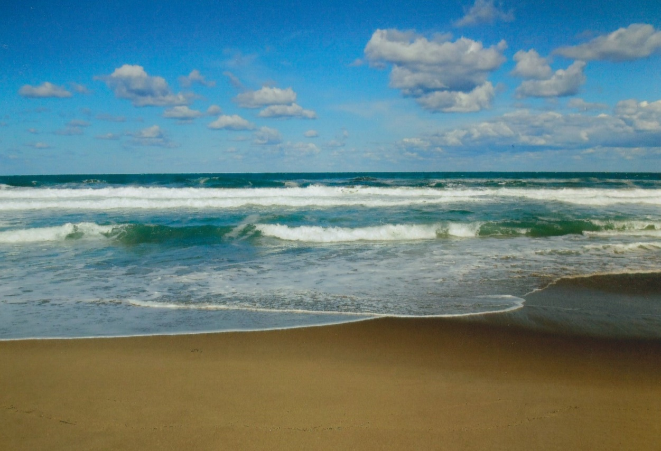
Sei frei
am Meer

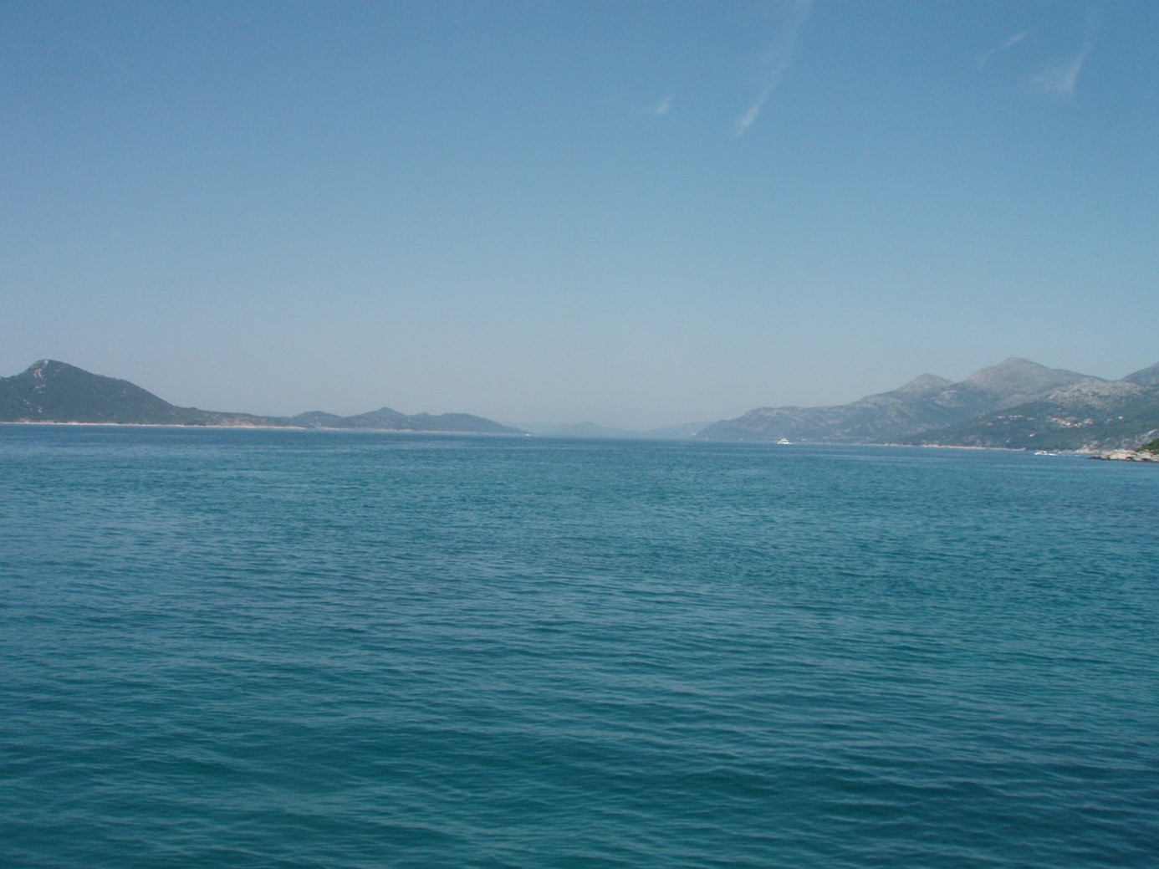

Ich bin frei, da

__________________________________________________________________________________________

______________________________________________________________________________

_________________________________________________________________________

___________________________________________________________

_________________________________________________________________________________________

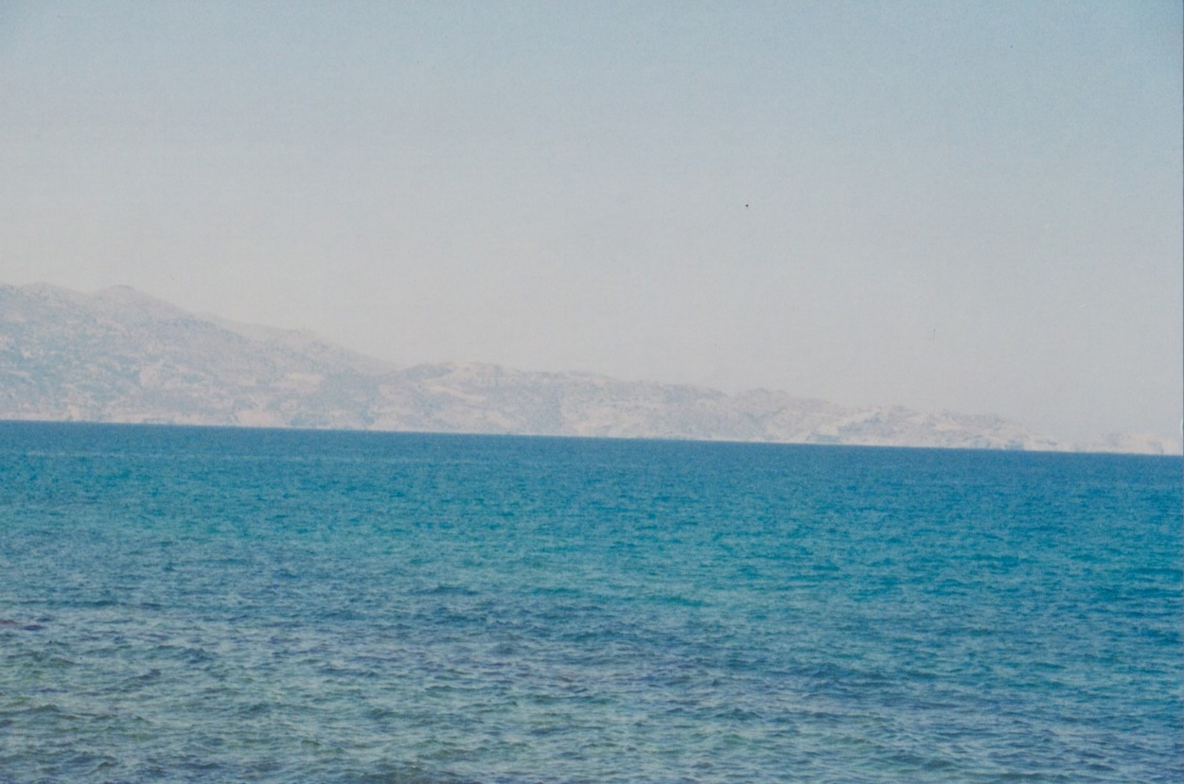

Ich darf:

____________________________________________________
________________________________
__________________________________________
_________________________________________________
___________________________________________
________________________________________________

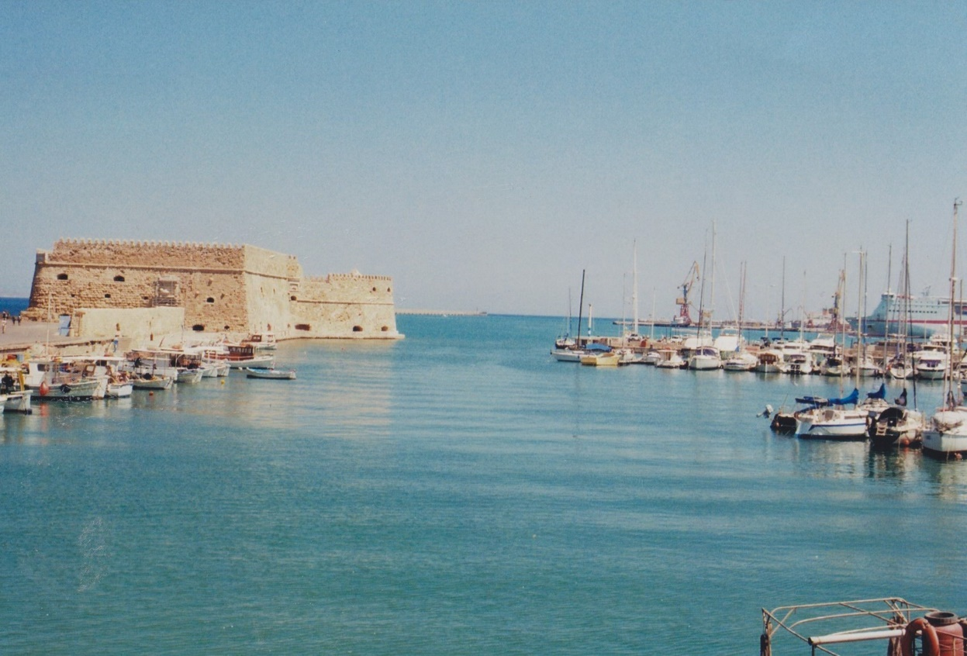
Ich bin
_____________________________________________________
________________________________________________________

___________________________________
__________
___________________________________
______________________________________

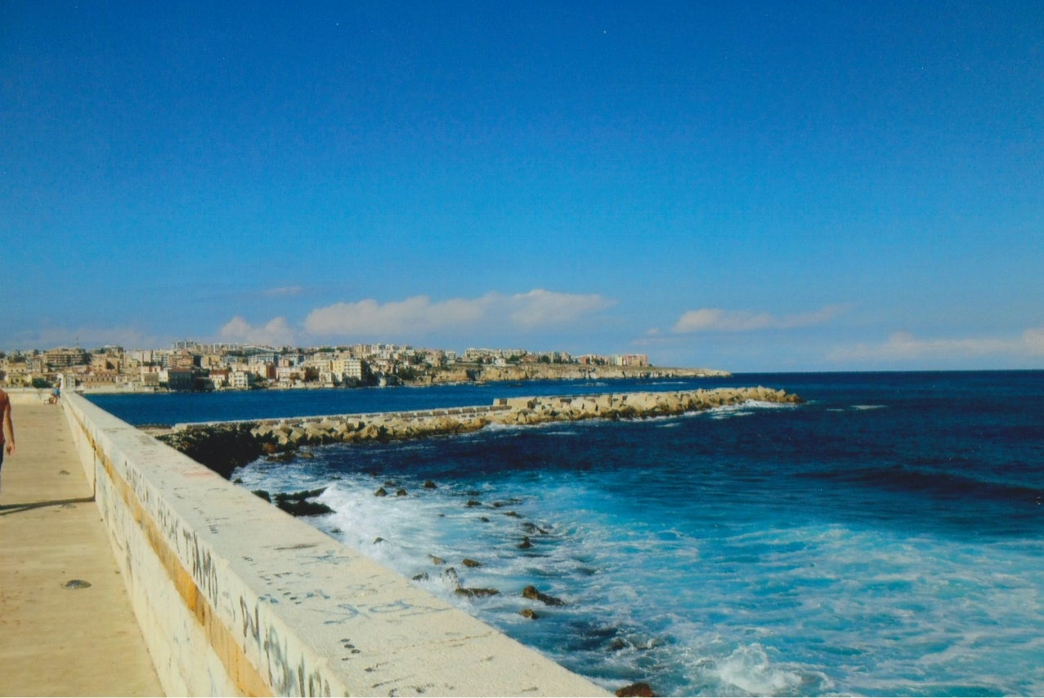
Ich kann
__________________________________________

__________________________________________________
__________________________________________________

____________________________________________________
_____________________________________________

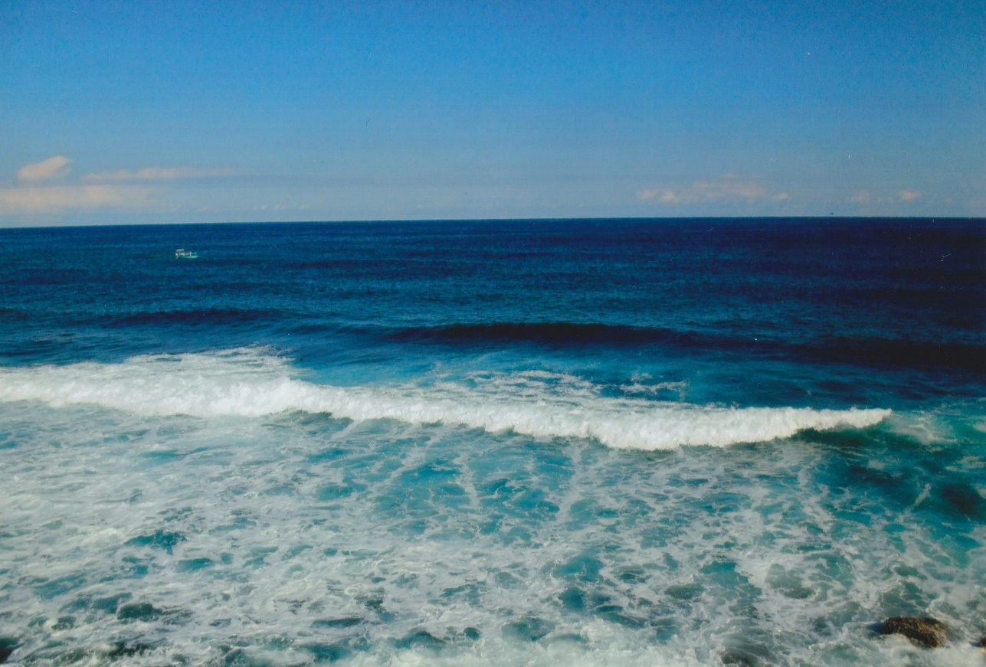
Ich will

______________________________________________

__________________________________________
_____________________________________________

_____________________________________________

___________________________________________

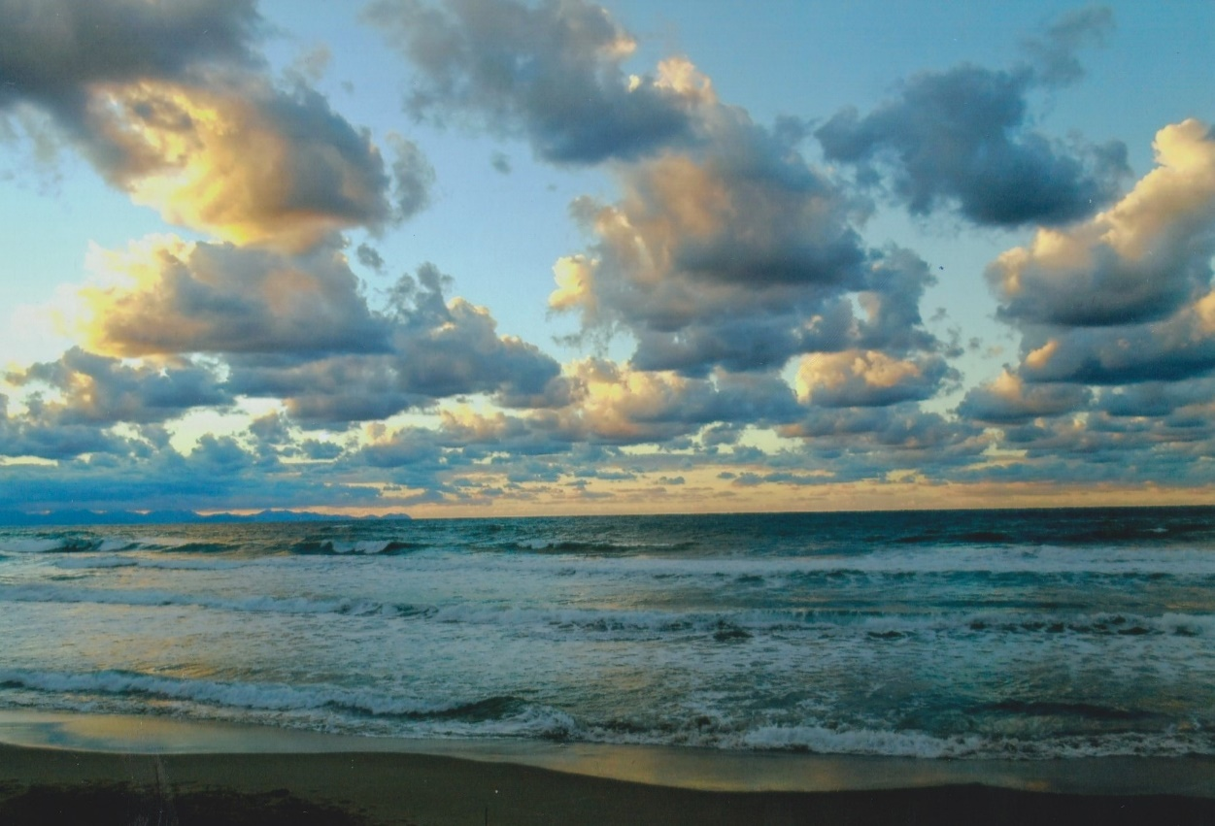
Ich werde
__________________________________________
______________________________________________

______________________________________________
____________________________________

________________________________________

___________________________

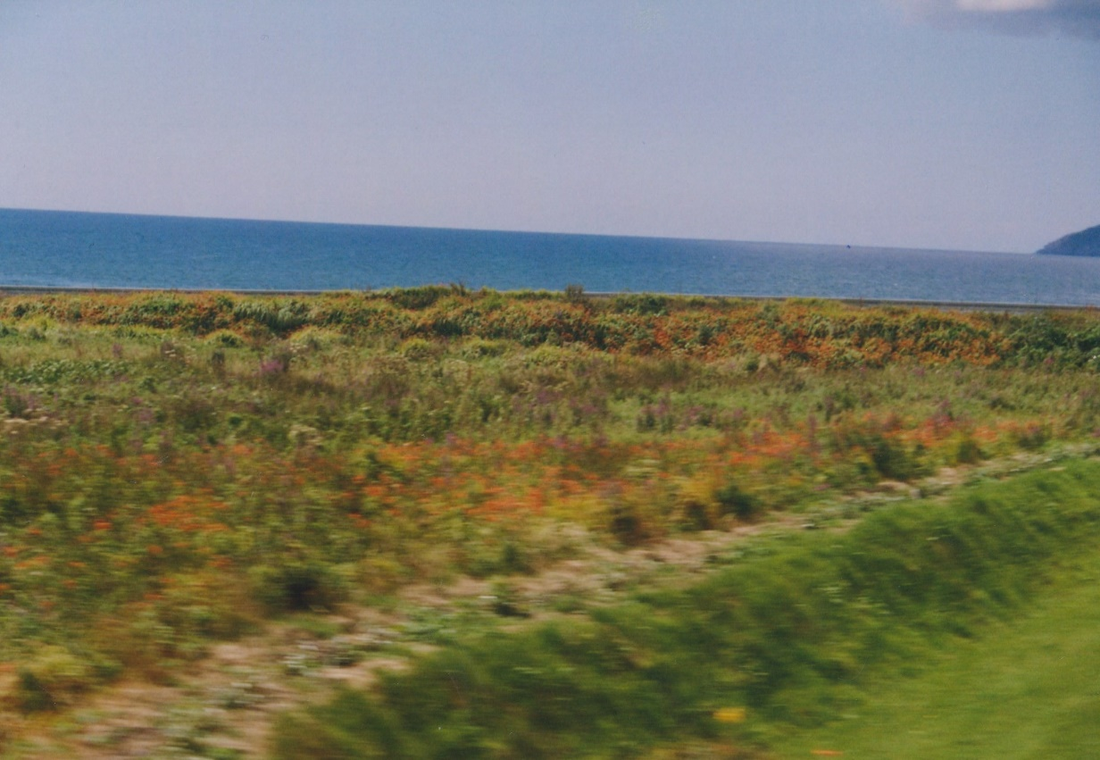
Ich schreibe

_________________________________________

____________________________________

______________________________________________

_______________________________________

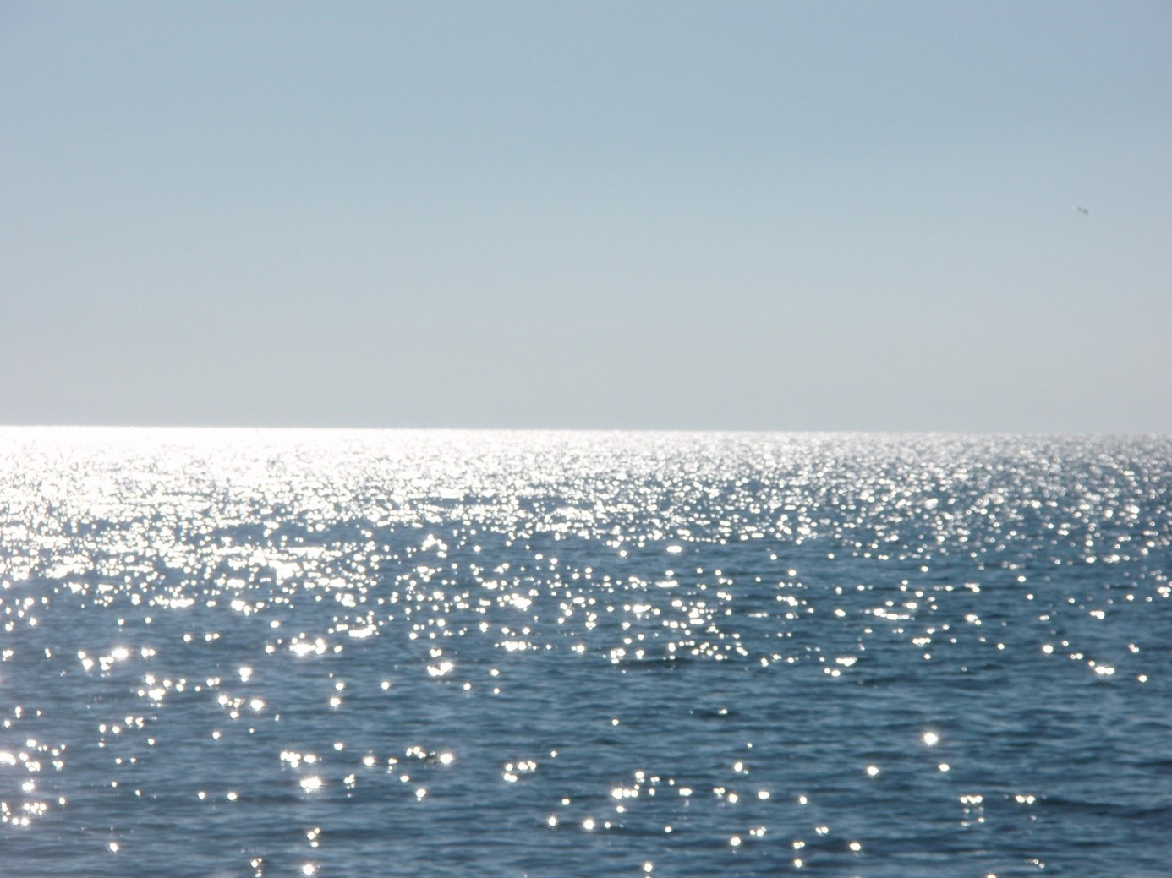

Ich denke:
____________________________

__________________________

__________________________

________________________

__________________________
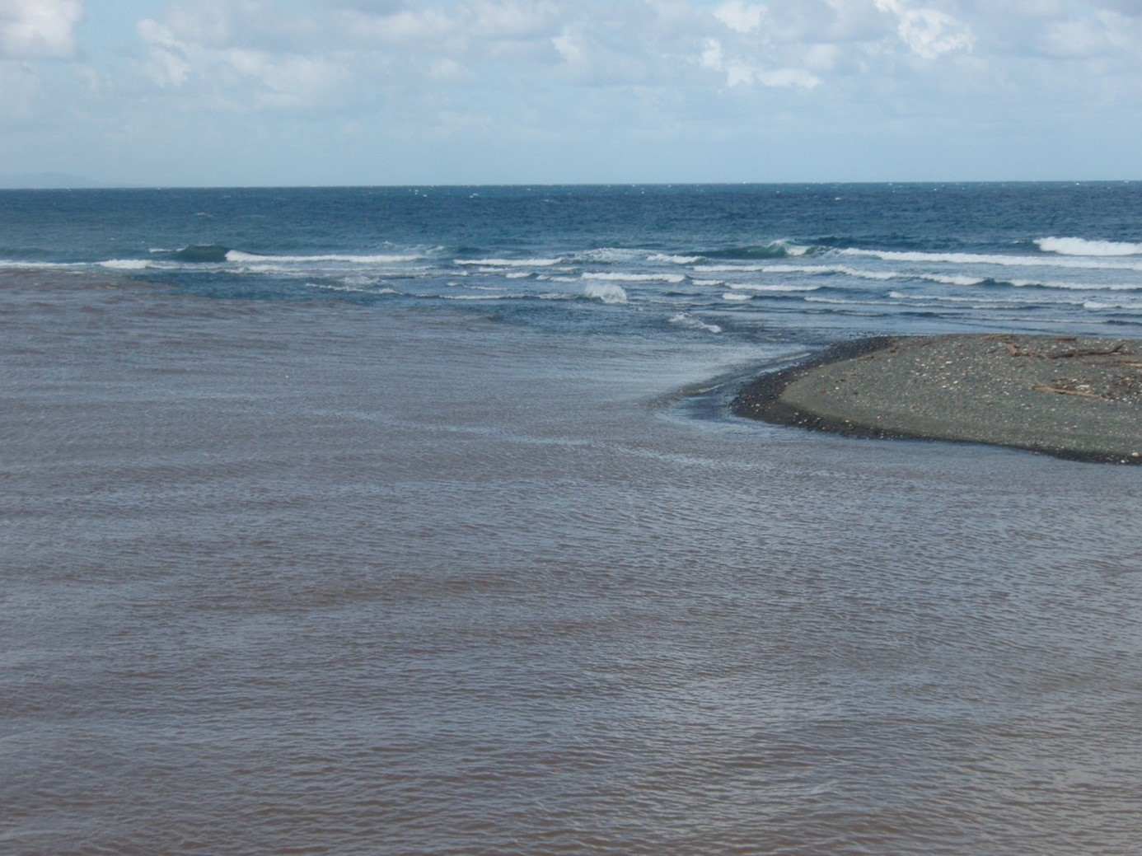
Ich mache

____________________________________

________________________

___________________________

____________________________________

____________________________
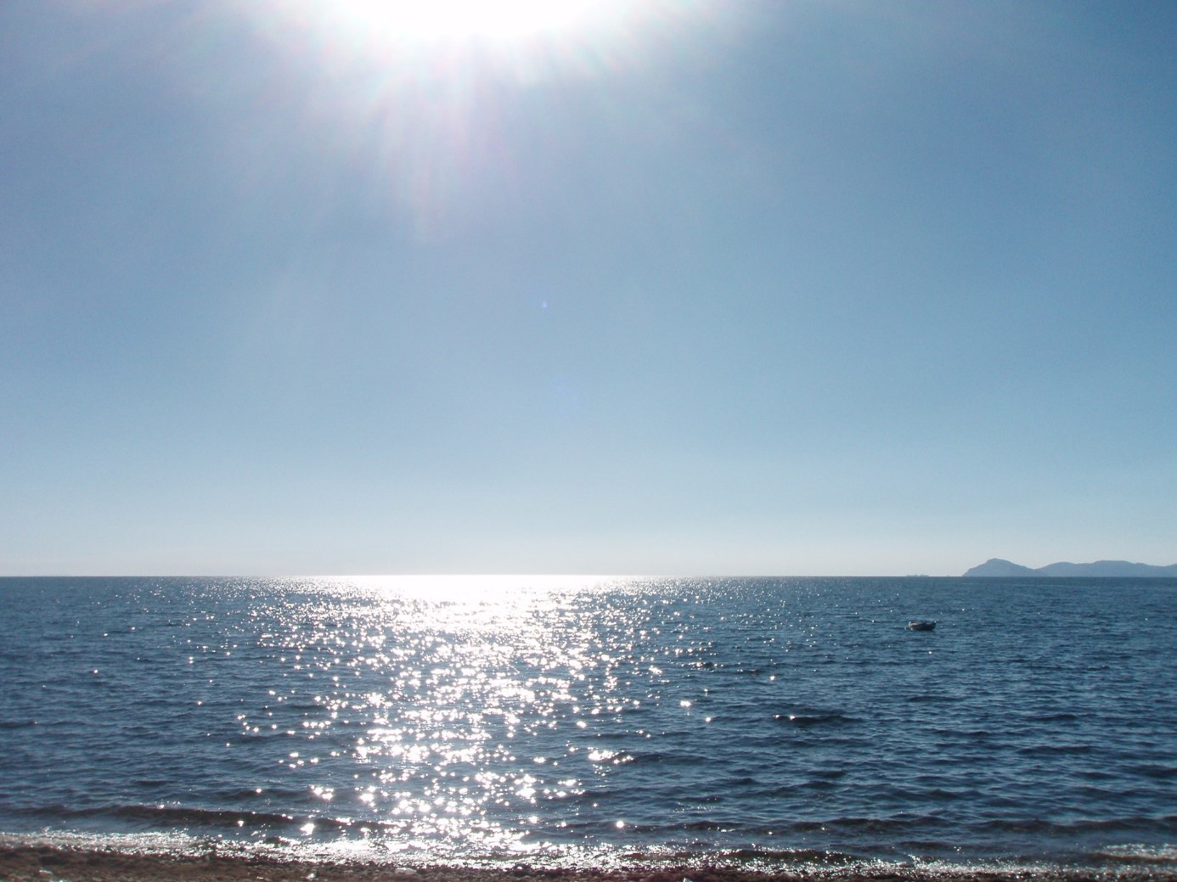
Ich lache über

_________________________________

___________________________________
____________________________________________
_____________________________________
__________________________________

________________________________
_________________________________
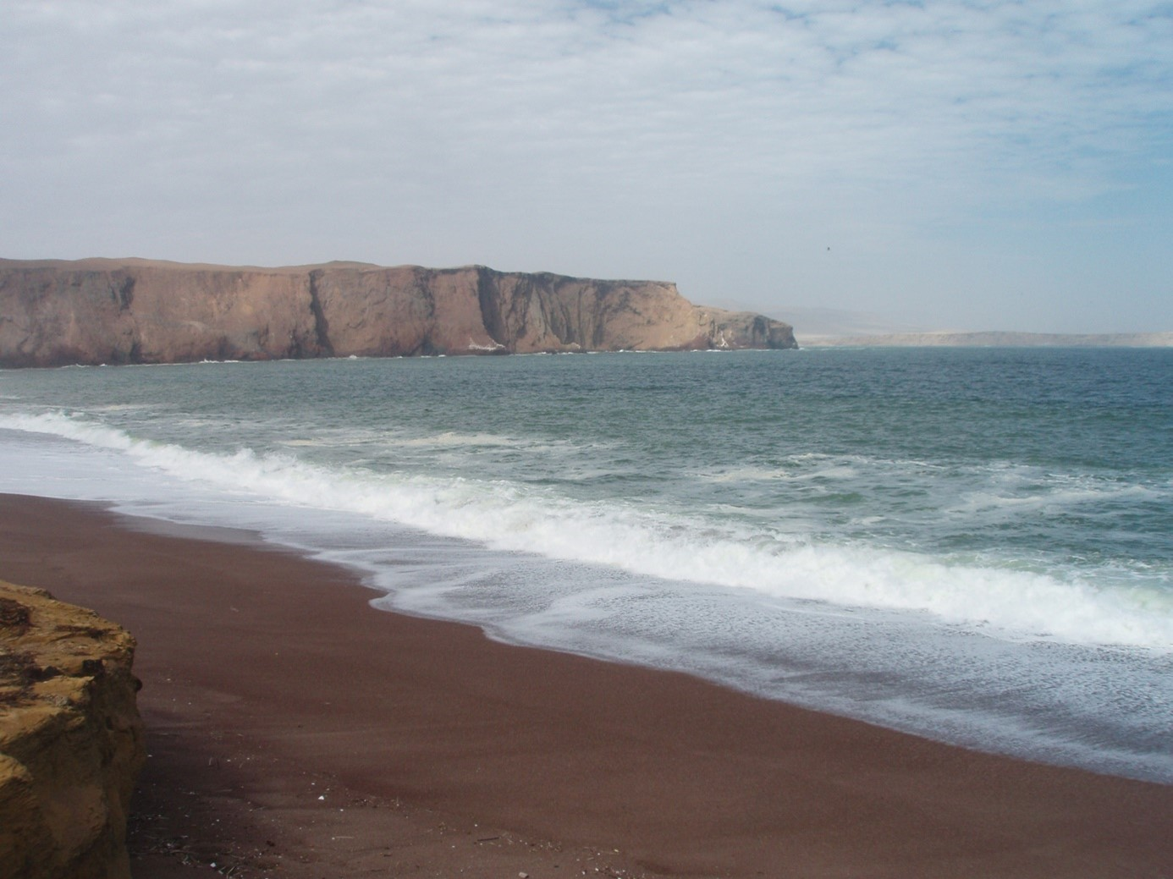
Ich weine, denn:

____________________________

_______________________

____________________________

______________________

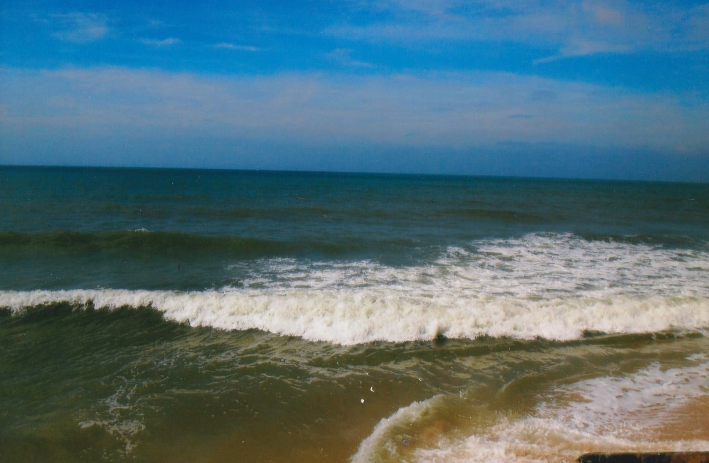
Ich träume von

_______________________________________________

______________________________
_______________________________________
_______________________
______________
__________________________________
___________________________________

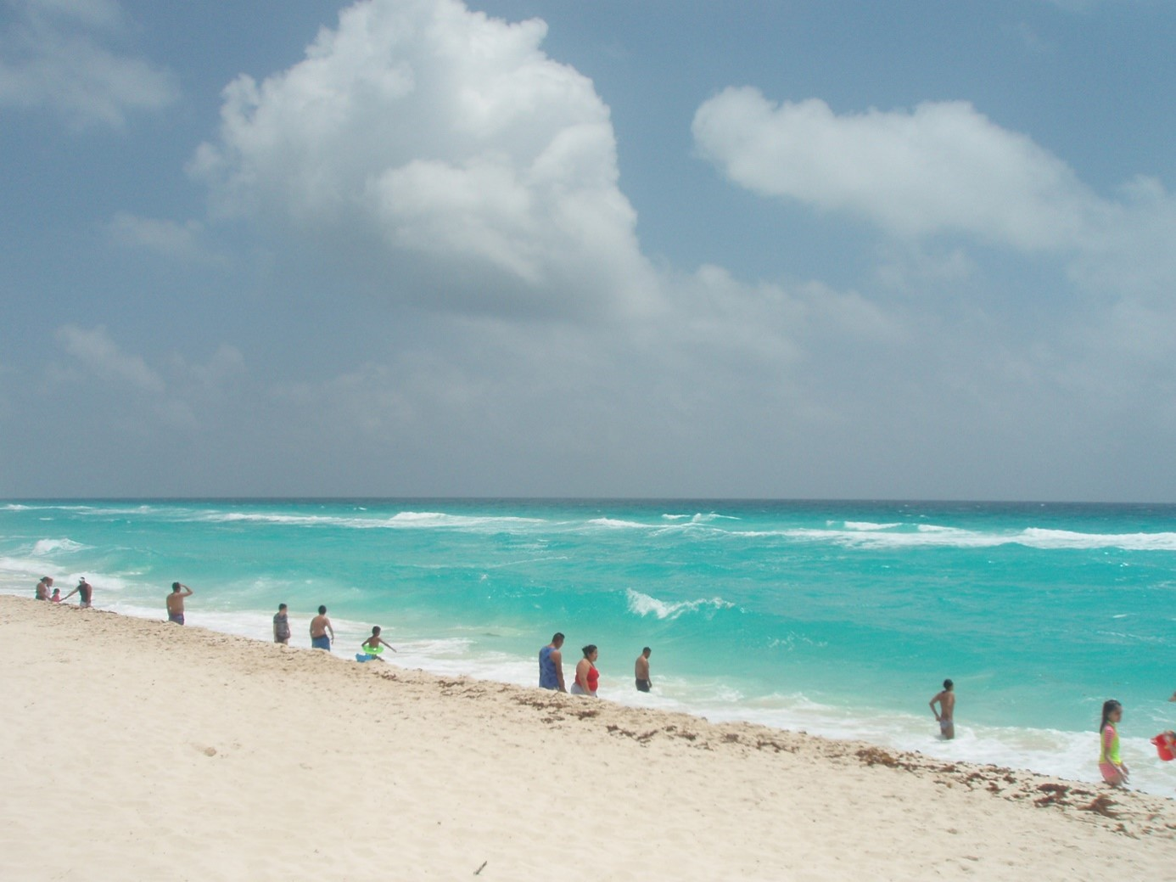
Ich liebe

___________________________________
_____________________________________
_______________________________
____________________________________
_____________________________
__________________________________
________________________

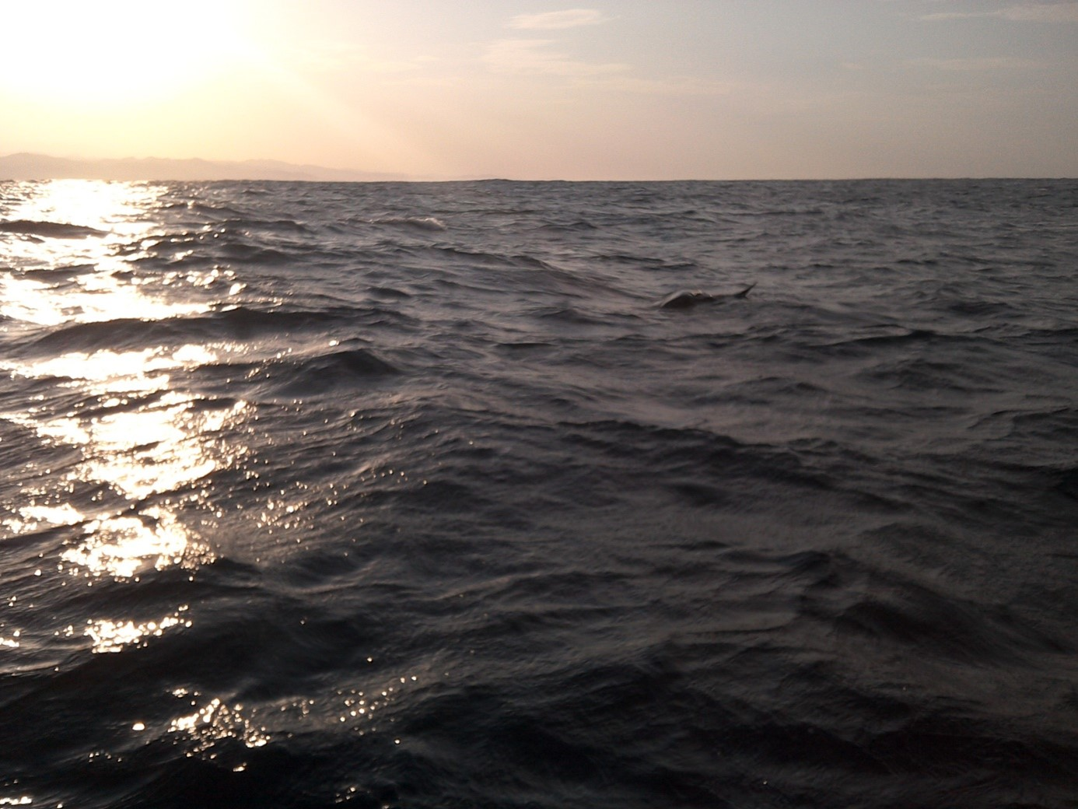
Mein Leben bleibt wunderbar, denn:

_ ______________________________________

________________________________
________________________________
______________________________________
_________________________________________
____________________________________

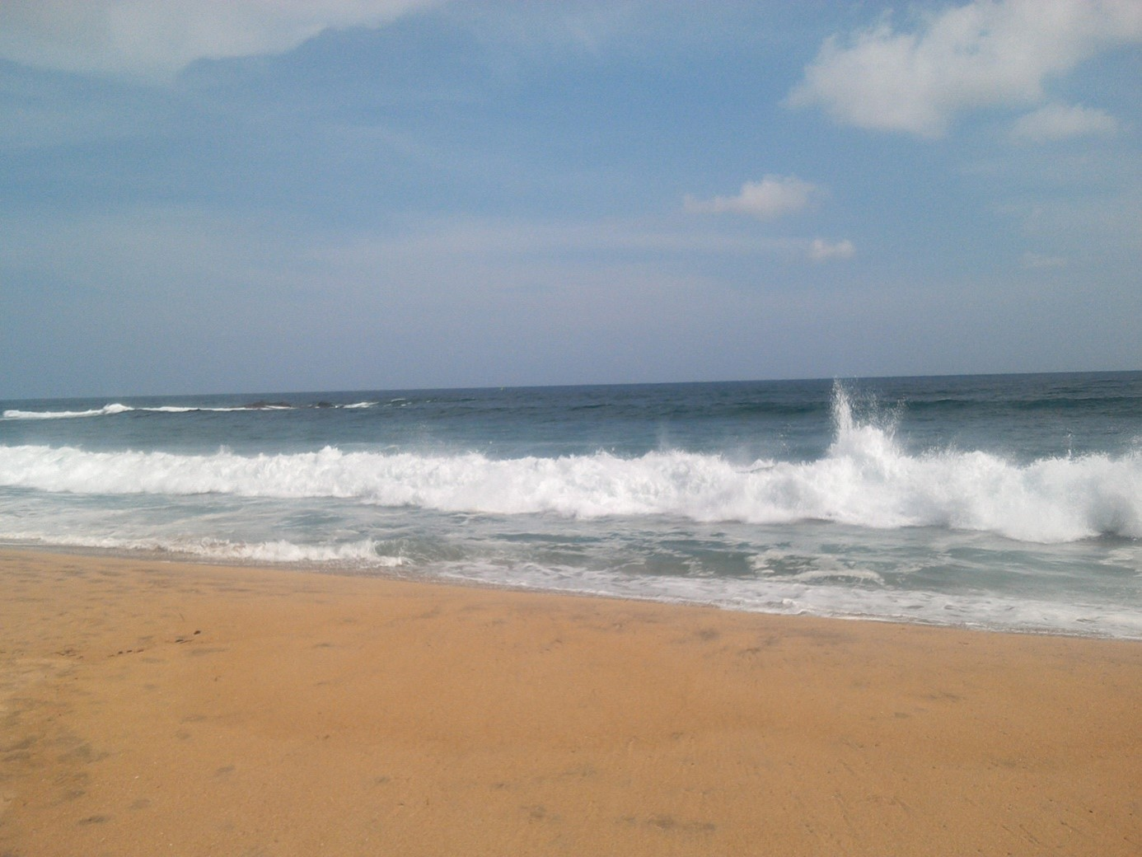
______________________
_______________________________________
__________________________
_______________________________
____________________________

Ich habe Glück, da
______________________________
_________________________
__________________________
______________________

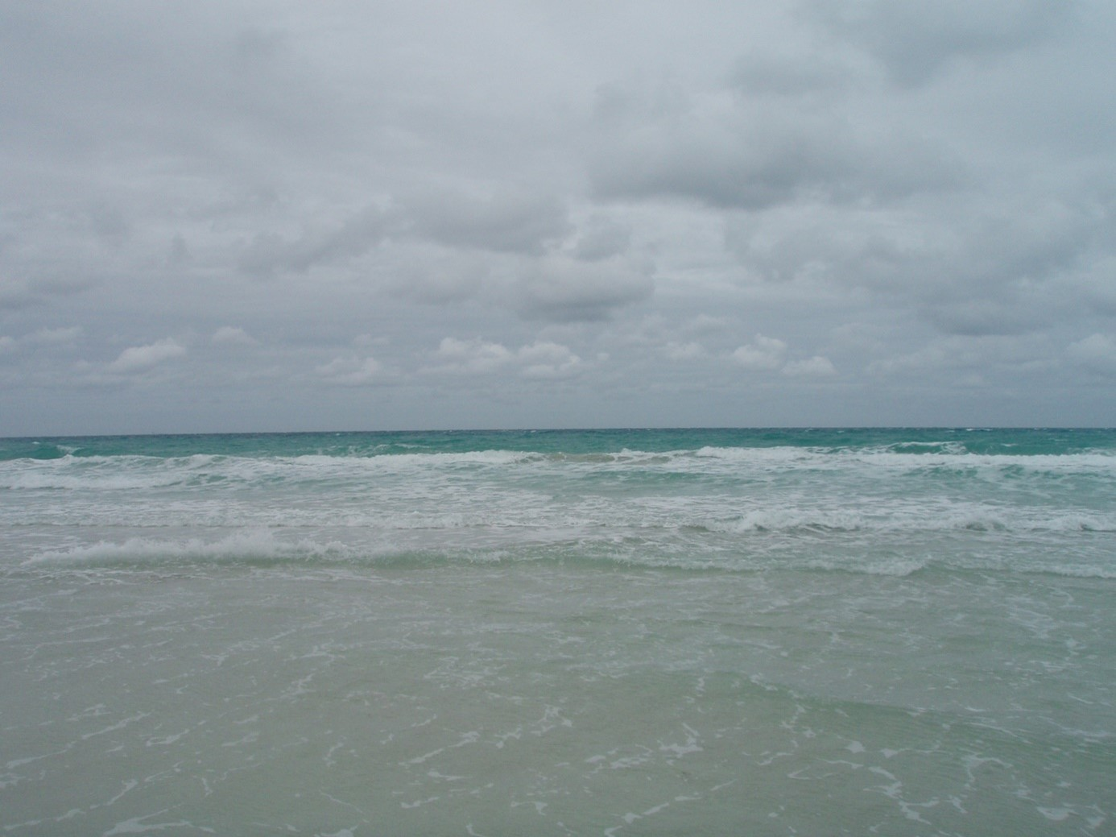
Und ich bleibe glücklich, denn

___________________________________

______________________________
________________________________
___________________________
________________________________________
_____________________
________
_____________________________

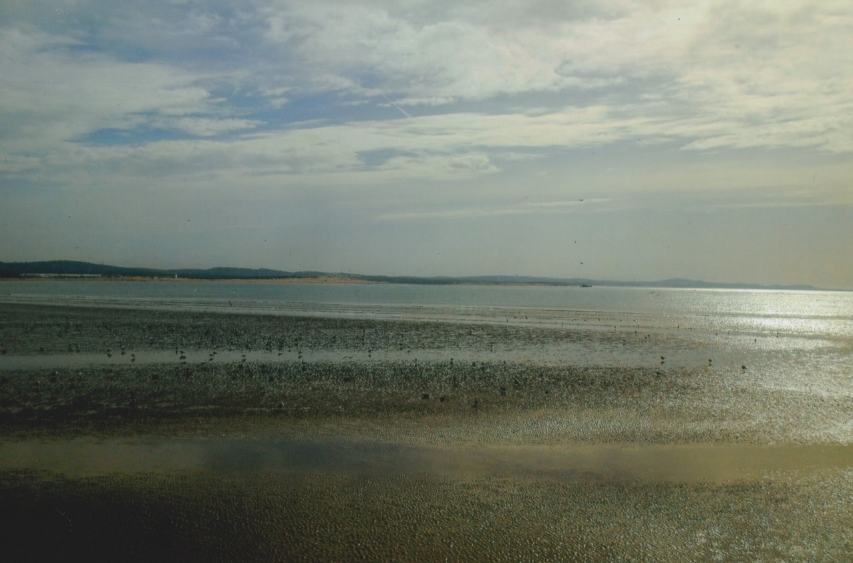

Ich bin frei, das sagt mir das Meer

