Sonnenuntergänge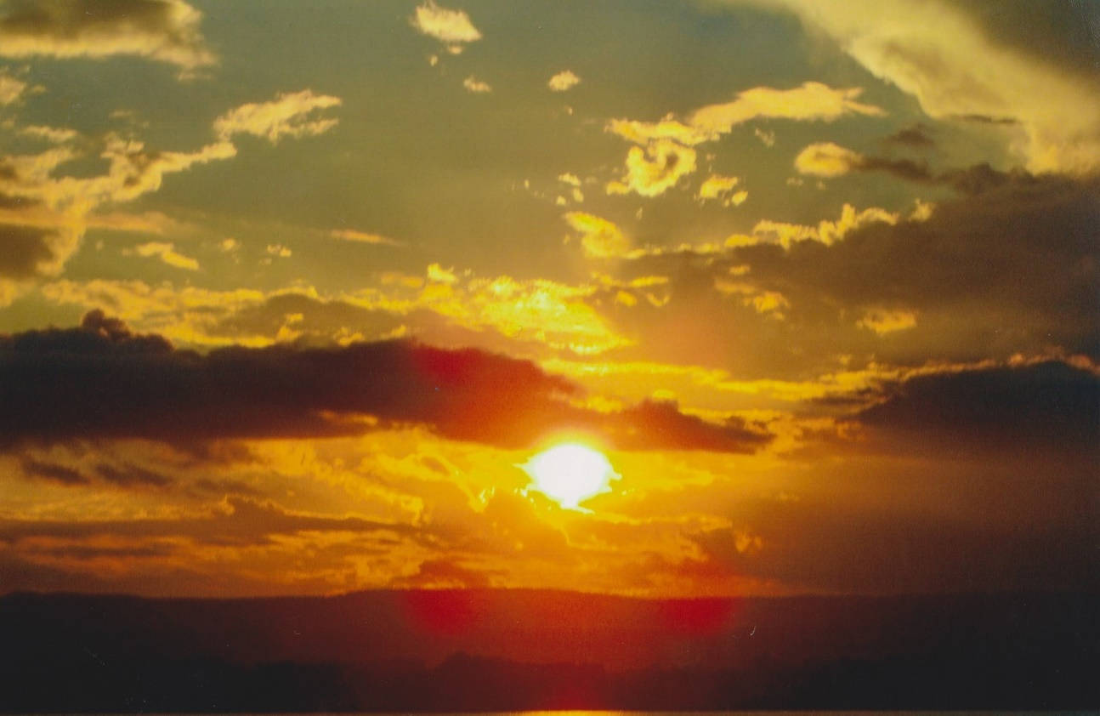

Meine schönsten Sonnenuntergänge: Platz um eure Fotos einzufügen

Ich denke bei Sonnenuntergänge nach, über:

___________________________________________________________________________________

____________________________________________________________________________________

______________________________________________________________________________________

___________________________________________________________________________________

________________________________________________________________________________________

_______________________________________________________________________________________

_________________________________________________________________________________

_____________________________________________________________________________________

_______________________________________________________________________________________

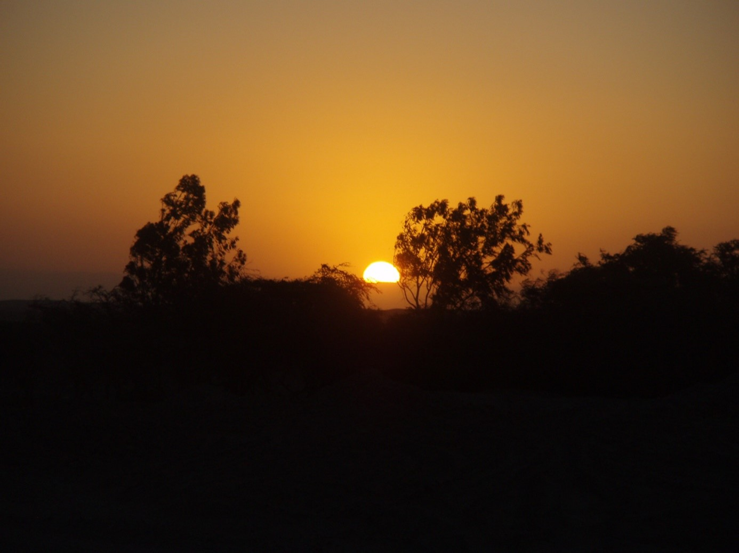

______________________________________________________

________________________________________________________

___________________________________________________________

_______________________________________________________

______________________________________________________

___________________________________________________________

________________________________________________________

Ich bewundere an Sonnenuntergängen:



_____________________

_____________________

_____________________

___________________

____________________

_____________________

___________________

_________________

_____________________

______________________

__________________

_____________________________________________________________________________________________

______________________________________________________________________________________________

_______________________________________________________________________________________

___________________________________________________________________________________________

Ich liebe an Sonnenuntergängen:



_____________________________________________________________________________

_____________________________________________________________________________________

________________________________________________________________________________

__________________________________________________________________________________

___________________________________________________________________________________

_______________________________________________________________________________

_________________________________________________________________________________

___________________________________________________________________________________

__________________________________________________________________________________

________________________________________________________________________________

__________________________________________________________________________________

__________________________________________________________________________________

__________________________________________________________________________________

_______________________________________________________________________________

Ich bin bei Sonnenuntergängen glücklich mit:



_____________________________________________

_______________________________________________

______________________________________________

______________________________________________

_______________________________________________

__________________________________________________

_______________________________________________

___________________________________________

_________________________________________________________________________________

_____________________________________________________________________________________

_____________________________________________________________________________________

___________________________________________________________________________________

_________________________________________________________________________________

Ich sehe folgende Farben:

_____________________________

__________________________________

_________________________________

__________________________________

_______________________________

__________________________________

_________________________________

_______________________________

_______________________________

________________________________

__________________________________

______________________________

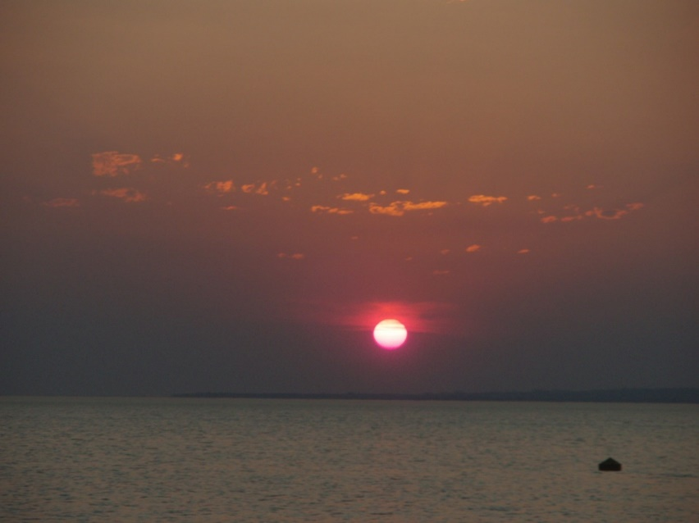



____________________________________________________________________________________________

_________________________________________________________________________________________

____________________________________________________________________________________________

______________________________________________________________________________________

___________________________________________________________________________________________

Der perfekte Moment im Leben wäre:

_____________________________-

_______________________

_________________________

__________________________

________________________

_________________________

_________________________

_________________________

_________________________

________________________

_______________________

__________________________

_______________________

_______________________

_________________________

_________________________

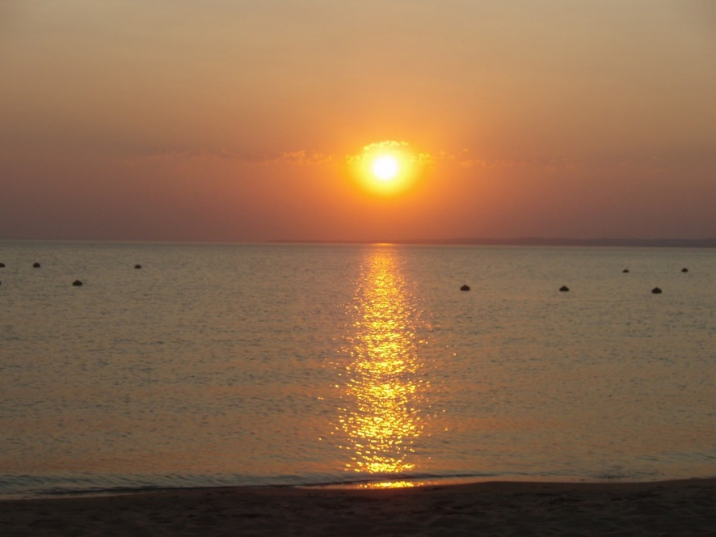

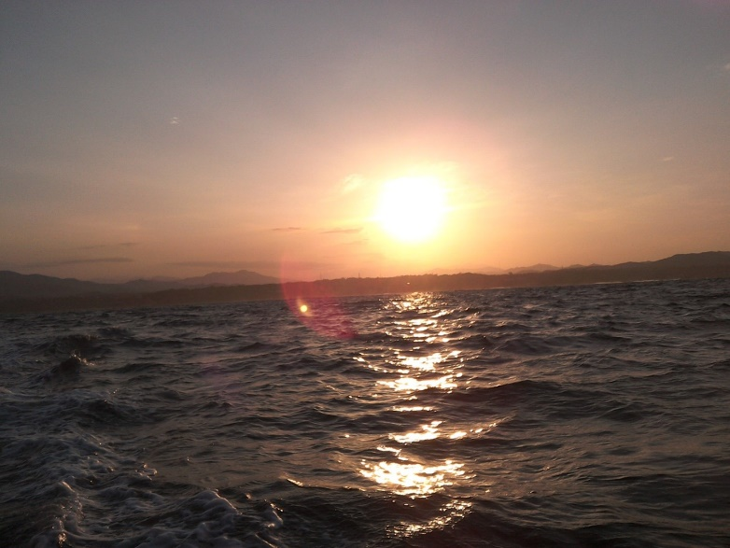

_______________________________________________________

_______________________________________________________

_________________________________________________________

________________________________________________________

__________________________________________________

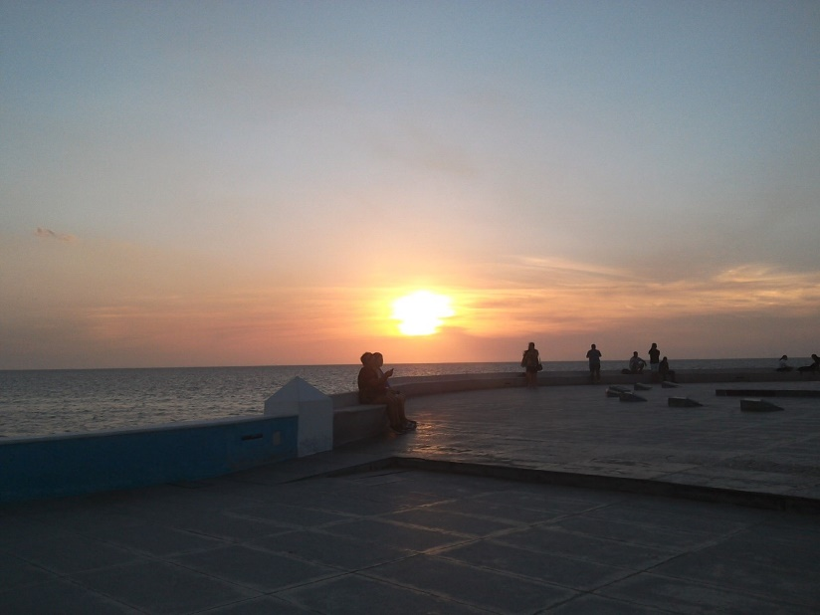

_________________________________________________________________________________

_______________________________________________________________________________________

_________________________________________________________________________________

_____________________________________________________________________________________

Der perfekte Moment ist jetzt, denn:



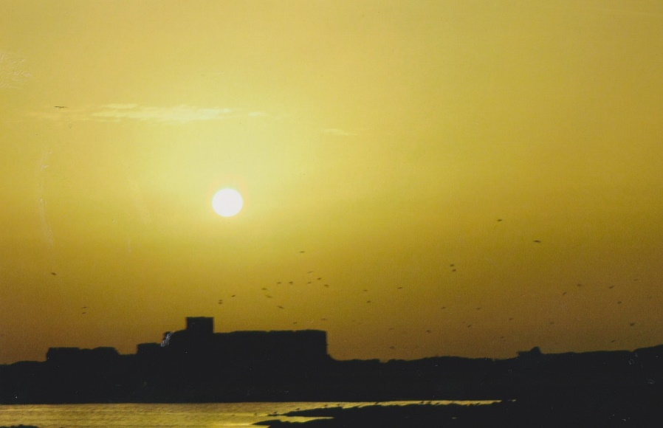

_________________________________________________________________________________

_____________________________________________________________________________________

___________________________________________________________________________________

_____________________________________________________________________________________

_____________________________________________________________________________________

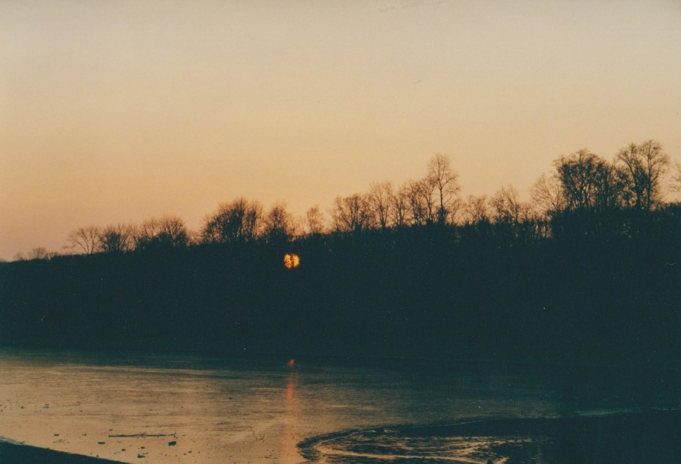

___________________

____________________

_______________________

__________________

_____________________

______________________

_____________________

__________________

_______________________

_________________________________________________________________________________________

_________________________________________________________________________________________

________________________________________________________________________________________

_______________________________________________________________________________________

_________________________________________________________________________________________

_______________________________________________________________________________________

Ich hatte einen perfekten Moment im letzten Monat:

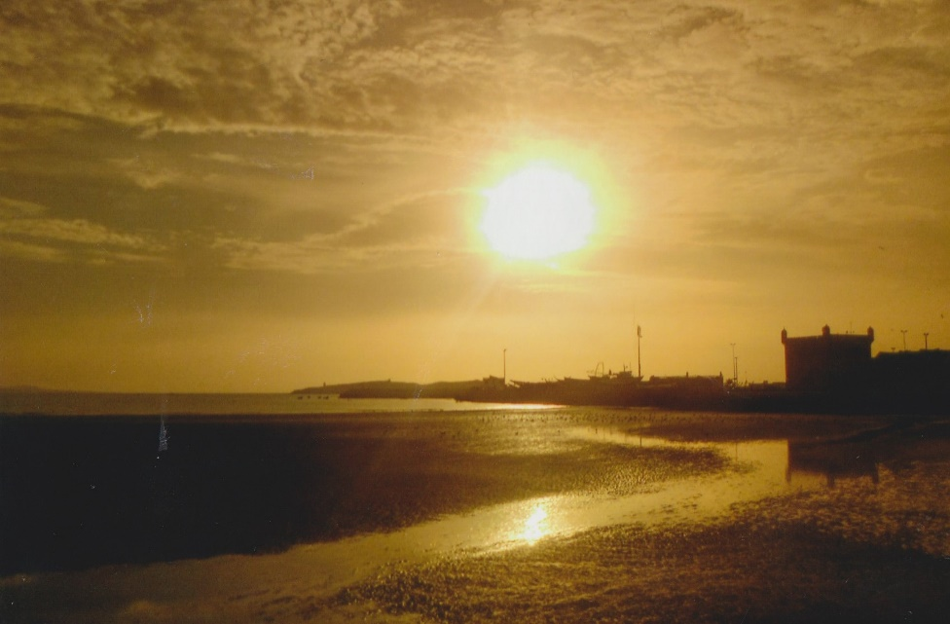

_____________________________________________________________________________________

_____________________________________________________________________________

__________________________________________________________________________________

___________________________________________________________________________________

_____________________________________________________________________________________

______________________________________________________________________

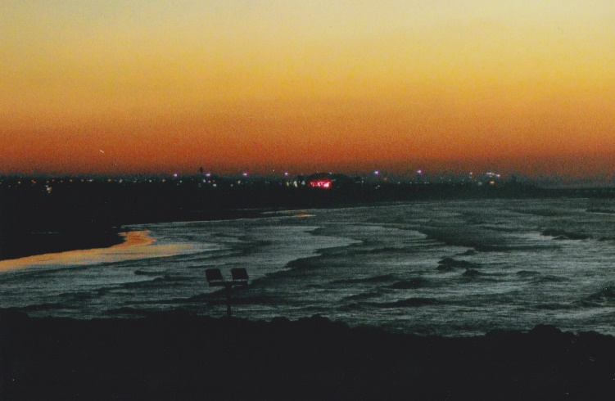

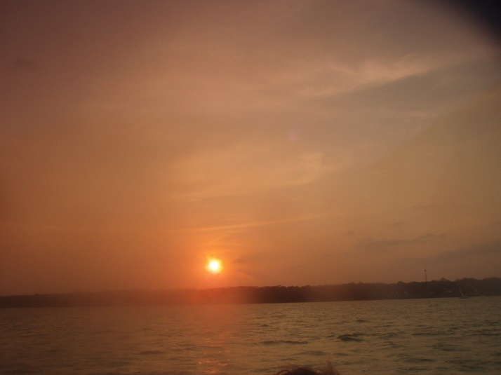

Ich hatte einen perfekten Moment im letzten Jahr:

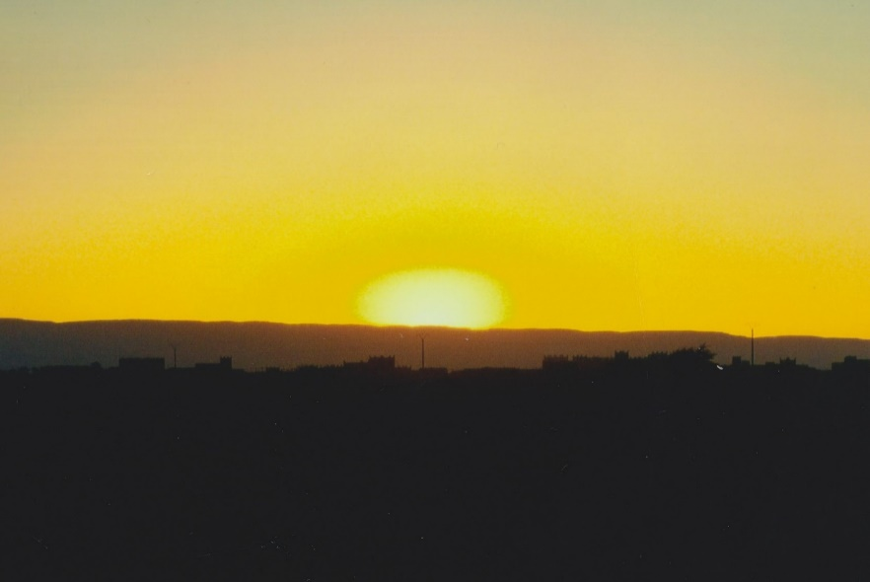

__________________________

__________________________

____________________

_______________________

__________________________

________________________

________________________-

______________________

________________________

________________________

________________________

__________________

__________________________

_________________________

_____________________

________________________

_______________________

_________________________

_________________________

_________________________

_______________________

_____________________

________________________

______________________

_____________________

_____________________

________________________

________________________

_____________________





Ich denke ich werde demnächst einen neuen perfekten Moment haben, indem:

_________________________________

_________________________________

_________________________________

_________________________________

________________________________

_____________________________________

_________________________________

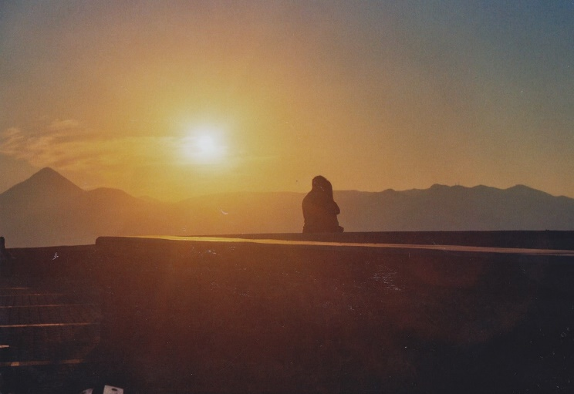

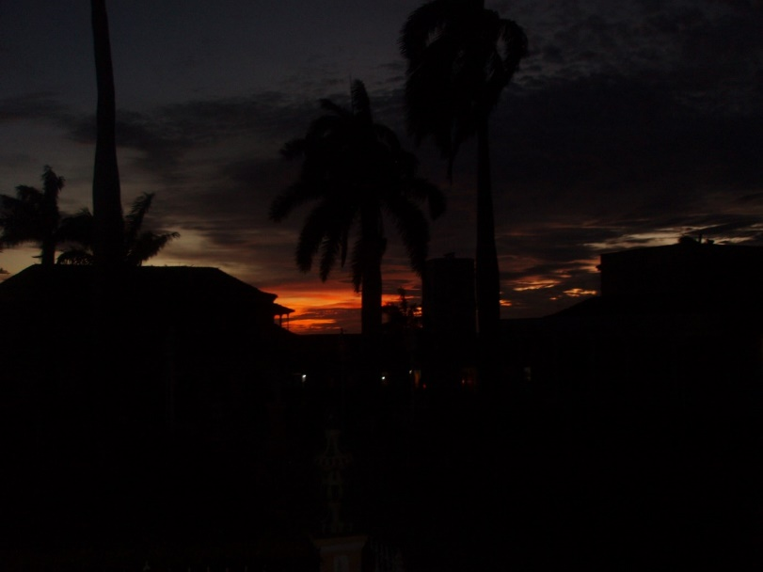

____________________________________________

______________________________________________

_____________________________________________

__________________________________________

______________________________________________

_______________________________________

____________________________________________

Ich nehme mir die Zeit, um zu genießen, Genuss heißt für mich:

_________________________________________________________________________________

________________________________________________________________________________



______________

____________________

__________________

__________________

__________________

__________________

____________________

_________________________________________________________________________________

___________________________________________________________________________________

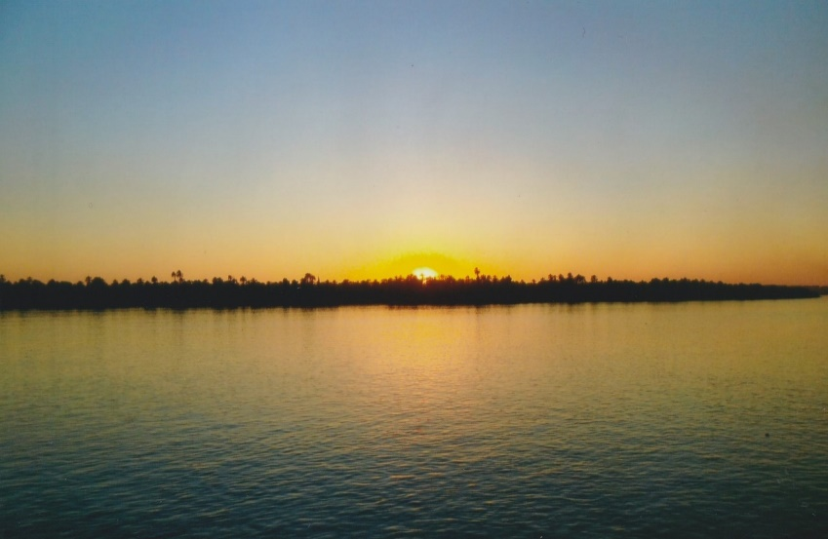

______________________________________________________________________________________

_________________________________________________________________________________

______________________________________________________________________________________

Das Schönste, was ich je erlebt habe, ist:



__________________________________________________________________________________

_______________________________________________________________________________

_________________________________________________________________________________

__________________________________________________________________________________

____________________________________________________________________________________

_____________________________________________________________________________

____________________________________________________________________________

________________________________________________________________________________

______________________________________________________________________________

_______________________________________________________________________________

_____________________________________________________________________________________

_______________________________________

______________________________________

_______________________________________

________________________________________

_______________________________________

________________________________________

_______________________________________

_____________________________________

________________________________________________________________________



Etwas Schönes, was ich sehen will, ist:

























